NAME:______________________

POINTS: /50

Cell Phones – As per school policy, cellular phones are allowed on campus; however, they are not allowed to be used during your time in the classroom. We all know that it can be very difficult to regulate the use of cell phones during class, but they can and will be regulated during instructional time (includes the restroom) in Mr. Duddleston’s class. The cell phones will be an opportunity for Mr. Duddleston to teach you the responsibility of having an important piece of equipment.

PROCEDURE:
1. Upon arriving to class before the bell rings, you are to make sure that your phone is on silent and put away in a secure location (your backpack).

2. If phone causes a disturbance (RINGS!), Mr. Duddleston will ask for the phone. Phone will be held in teachers desk until the end of the class period or a determined time and location.

CONSEQUENCES:
1. If you do not make it to class on time, you are responsible for turning off your phone and placing it in a place where you will not be tempted to use it.

EXCEPTION(S):
- THERE ARE NONE!

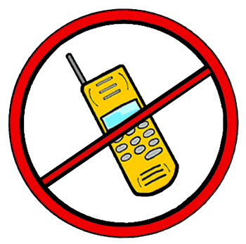

THE REASON FOR THE PROCEDURE IS TO TEACH STUDENTS THE RESPONSIBILITY OF HAVING A CELL PHONE AND WHAT ACTIONS ARE APPROPRIATE AND WHICH ARE NOT.

CD PLAYERS, iPODs, MP3 PLAYERS, ETC. – As per school policy, electronic devices are NOT allowed on campus at any time. This includes devices such as compact disc players, MP3 players, video cameras, digital cameras, and any other device that will interfere with the instructional process. All in all, the school does not want to take away your fun, your means for creativity; the reason for not allowing such devices is to ensure your focus on your studies and academic performance. I know that some of you “read, write, and work” better with music; however, during school hours, you are to do your best without them. While at home, you can have an entire musical ensemble play for you to help you do well. At school, you are surrounded by many other learning styles. Your “need” for music or any sort of distracting educational aids will distract those other students and hinder once again the educational process.**

Making my procedures, rules, and educational process YOURS:
1. In your own words, paraphrase the procedure for having a cell phone in Mr. Duddleston’s class.
1._____________________________________________________________________
______________________________________________________________________
______________________________________________________________________
2._____________________________________________________________________
______________________________________________________________________
______________________________________________________________________

2. In your own words, paraphrase the consequences for having a cell phone in Mr. Duddleston’s class.
1._____________________________________________________________________
______________________________________________________________________
______________________________________________________________________
2.____________________________________________________________________
______________________________________________________________________
______________________________________________________________________

3. What is the rule for electronic devices on school grounds and campus?
________________________________________________________________________

4. In your own words, what is the educational process? Who makes up this process? Why is it so important? ________________________________________________________________________________________________________________________________________________________________________________________________________________________________________________________________________________________________

