|  |  |
| --- | --- |
| Supporting Question 3: United States Government | |
| **Featured Source** | **Source A:** The Gadsden Purchase (excerpts) <http://avalon.law.yale.edu/19th_century/mx1853.asp> | |

**Gadsden Purchase Treaty : December 30, 1853  
BY THE PRESIDENT OF THE UNITED STATES OF AMERICA**  
A PROCLAMATION.  
WHEREAS a treaty between the United States of America and the Mexican Republic was concluded and signed at the City of Mexico on the thirtieth day of December, one thousand eight hundred and fifty-three; which treaty, as amended by the Senate of the United States, and being in the English and Spanish languages, is word for word as follows:  
  
…

ARTICLE I  
The Mexican Republic agrees to designate the following as her true limits with the United States for the future: retaining the same dividing line between the two Californias as already defined and established, according to the 5th article of the treaty of Guadalupe Hidalgo, the limits between the two republics shall be as follows: Beginning in the Gulf of Mexico, three leagues from land, opposite the mouth of the Rio Grande, as provided in the 5th article of the treaty of Guadalupe Hidalgo; thence, as defined in the said article, up the middle of that river to the point where the parallel of 31° 47' north latitude crosses the same; thence due west one hundred miles; thence south to the parallel of 31° 20' north latitude; thence along the said parallel of 31° 20' to the 111th meridian of longitude west of Greenwich; thence in a straight line to a point on the Colorado River twenty English miles below the junction of the Gila and Colorado rivers; thence up the middle of the said river Colorado until it intersects the present line between the United States and Mexico.  
  
For the performance of this portion of the treaty, each of the two governments shall nominate one commissioner, to the end that, by common consent the two thus nominated, having met in the city of Paso del Norte, three months after the exchange of the ratifications of this treaty, may proceed to survey and mark out upon the land the dividing line stipulated by this article, where it shall not have already been surveyed and established by the mixed commission, according to the treaty of Guadalupe, keeping a journal and making proper plans of their operations. For this purpose, if they should judge it necessary, the contracting parties shall be at liberty each to unite to its respective commissioner, scientific or other assistants, such as astronomers and surveyors,

|  |  |
| --- | --- |
| Supporting Question 3: United States Government | |
| **Featured Source** | **Source B:** The Tohono O’odham Reservation Map <https://openborders.info/blog/tag/tohono-oodham/> | |

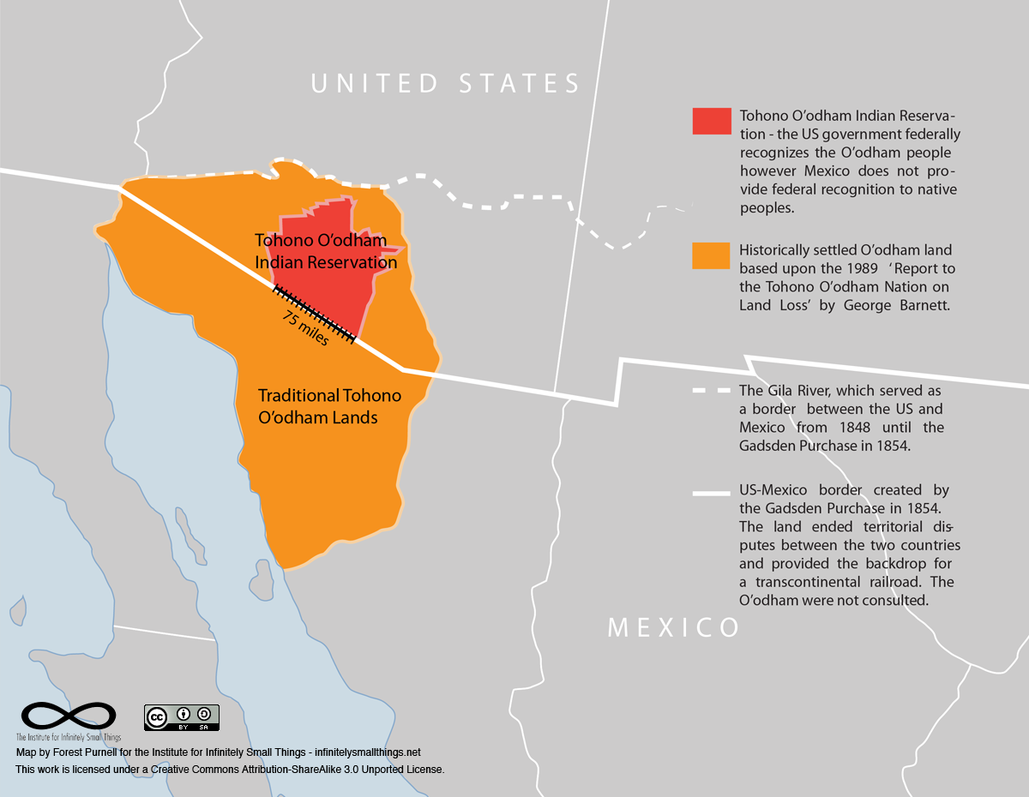

|  |  |
| --- | --- |
| Supporting Question 3: United States Government | |
| **Featured Source** | **Source C:** Source C: Tohono O’odham Constitution (excerpts) <https://www.narf.org/nill/constitutions/tohono/Constitution.pdf> | |

**CONSTITUTION OF THE TOHONO O’ODHAM NATION**

PREAMBLE  
We, the members of the Tohono O'odham Nation, formerly known as the Papago Tribe , do ordain and establish this constitution for the people of this nation, in order to affirm our sovereign powers of self -- government, to preserve , protect and build upon our unique and distinctive culture and traditions, to conserve our common resources , to establish a responsive form of government, to provide for the free expression of our people , to promote the rights, education and welfare of the present and future generations of our people and to show our gratitude to I'itoi our Maker . This constitution when duly adopted and approved shall supersede the Constitution and Bylaws of the Papago Tribe, Arizona , as amended, ratified by the adult Indians of the Papago Tribe on December 12, 1936, and approved by the Secretary of the Interior on January 6, 1937 .

ARTICLE III - RIGHTS OF MEMBERS  
Section I . All political power is inherent in the people . The government of the Tohono O'odham Nation derives its powers from the consent of the governed and is established to protect and maintain their individual rights. It shall not deny to any member of the Tohono O'odham Nation the equal protection of its laws or deprive any member of liberty or property without due process of law.

Section 2 . All members of the Tohono O'odham Nation shall have the freedom of worship, speech, press and assembly.

Section 3 . All members of the Tohono O’odham Nation shall be given opportunity to participate in the economic resources and activities of the Tohono O'odham Nation.

Section 4 . The listing of the foregoing rights shall not be construed as denying or abridging other fundamental rights of the people guaranteed by Title II of the Indian Civil Rights Act of April 1, 1968 (82 Stat . 77).

ARTICLE IV - FORM OF GOVERNMENT  
The government of the Tohono O'odham Nation shall be composed of three independent  
branches : the LEGISLATIVE, consisting of the Tohono O'odham Council; the EXECUTIVE, consisting of the office of Chairman of the Tohono O'odham Nation; and the JUDICIAL, consisting of the Tohono O'odham Judiciary .

|  |  |
| --- | --- |
| Supporting Question 3: United States Government | |
| **Featured Source** | **Source D:** Tohono O’odham current government | |

Use the link to the Tohono O’odham’s most updated list of tribal leaders: <http://www.tonation-nsn.gov/tribal-government/>

Legislative Districts: <http://www.tonation-nsn.gov/districts/>   
  
Tohono O’odham Legislative Branch: <http://www.tolc-nsn.org>