|  |  |
| --- | --- |
| **Source Bank 1:**  **Source 1A**- Jo Ann Robinson, memoir, *The Montgomery Bus Boycott and the Women Who Started It* (excerpts), 1987  **Source 1B**- Jo Ann Robinson, reproduction and transcript of the leaflet calling for the Montgomery bus boycott, December 5, 1955  **Source 1C**- Thomas Gray, oral history Interview describing the Montgomery bus boycott conducted on, no date  **Source 1D**- Martin Luther King, Jr., address to the first Montgomery Improvement Association (MIA) mass meeting about the bus boycott, December 5, 1955 | |

SOURCE A:

I sat down and quickly drafted a message and then called a good friend and colleague…who had access to the college’s mimeograph equipment. When I told him that the WPC was staging a boycott and needed to run off the notices, he told me that he too had suffered embarrassment on the city buses….Along with two of my most trusted senior students, we quickly agreed to meet almost immediately, in the middle of the night, at the college’s duplicating room. We were able to get three messages to a page…in order to produce the tens of thousands of leaflets we knew would be needed. By 4 a.m. Friday, the sheets had been duplicated, cut in thirds, and bundled….

Between 4 and 7 a.m., the two students and I mapped out distribution routes for the notices. Some of the WPC officers previously had discussed how and where to deliver thousands of leaflets announcing a boycott, and those plans now stood me in good stead….

After class my two students and I quickly finalized our plans for distributing the thousands of leaflets so that one would reach every black home in Montgomery. I took out the WPC membership roster and called [them]….I alerted all of them to the forthcoming distribution of the leaflets, and enlisted their aid in speeding and organizing the distribution network….

Throughout the late morning and early afternoon hours we dropped off tens of thousands of leaflets. Some of our bundles were dropped off at schools. .

. . Leaflets were also dropped off at business places, storefronts, beauty parlors, beer halls, factories, barbershops, and every other available place. Workers would pass along notices both to other employees as well as to customers….

By 2 o’clock thousands of the mimeographed handbills had changed hands many times. Practically every black man, woman, and child in Montgomery knew the plan and was passing the word along.

*Source: From The Montgomery Bus Boycott and the Women Who Started It by JoAnn Robinson. Edited by David J. Garrow. Copyright 1987 by the University of Tennessee Press. Reprinted by permission.*

SOURCE B:

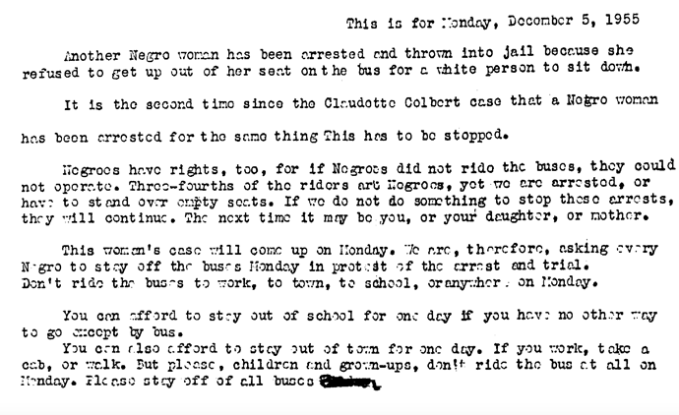

*From The Montgomery Bus Boycott and the Women Who Started It by JoAnn Robinson. Edited by David J. Garrow. Copyright 1987 by the University of Tennessee Press.*

Transcript of the leaflet calling for the Montgomery bus boycott:

This is for Monday, December 5, 1955

Another Negro woman has been arrested and thrown into jail because she refused to get up out of her seat on the bus for a white person to sit down.

It is the second time since the Claudette Colbert case that a Negro woman has been arrested for the same thing. This has to be stopped.

Negros have rights, too, for if Negros did not ride the buses, they could not operate. Three-fourths of the riders are Negros, yet we are arrested, or have to stand over empty seats. If we do not do something to stop these arrests, they will continue. The next time it may be you, or your daughter, or mother.

This woman’s case will come up on Monday. We are, therefore, asking every Negro to stay off the buses Monday in protest of the arrest and trial. Don’t ride the bus to work, to town, to school, or anywhere, on Monday.

You can afford to stay out of school for one day if you have no other way to go except by bus.

You can also afford to stay out of town for one day. If you work, take a cab, or walk. But please, children and grown-ups, don’t ride the bus at all on Monday. Please stay off of all buses.

SOURCE C:

NOTE: Teachers and their students can listen to an oral history with Thomas Gray talking about the Montgomery Bus Boycott by clicking on this link:

[*http://www.montgomeryboycott.com/thomas-gray/*](http://www.montgomeryboycott.com/thomas-gray/)

SOURCE D:

NOTE: On December 1, 1955, Mrs. Rosa Parks, an African American woman, refused to relinquish her seat on a Montgomery, Alabama, city bus to a white passenger. She was arrested by the Montgomery police for her act of protest, and the community quickly rallied to her defense, founding the Montgomery Improvement Association (MIA) and organizing a bus boycott. Four days after her arrest, on December 5, 1955, Dr. Martin Luther King, Jr. addressed the very first mass meeting of the MIA as the group’s president.

*Teachers and students can read a transcript of King’s speech and hear an excerpt of original recording on the website of the Martin Luther King, Jr. Research and Education Institute of Stanford University (* [*http://mlk-kpp01.stanford.edu*](http://mlk-kpp01.stanford.edu/) *) by performing a site search for “Address to the first Montgomery Improvement Association (MIA) Mass Meeting.”*