Fun and Easy To Make Relaxation Flip Books
Last month I came across these relaxation scripts online (link) that I found really fun and easy to use. This site was intended to offer techniques for anxious little ones to use when having to give blood. Kids had fun practicing these, and it was inexpensive to reproduce laminated flip books to send home with clients. Its also small enough for me to keep one on hand in my purse.
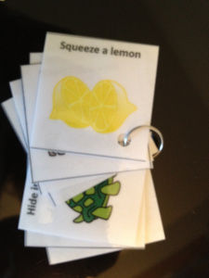
This was so easy to make.
- print the pictures in color from the website
- laminate the sheet
- cut out each picture individually
- punch a hold in the corner of each card
- slide each picture into a ring, such as a small key ring or notecard ring.
I have done this with boys, girls, older, younger, and even with families. After learning all the techniques, I have them choose their top 3 favorites to practice over the week when they feel angry, frustrated, or anxious. It’s a lot of fun and I have had great feedback from this simple, yet effective tool!
Here are the techniques. Each one is intended to target a certain part of the body, such as the jaw, shoulders, and arms. My 3 favorites are the Lemon, Turtle, and Cat!
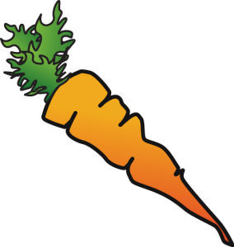
Jaw: Chew That Carrot
Now, pretend that you are trying to eat a giant, hard carrot. It is very hard to chew. Bite down on it. As hard as you can. We want to turn that carrot into mush! Keep biting. (Hold for 10 seconds). Good. Now relax. You’ve eaten the carrot. Let yourself go as loose as you can.

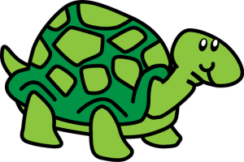

Shoulders and Neck: Hide in Your Shell
Now pretend you are a turtle. Try to pull your head into your shell. Try to pull your shoulders up to your ears and push your head down into your shoulders. Hold it tight! (Hold for 10 seconds). Okay, you can come out now. Feel your shoulders relax.
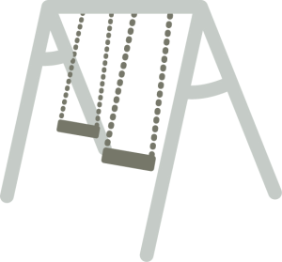
Back: Swing Up High
Pretend you are on a swing at the park. Swing your upper body back and forth, back and forth. To get really high, use your arms to help you swing! Keep swinging! (Hold for 10 seconds). Great. You’re all done on the swing. Sit back and relax.

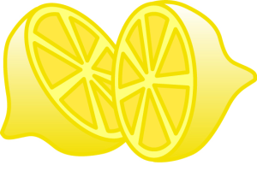

Hands and Arms: Squeeze a Lemon
Pretend you have a whole lemon in each hand. Now squeeze it hard. Try to squeeze all the juice out! Feel the tightness in your hand and arm as you squeeze. Squeeze hard! Don’t leave a single drop. (Hold for 10 seconds). Now relax and let the lemon drop from your hand. See how much better your hand and arm feel when they are relaxed.
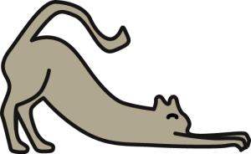
Arms and Shoulders: Stretch Like a Cat
Pretend you are a furry, lazy cat and you just woke up from a nap. Stretch your arms out in front of you. Now raise them way up high over your head. Feel the pull in your shoulders. Stretch higher and try to touch the ceiling. (Hold for 10 seconds). Great! Let them drop very quickly and feel how good it is to be relaxed. It feels good and warm and lazy.

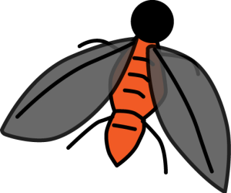

Face and Nose: Get That Fly Off Your Nose
Here comes a pesky old fly and he has landed on your nose! Try to get him off without using your hands. Wrinkle up your nose. Make as many wrinkles in your nose as you can. Scrunch up your nose real hard and hold it just as tight as you can. Notice that when you scrunch up your nose, your cheeks and your mouth and your forehead and your eyes all help you and they get tight, too. (Hold for 10 seconds). Good. You’ve chased him away. Now you can just relax and let your whole face go smooth.
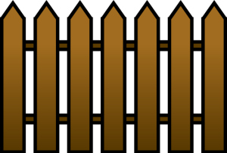
Stomach: Squeeze Through a Fence
Now pretend that you want to squeeze through a narrow fence. You’ll have to make yourself very skinny if you’re going to make it through. Suck your stomach in, try to squeeze it against your back bone. Get it real small and tight. Hold it as tight as you can! (Hold for 10 seconds). Okay, you’ve made it! You got through the fence. Settle back and let your stomach come back out where it belongs.

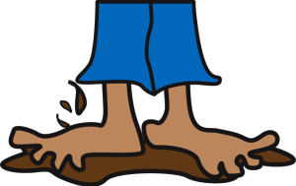

Legs and Feet: Squish Your Toes in the Mud
Now pretend that you are standing barefoot in a big, fat mud puddle. Squish your toes down deep into the mud. Try to get your feet down to the bottom of the mud puddle. You’ll probably need your legs to help you push. Squish your toes down. Push your feet, hard! (Hold for 10 seconds). Okay, come back out now. Relax your feet, relax your legs, and relax your toes. It feels so good to be relaxed. No tenseness anywhere. You feel warm and tingly.

