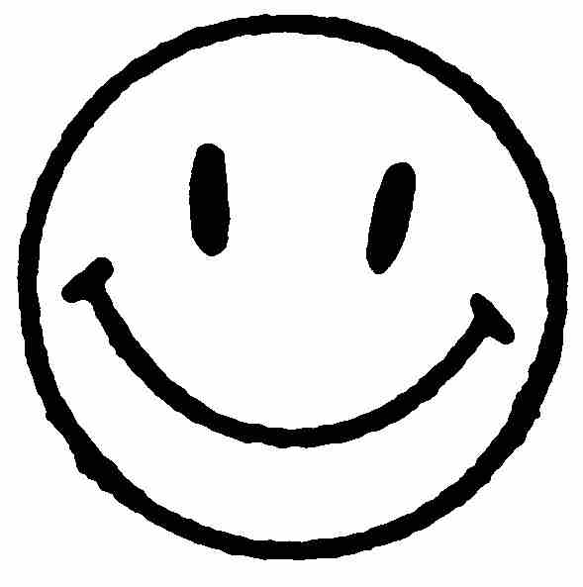
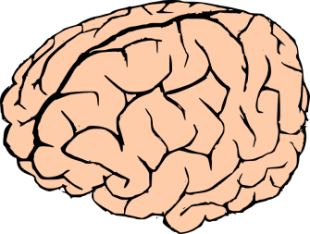
Name:__________________________________
I CAN TRAIN MY BRAIN!
What I SHOULD tell my brain | What I SHOULD NOT tell my brain
_ _ _ _ _ _ _ _ _ _ _ _ _ _ _ _ _ _ _ _ _ _ _ _ _ _ _ _ _ _ _ _ _ _ _ _ _ _ _ _ _ _ _ _ _ _ _ _ _ _ _ _ _ _ _ _ _ _ _ _ _ _ _ _ _ _ _ _ _ _ _ _ _ _ _ _
Learning is fun! | I am not that smart. | I’ll try a different strategy.
This is too hard so I give up. | I will keep working hard. | I will fail all of my tests.
I believe in myself. | I can’t do hard work. | I’ll learn how to do this.

