[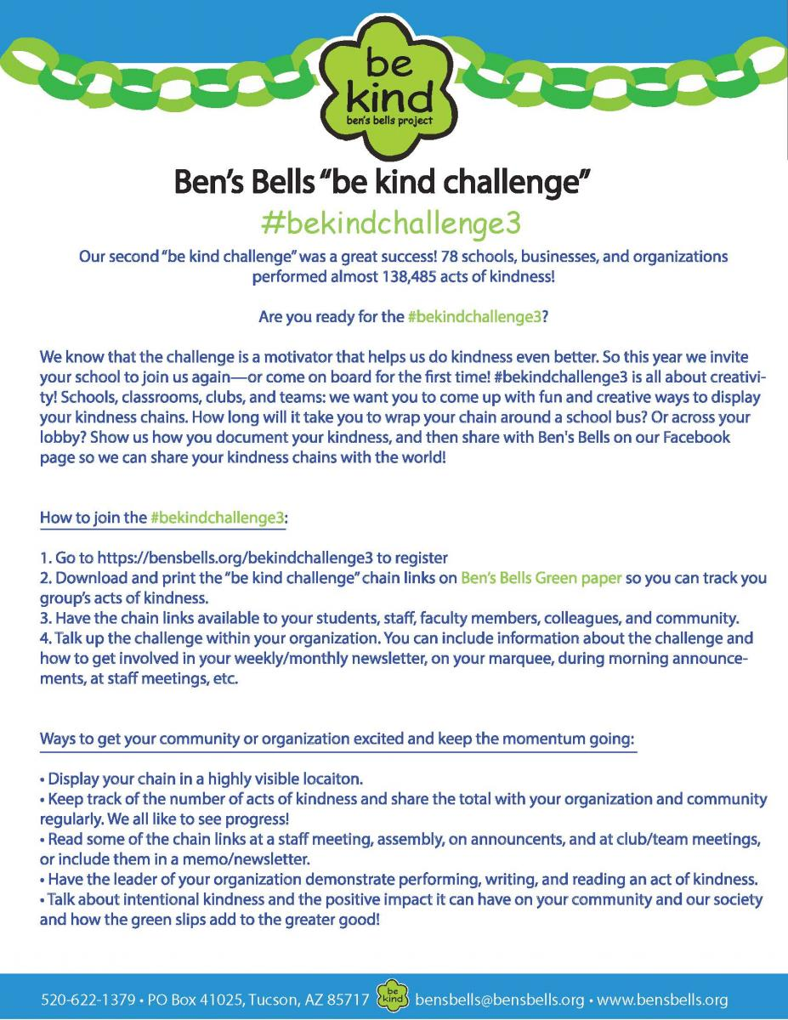](https://bensbells.org/sites/default/files/images/Mo1_be%20kindchallenge3Instrux_16-17.pdf)

[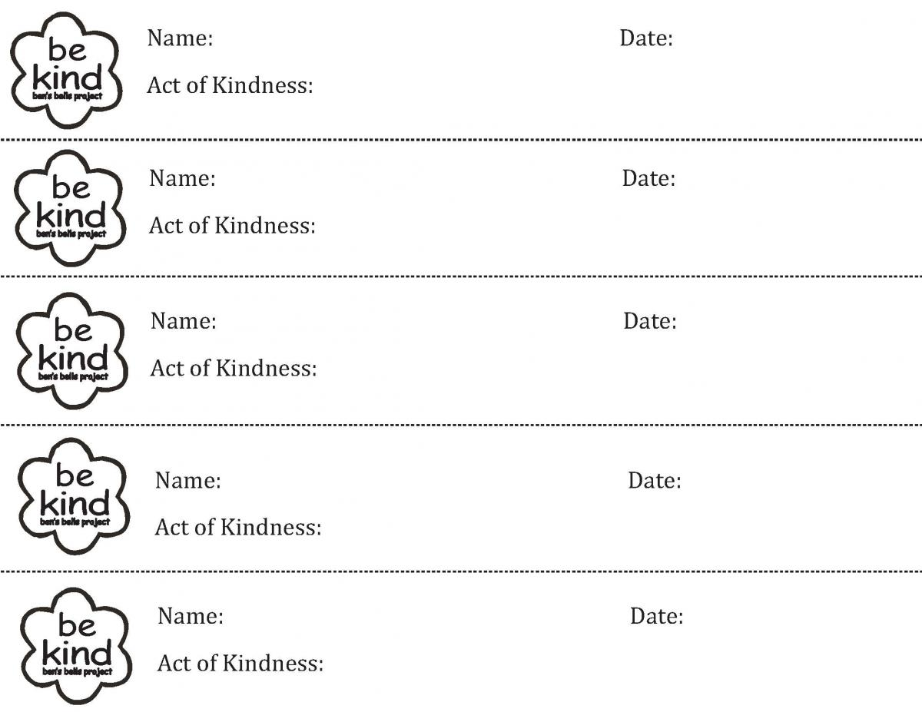](https://bensbells.org/sites/default/files/images/Mo1_bekindchallenge%20slips_name.pdf)