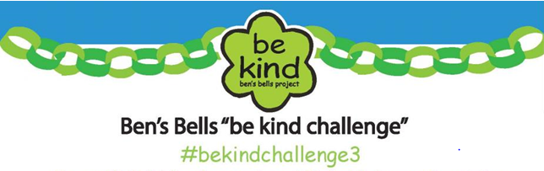

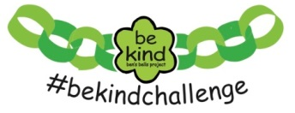
In 2014, we were challenged to do 1,000 Acts of Kindness……
WE ACCOMPLISHED 3,009 KIND ACTS!
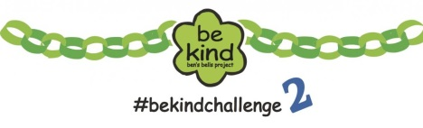
In 2015, we were challenged to do 5,000 Acts of Kindness…..
WE ACCOMPLISHED 6,768 KIND ACTS!
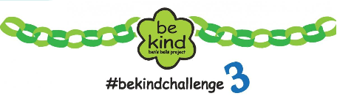
In 2016, we are being challenged to do 7,000 Acts of Kindness…
AND WITH YOUR HELP,
WE CAN ACCOMPLISH
EVEN MORE KIND ACTS
THAN EVER BEFORE!

