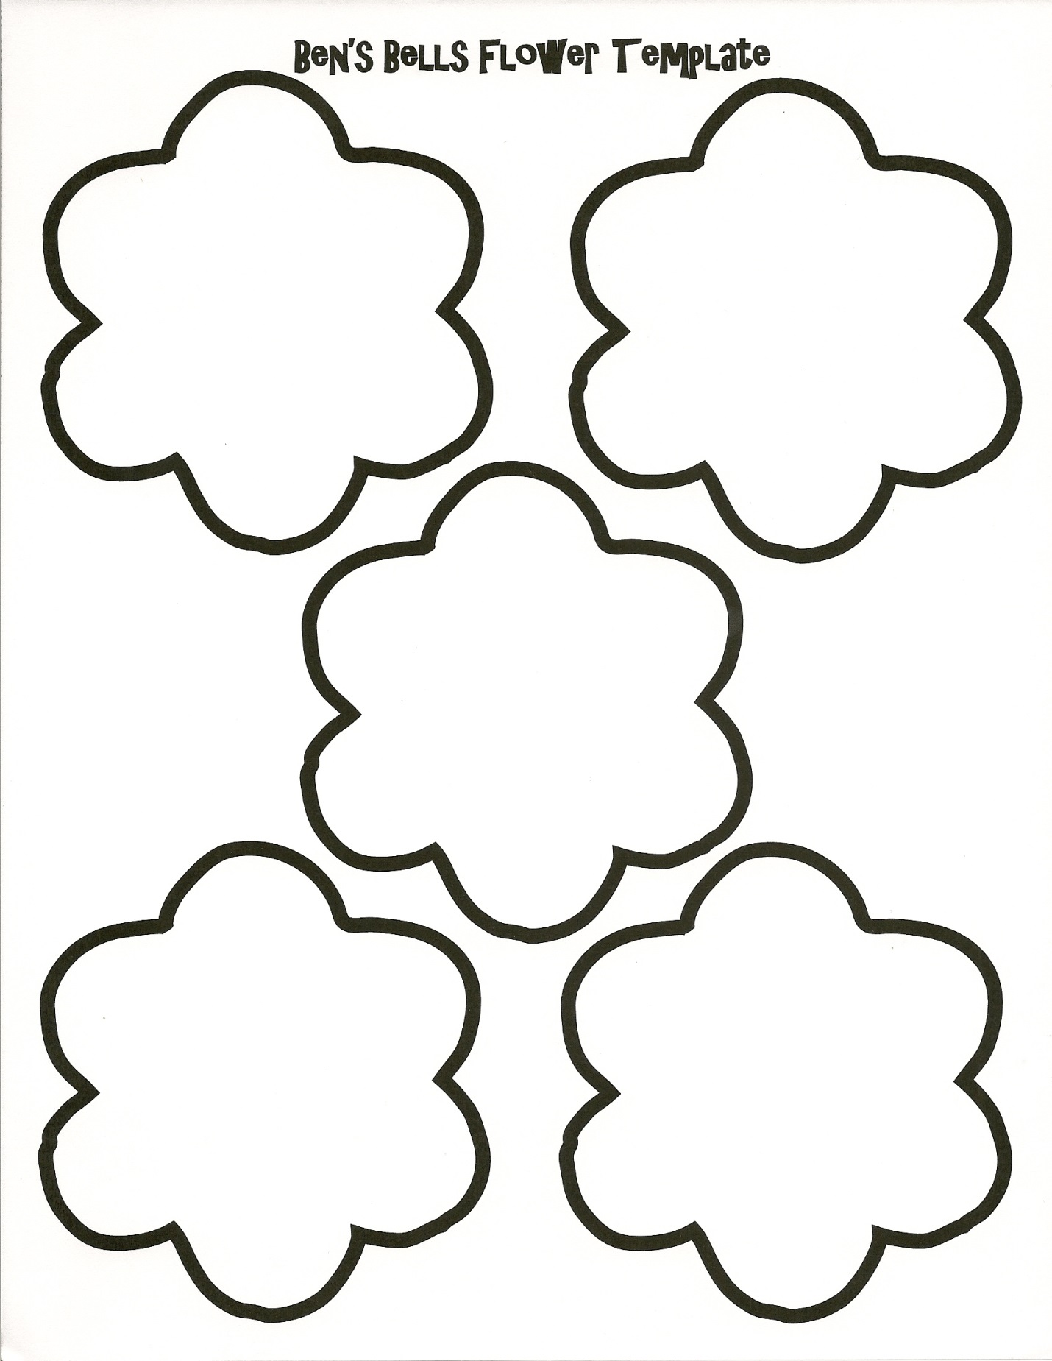

I am a I can
good do
person. hard things.

I
can choose
to be in my
Clear Mind.

I am strong, I am a
and I can get kind person,
through hard and I choose to
times. be kind!
I I
can take a can choose
time out to have a
when I need to. better day.

I am good enough,
I am smart enough,
and…
people like me.

I I can
will be find peace
KIND inside my
to myself. heart.

