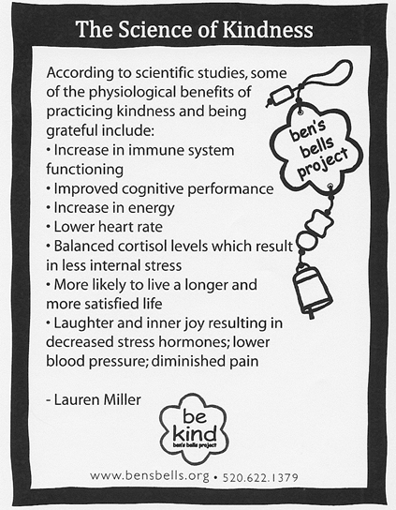

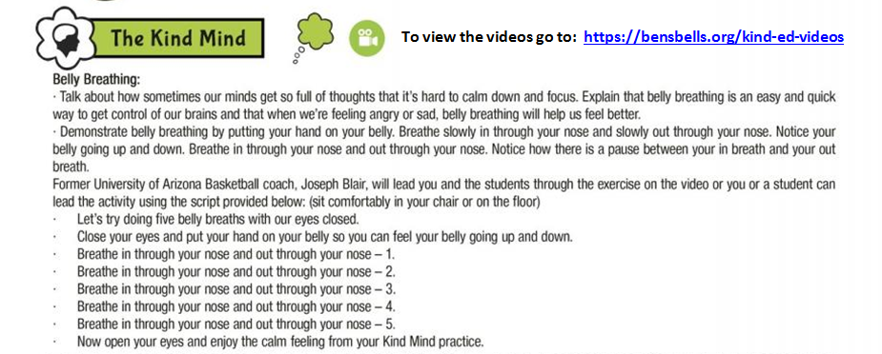

Stretch towards Self-Kindness…
with these gentle stretching exercises.

It is important to remember to be kind to ourselves every day. One way to do that is by paying attention to what is going on with our bodies and looking for signs of stress, which is a pressure that we feel inside ourselves. It is important to learn skills that will help our bodies to calm down and our minds to re-focus during times of stress.
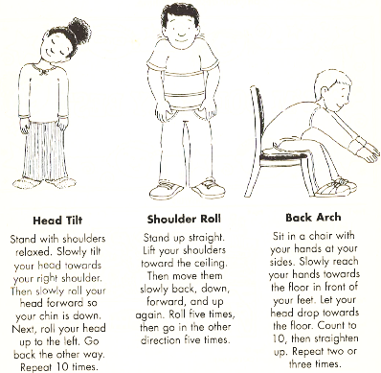
One easy way we can calm our bodies down and re-focus our minds is to do some gentle stretching. Practice these gentle stretches below on a daily basis to help your body feel less stressed and help your mind be even more focused on being kind!

* Pictures and descriptions of stretches are courtesy of “Believe, Achieve, and Succeed at Test Time! An Educational Activities Book” by Julie Theisz, 2005, Positive Promotions, pg. 15.

