Grades K – 3

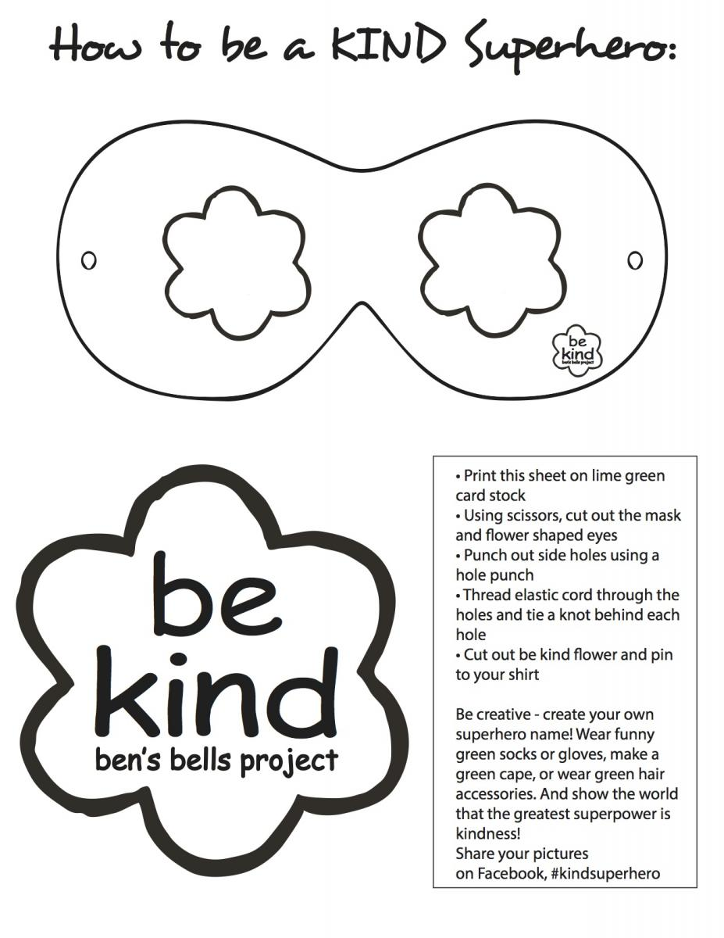
Grades 4 - 6

