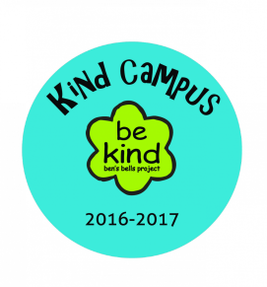**____________________ Has a**

**Gratitude Attitude!**

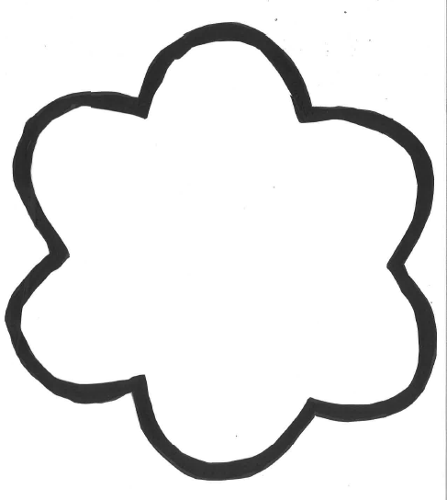**This person is thankful for**…