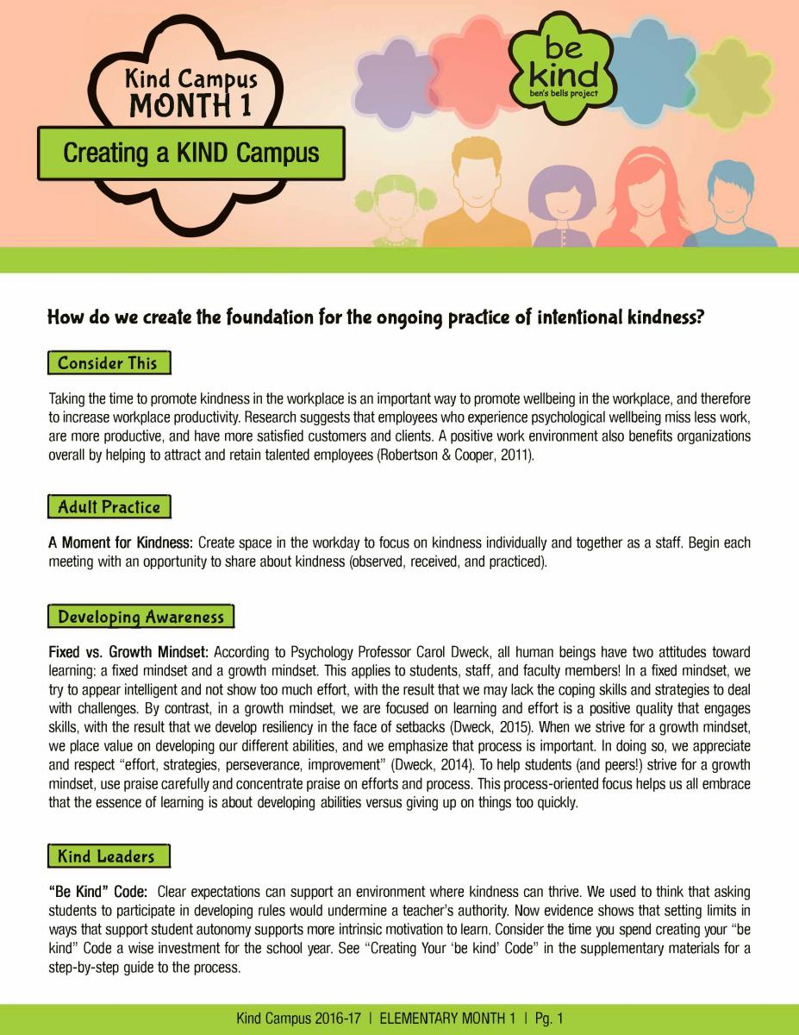

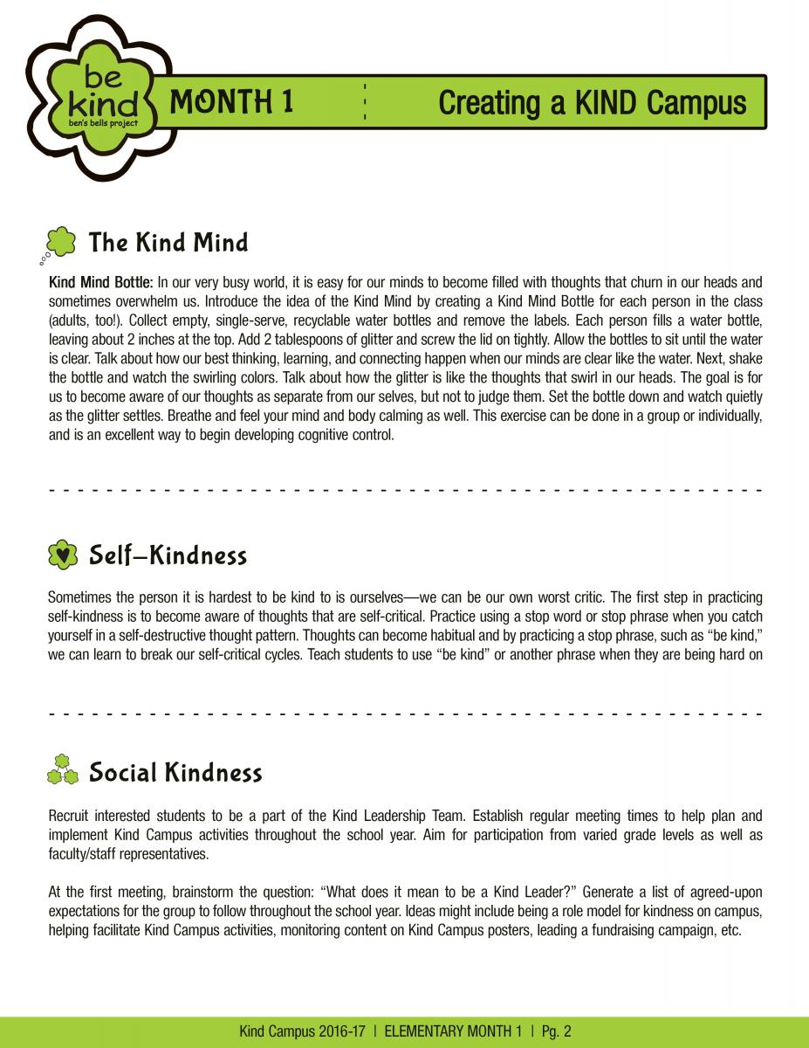

(Write your stop word or phrase on inside of a Kindness Flower and display it to remind you to “be kind” to yourself!)

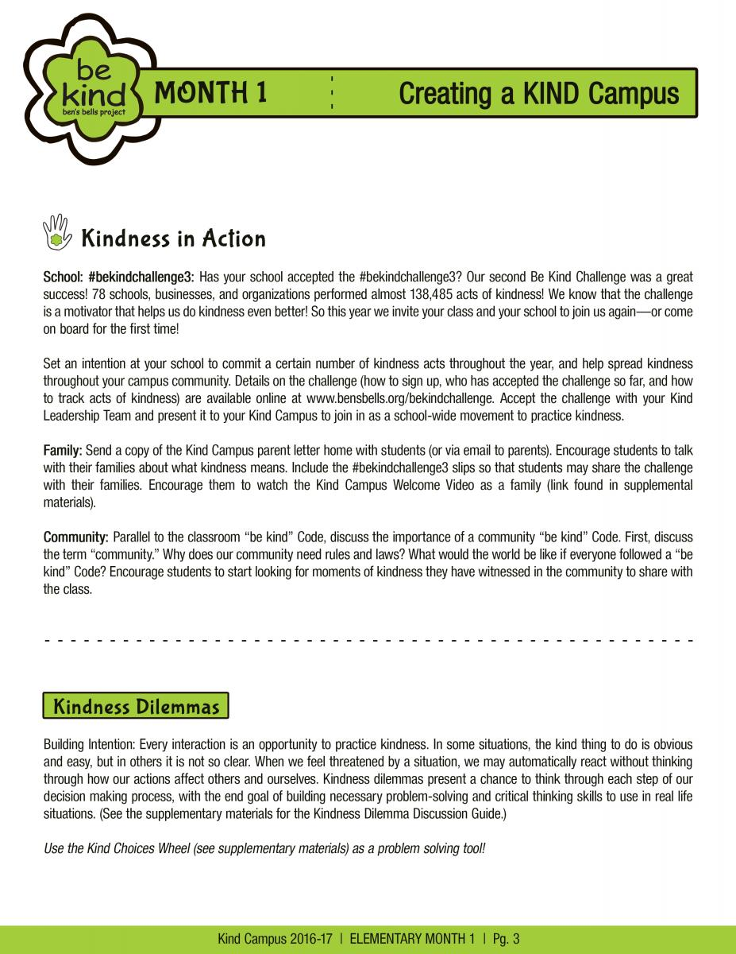

You can also go to: https://www.youtube.com/watch?v=t0Bw9vuPz-0

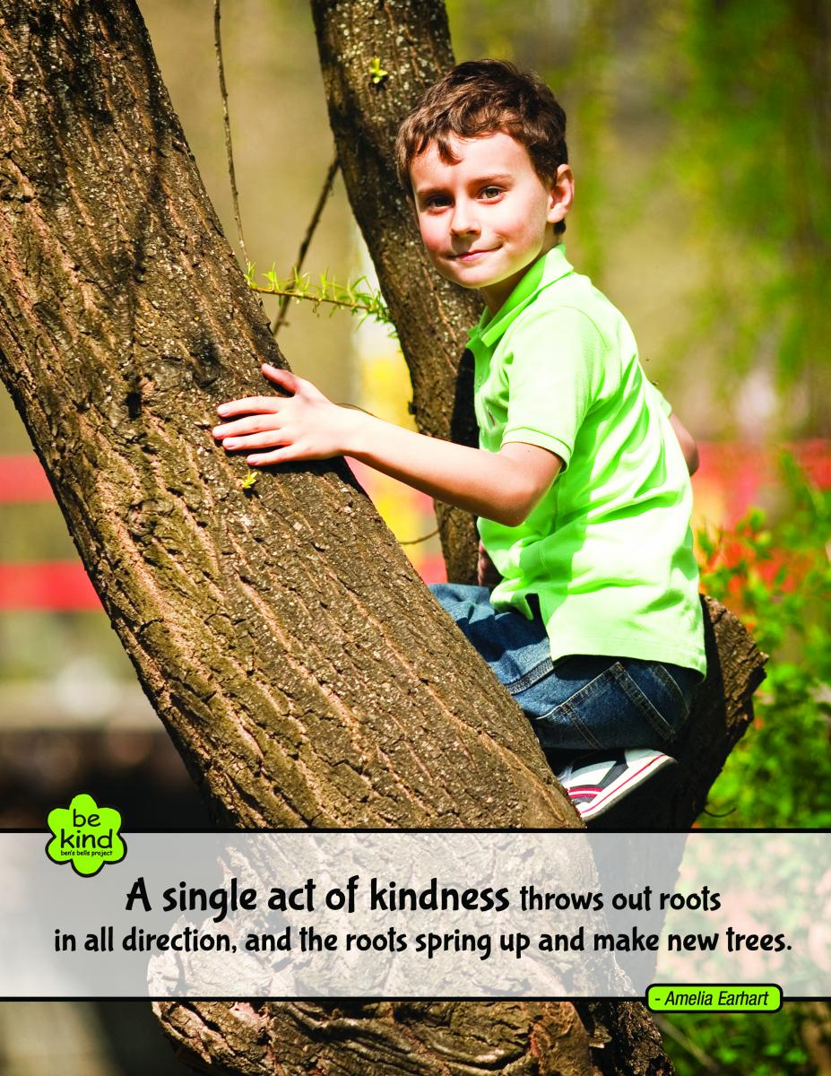

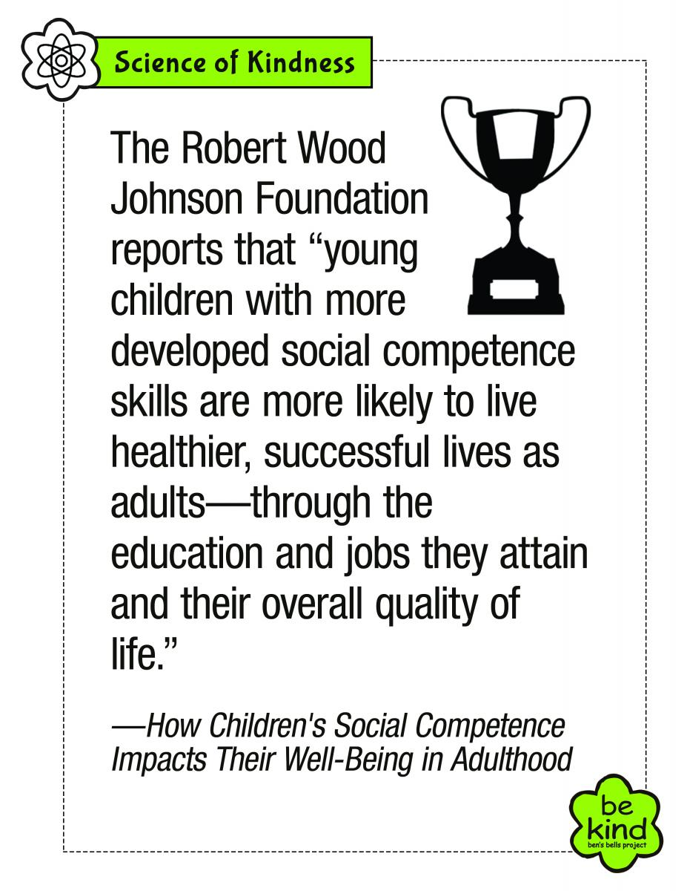

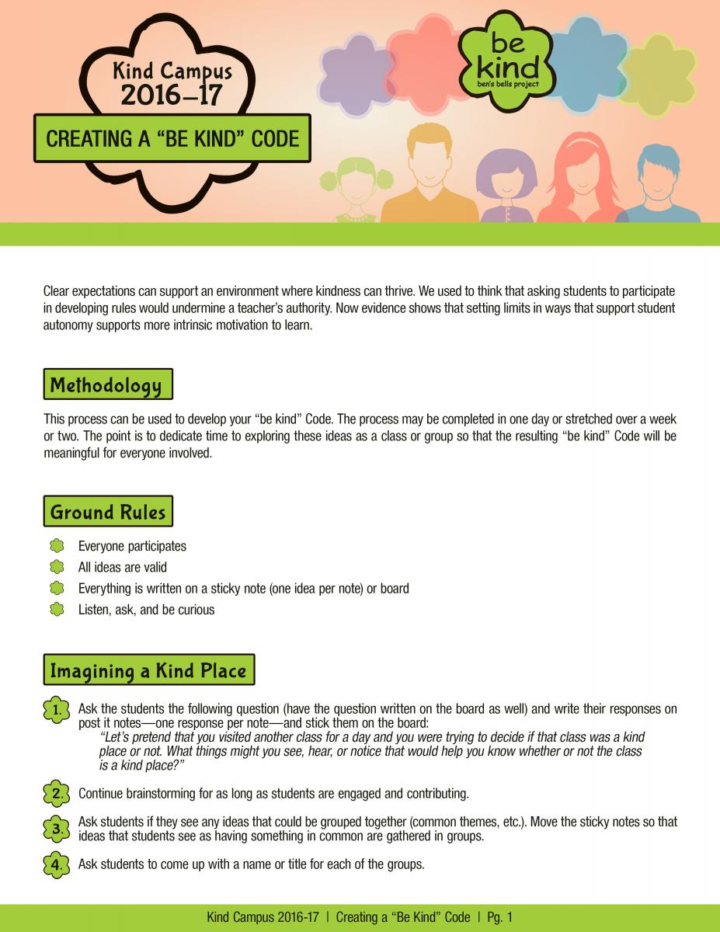

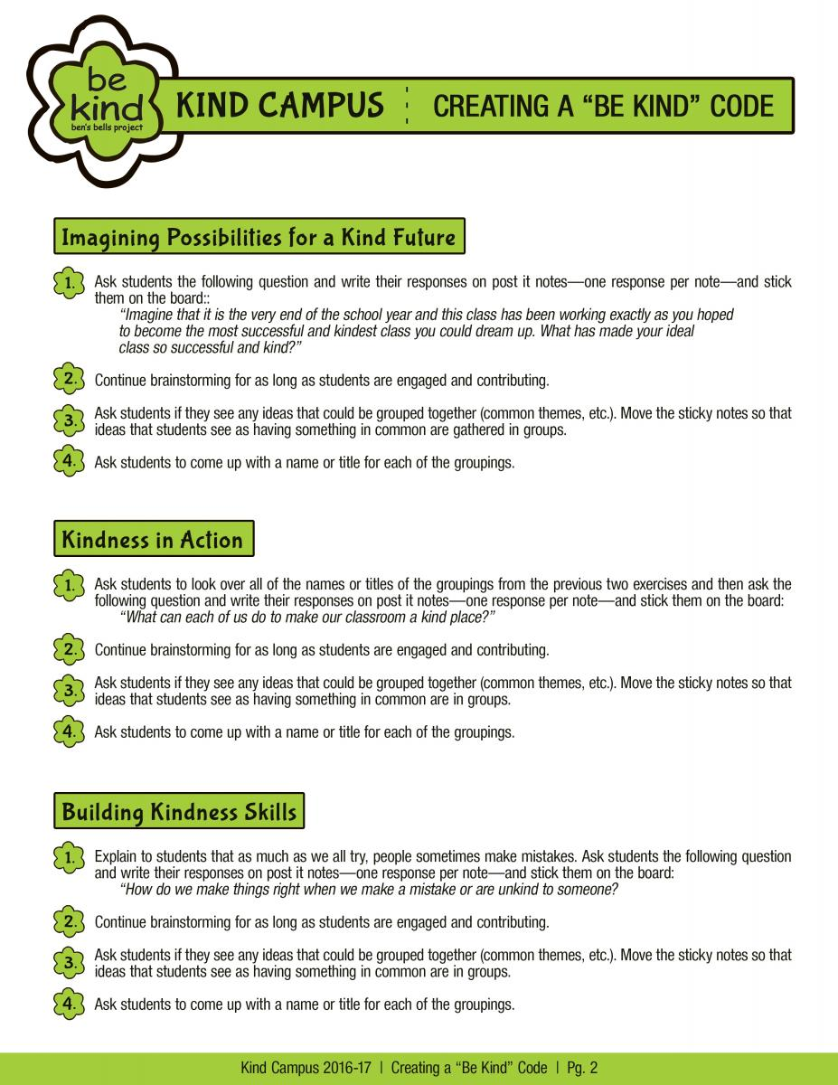

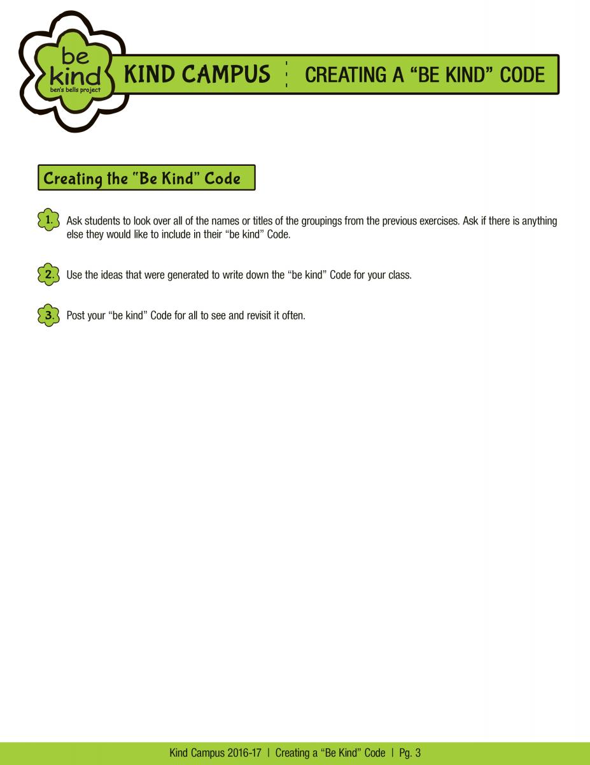

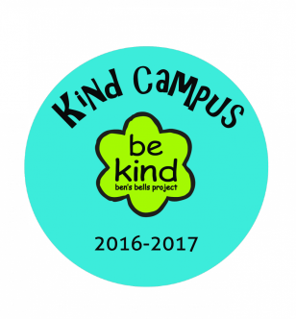
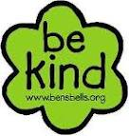
Ben’s Bells Kind Campus Program
Our Classroom’s “Be Kind” Code

1. Imagining a Kind Place – What things might you see, hear, or notice that would help you know whether or not the class is a kind place? ___________________________________________________________________

______________________________________________________________________________________

2. Imagining Possibilities for a Kind Future – What has made our ideal class so successful and kind?__________

______________________________________________________________________________________

3. Kindness in Action – What can each of us do to make our classroom a kind place? _______________________

______________________________________________________________________________________

4. Building Kindness Skills – How do we make things right when we make a mistake or are unkind to someone?____

______________________________________________________________________________________

________________________________’s Classroom “Be Kind” Code
We are going to keep a KIND ENVIRONMENT in our classroom by:

1.________________________________________________________________________________________________
2.________________________________________________________________________________________________
3.________________________________________________________________________________________________
4. _______________________________________________________________________________________________
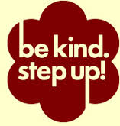

By signing below, we agree as a class to follow our “Be Kind” Code:
____________________________ ____________________________ ____________________________ ____________________________ ____________________________ ____________________________ ____________________________ ____________________________ ____________________________ ____________________________ ____________________________ ____________________________ ____________________________ ____________________________ ____________________________ ____________________________ ____________________________ ____________________________ ____________________________ ____________________________ ____________________________ ____________________________ ____________________________ ____________________________ ____________________________ ____________________________ ____________________________ ____________________________ ____________________________ ____________________________ ____________________________ ____________________________ ____________________________
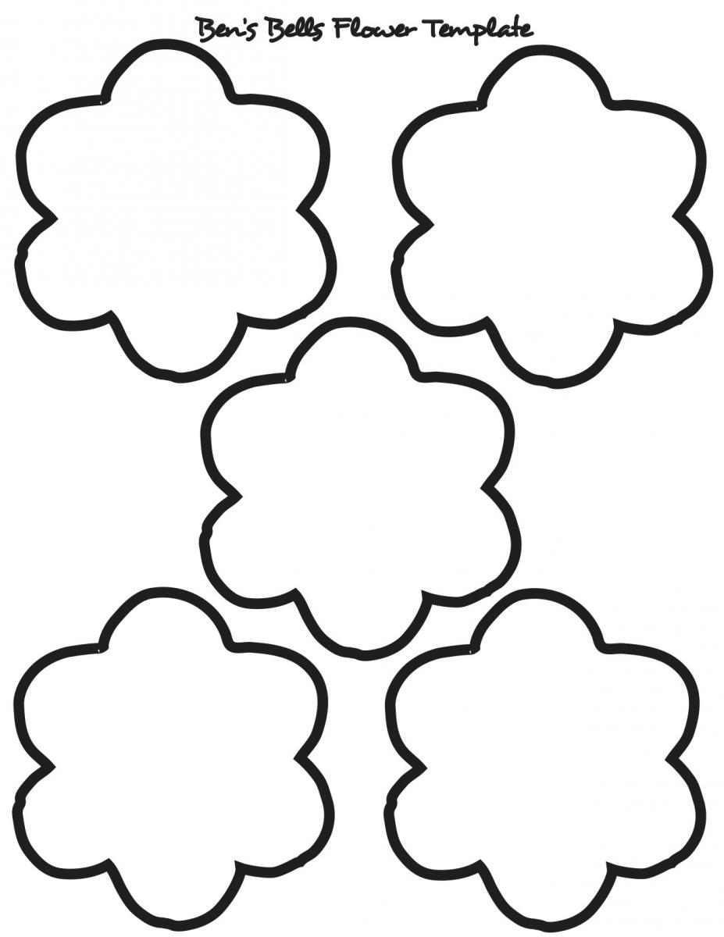

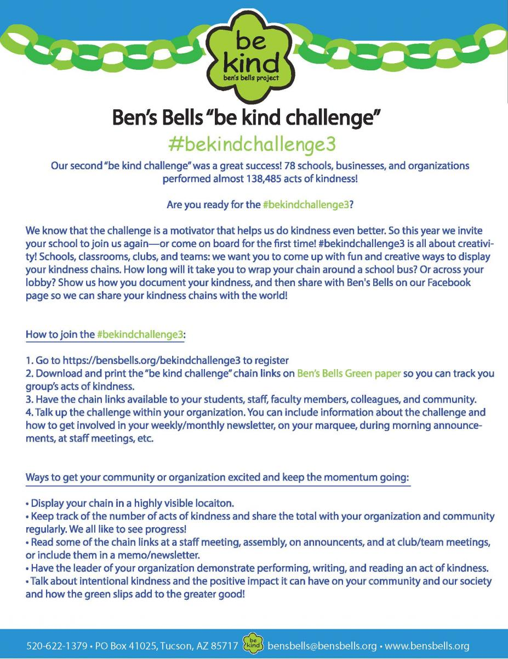

(Elvira has already been registered! )

(You can print your own or wait to receive copies of these green slips in your mail box.)

(We will again be displaying them in the Elvira Cafeteria.)

(Progress will be tracked and displayed again in the cafeteria.)

