[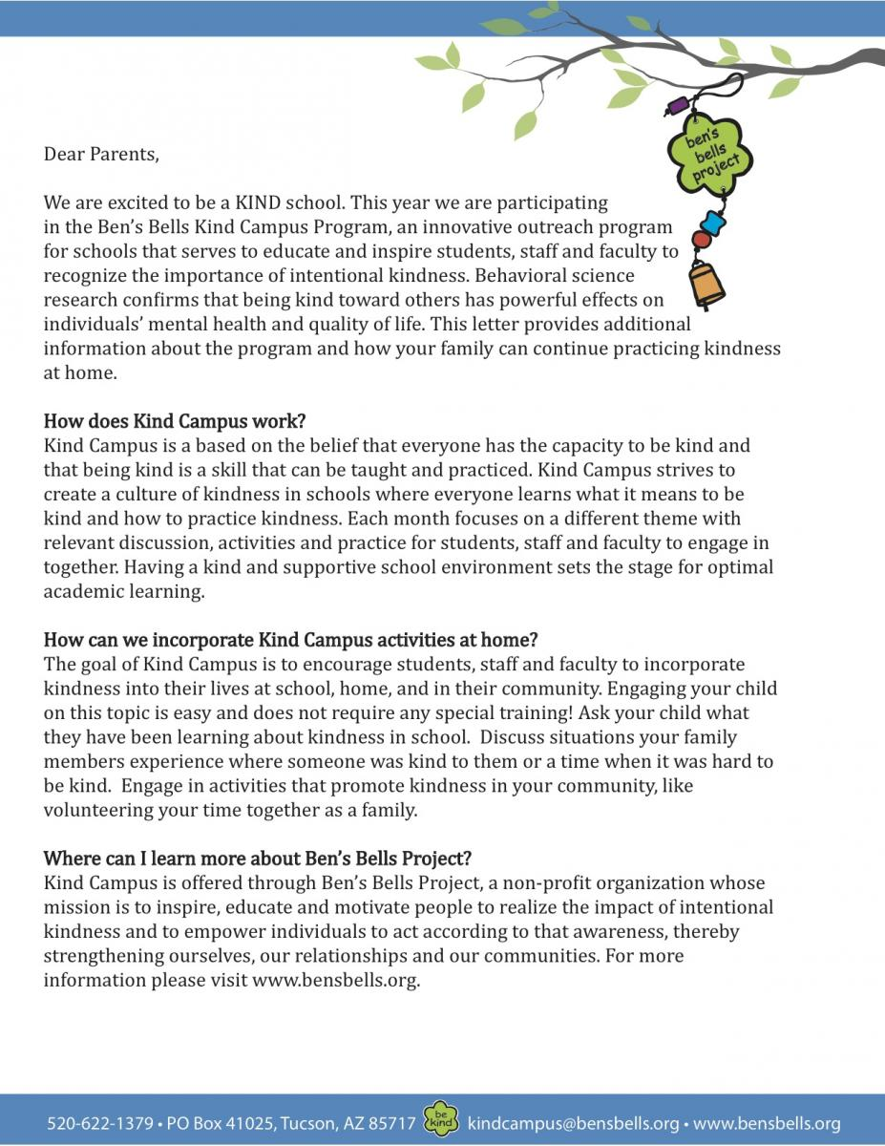](https://bensbells.org/sites/default/files/docs/parentletter20142015.pdf)

[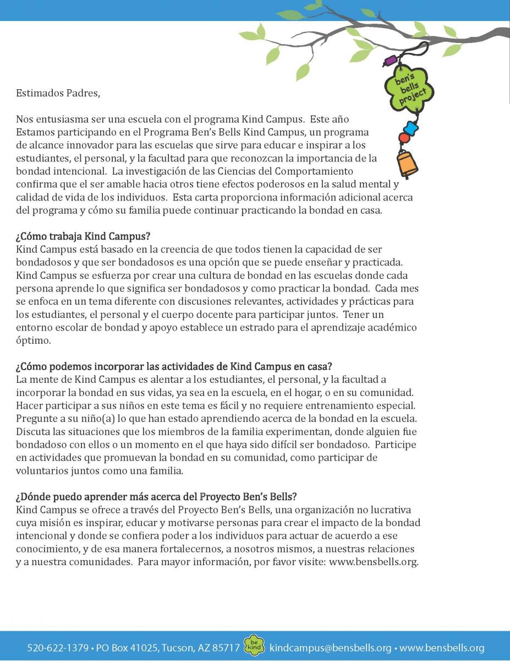](https://bensbells.org/sites/default/files/images/parentletterspanish20142015.pdf)

[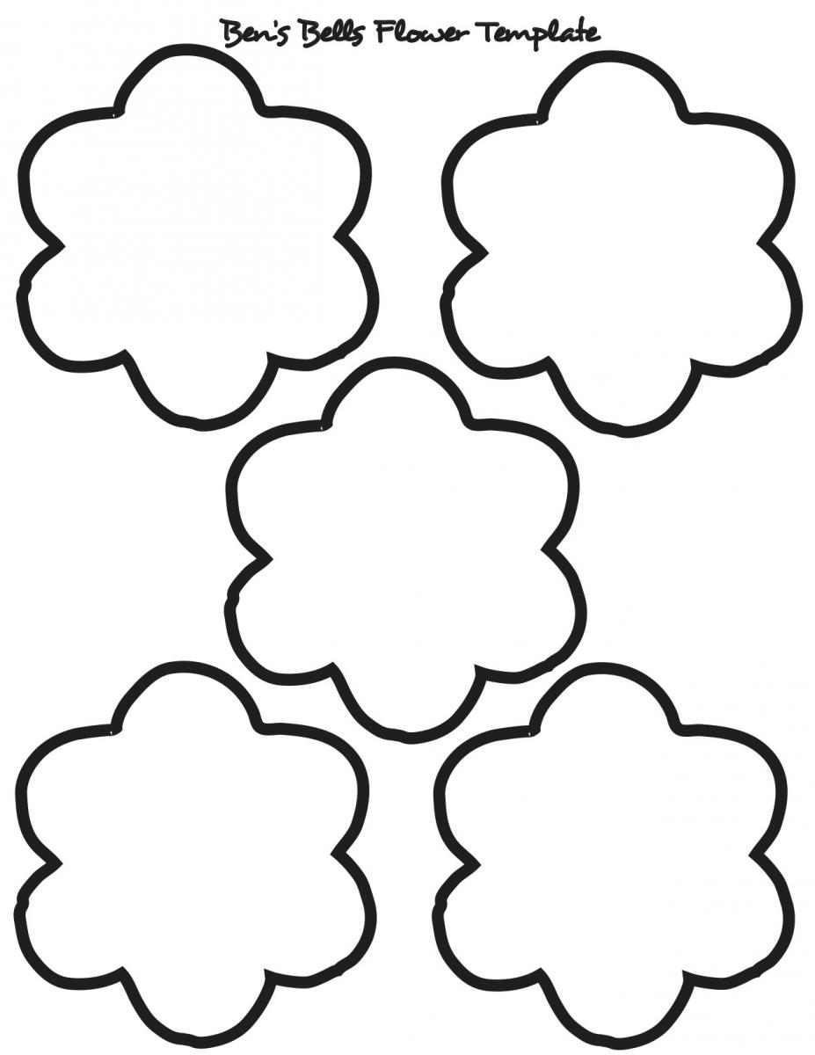](https://bensbells.org/sites/default/files/images/Ben's%20Bells%20flower%20template.pdf)

[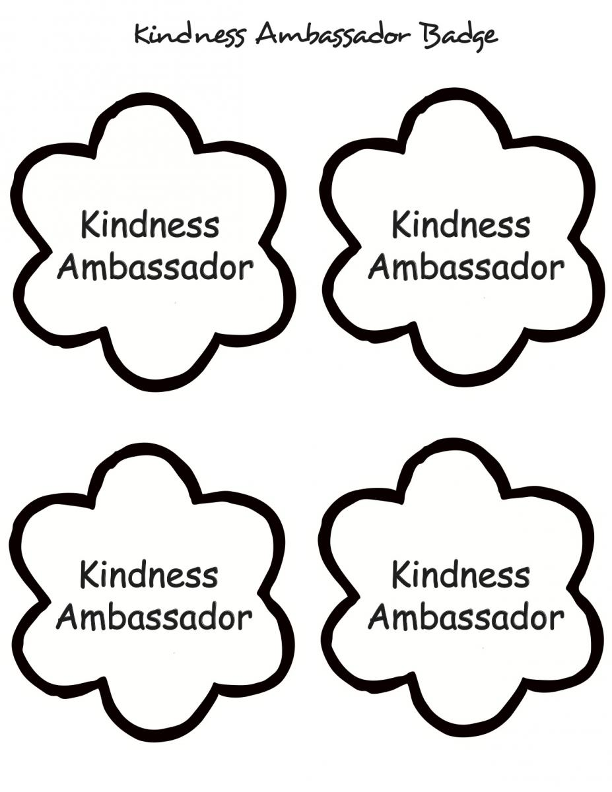](https://bensbells.org/sites/default/files/docs/kindnessambassadorbadge_0.pdf)

[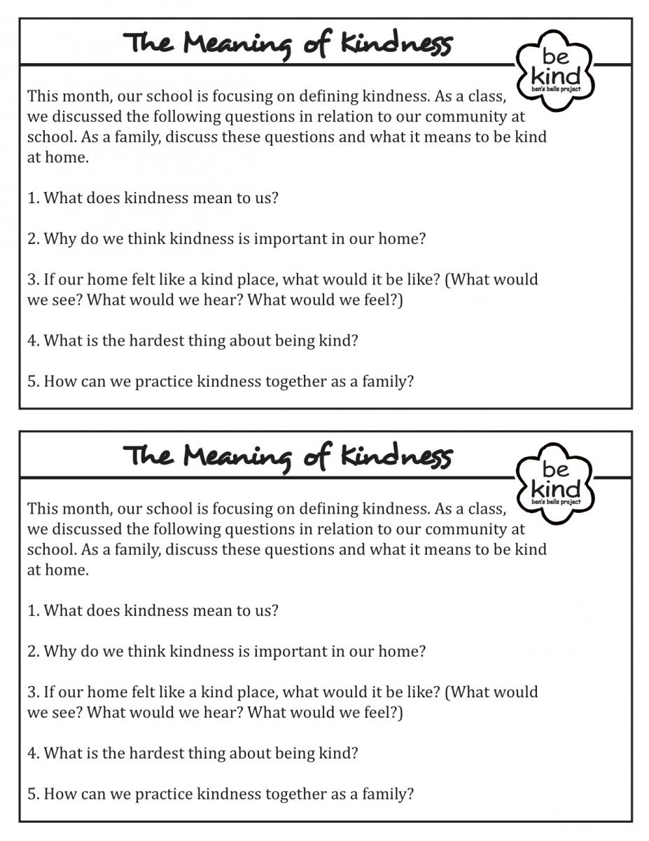](https://bensbells.org/sites/default/files/docs/meaningofkindnesshandout_0.pdf)

[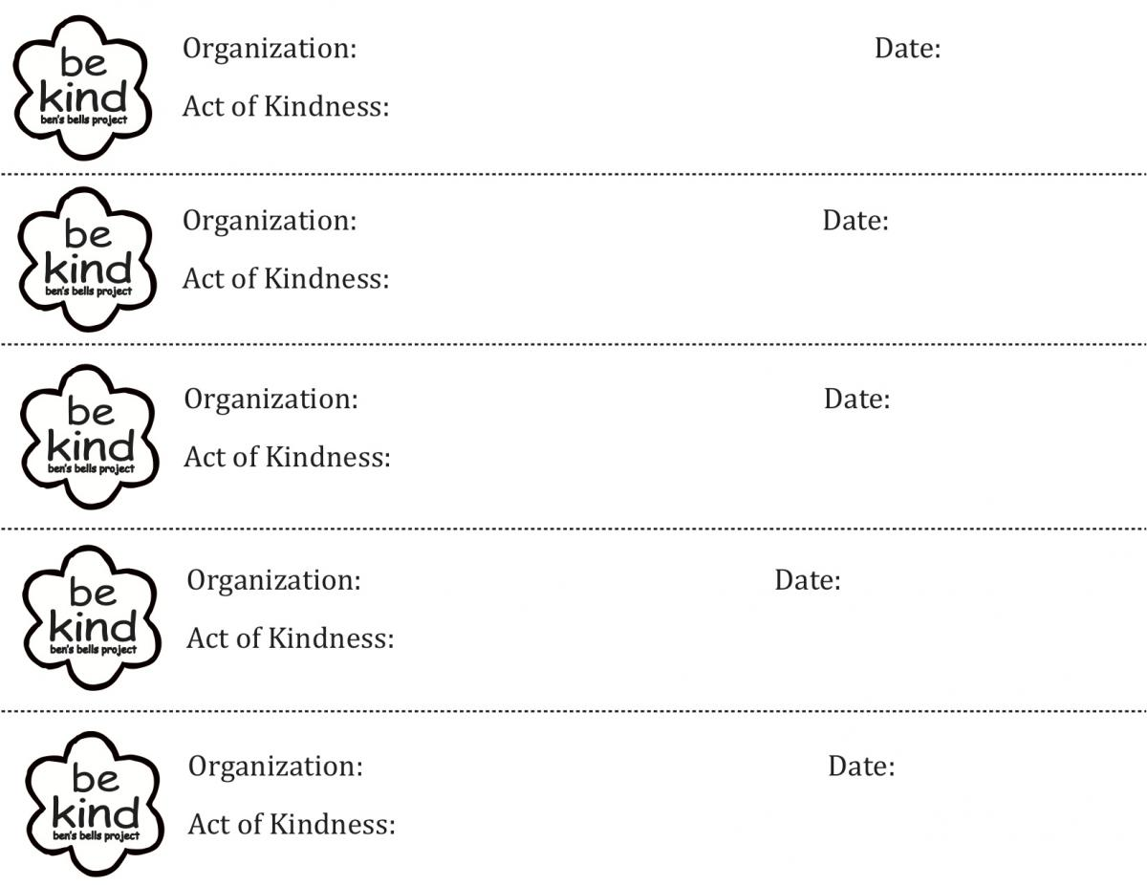](https://bensbells.org/sites/default/files/images/bekindchallenge%20slips.pdf)

[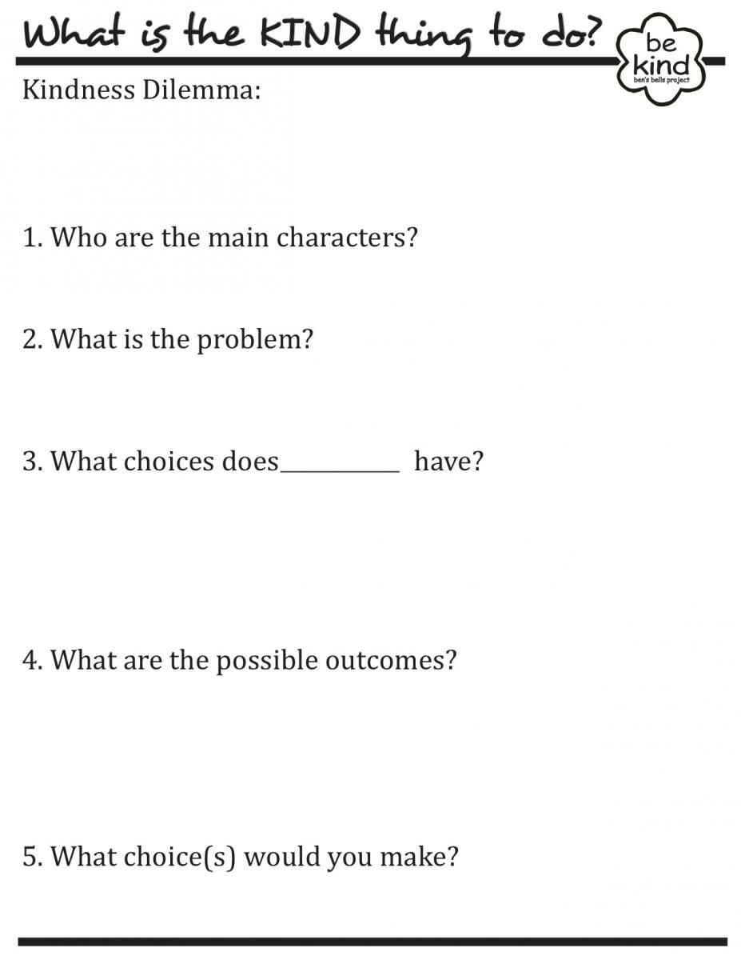](https://bensbells.org/sites/default/files/docs/kindnessdilemmadiscussionposter.pdf)

[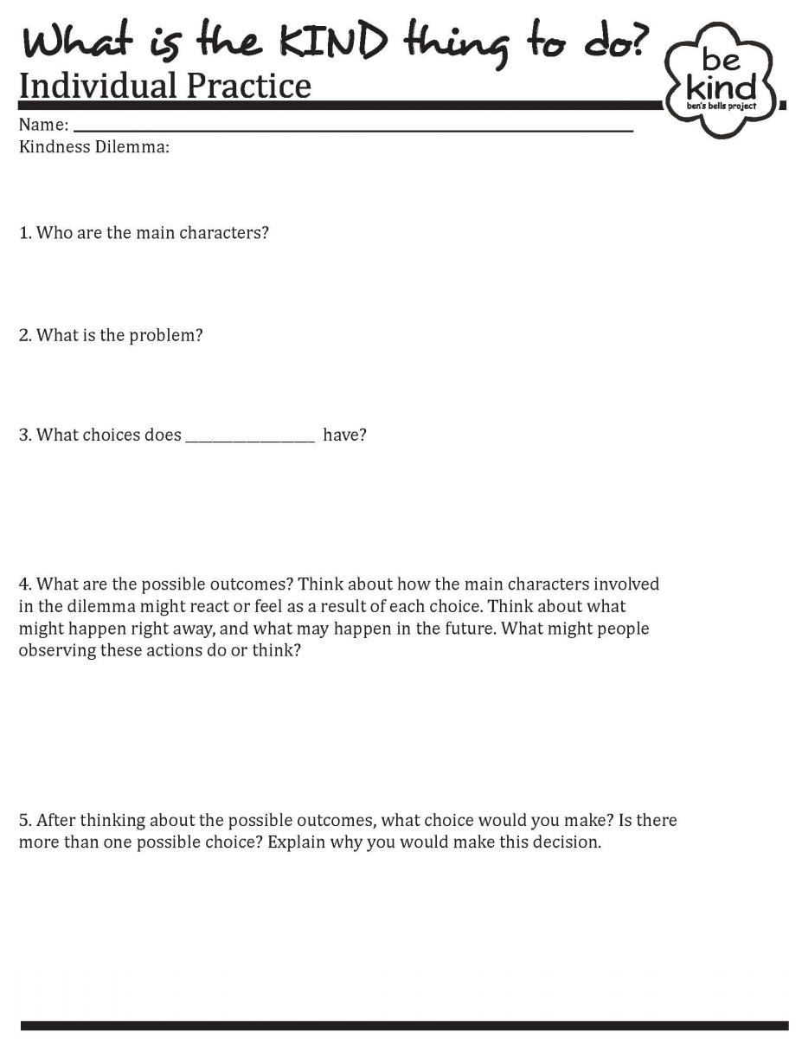](https://bensbells.org/sites/default/files/images/kindnessdilemmaindividualpractice.pdf)

[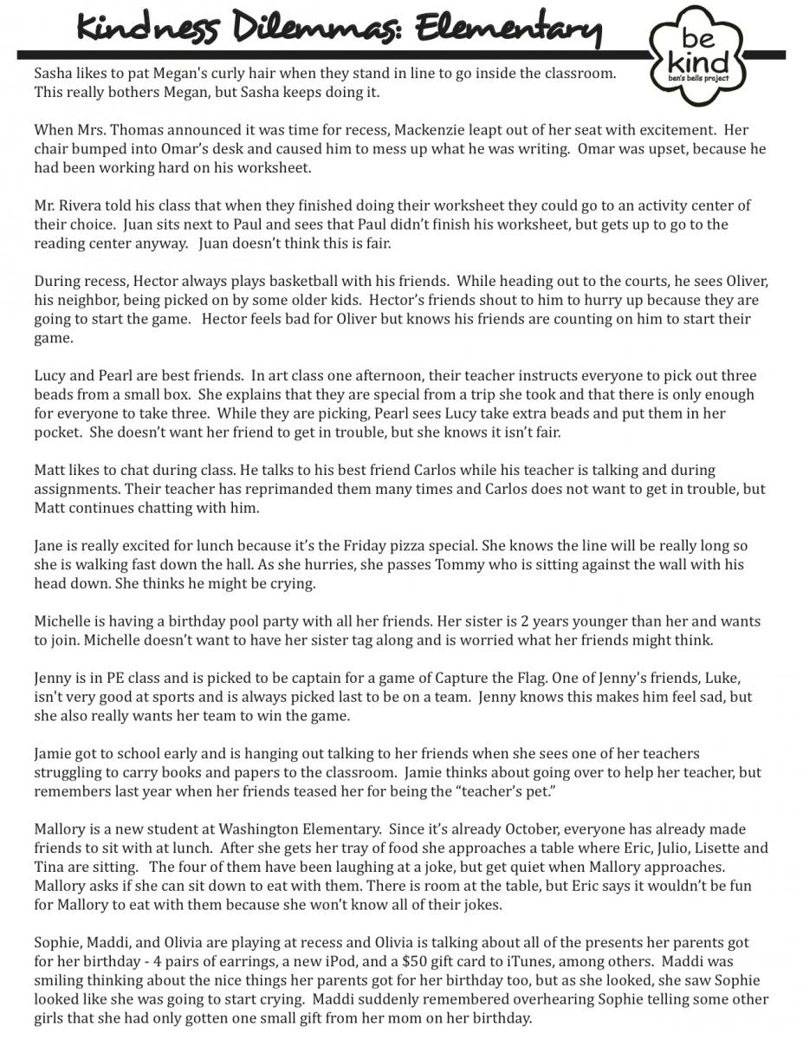](https://bensbells.org/sites/default/files/docs/kindnessdilemmasamples.pdf)

[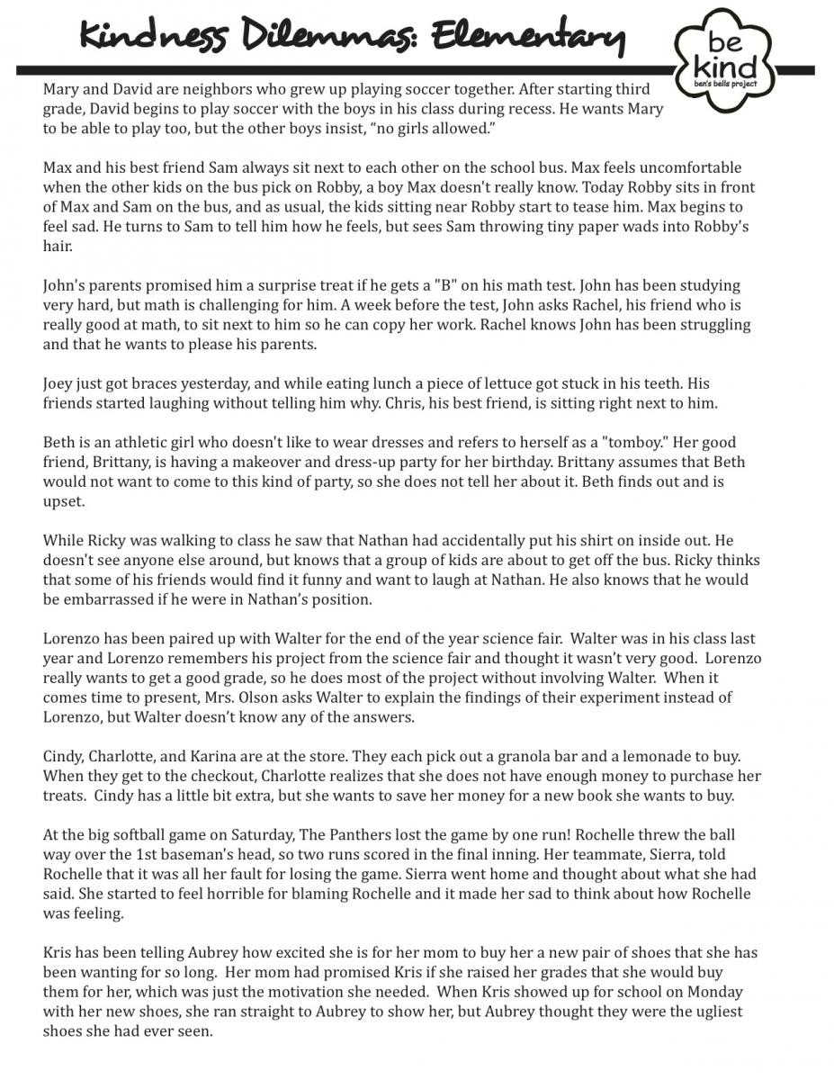](https://bensbells.org/sites/default/files/docs/kindnessdilemmasamples2.pdf)

[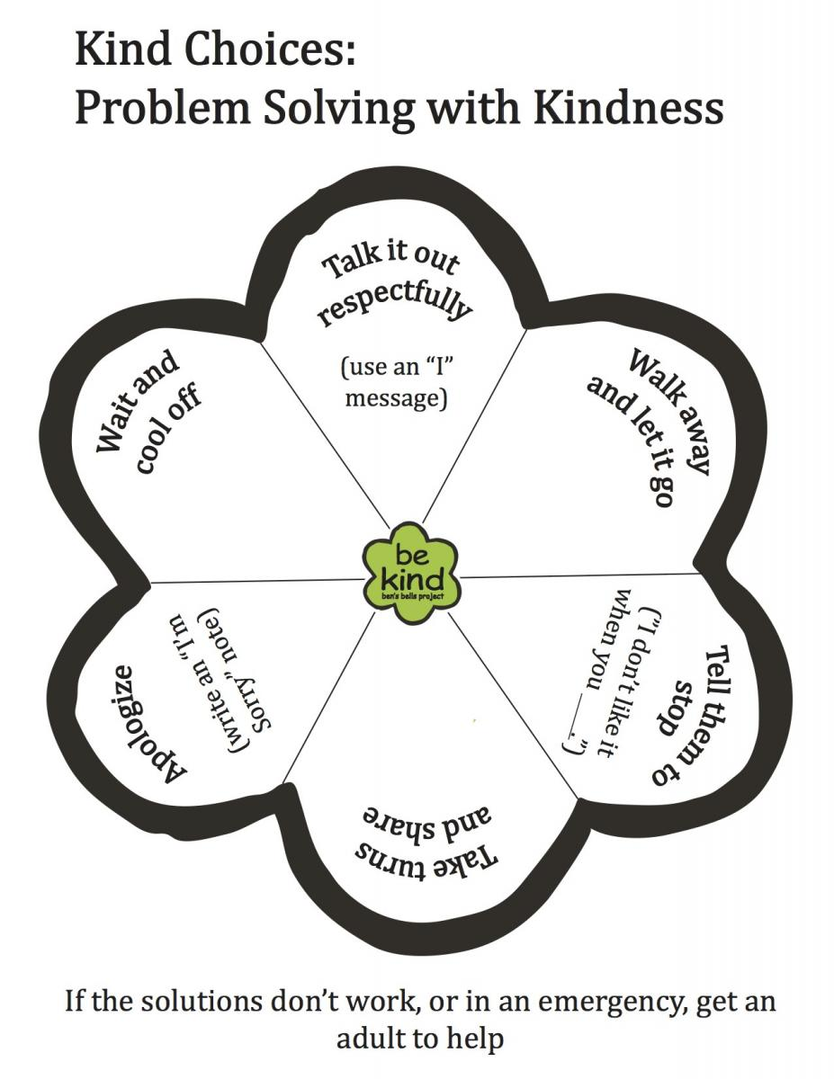](https://bensbells.org/sites/default/files/images/Kind%20Choices%20(1).pdf)

[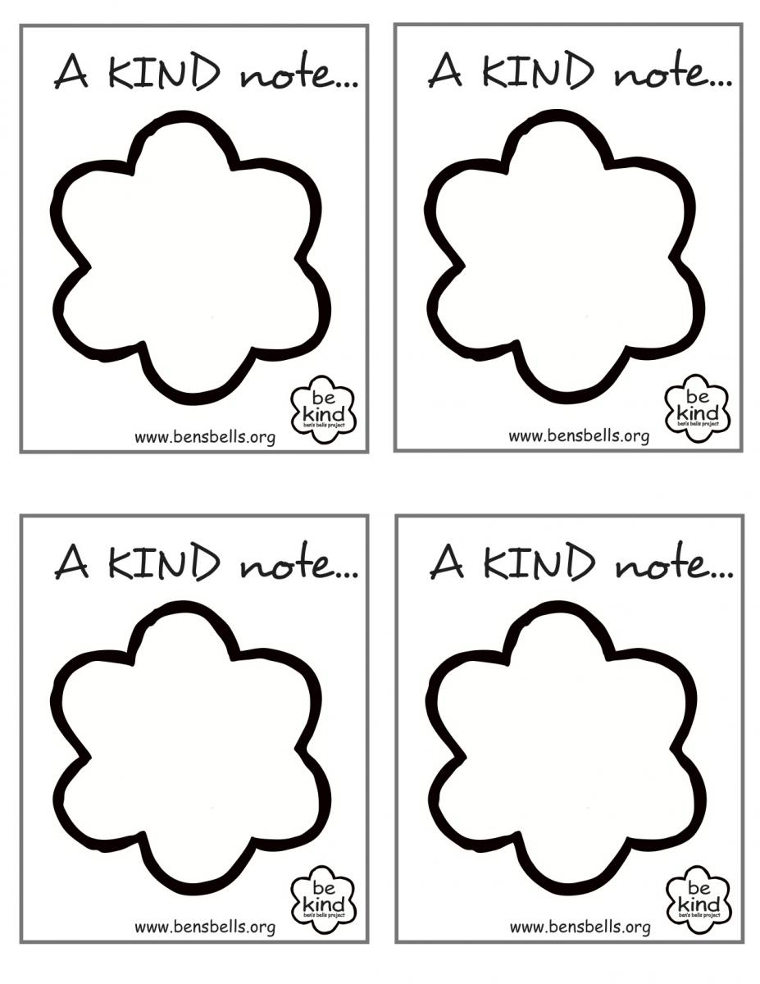](https://bensbells.org/sites/default/files/docs/kindcampuskindnotes.pdf)

[](https://bensbells.org/sites/default/files/images/thankyounote.pdf)

[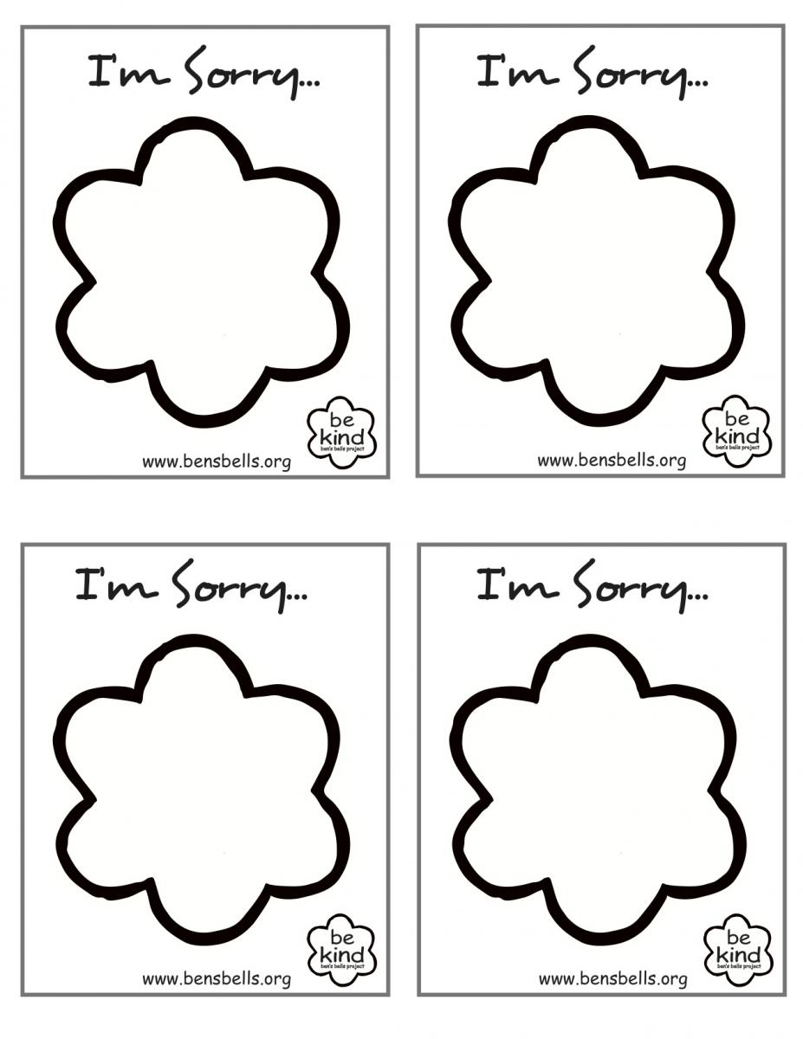](https://bensbells.org/sites/default/files/images/sorrynote.pdf)

[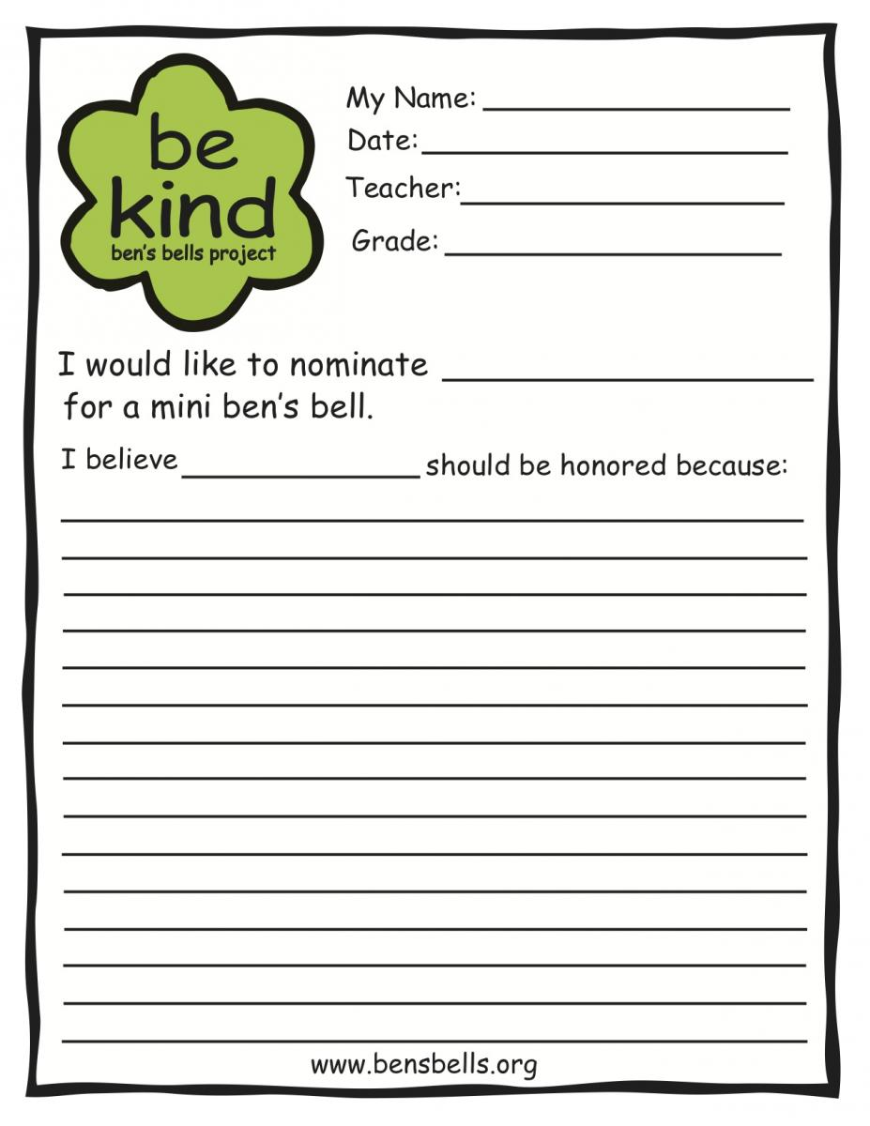](https://bensbells.org/sites/default/files/images/minibellingnominationformcolor.pdf)

[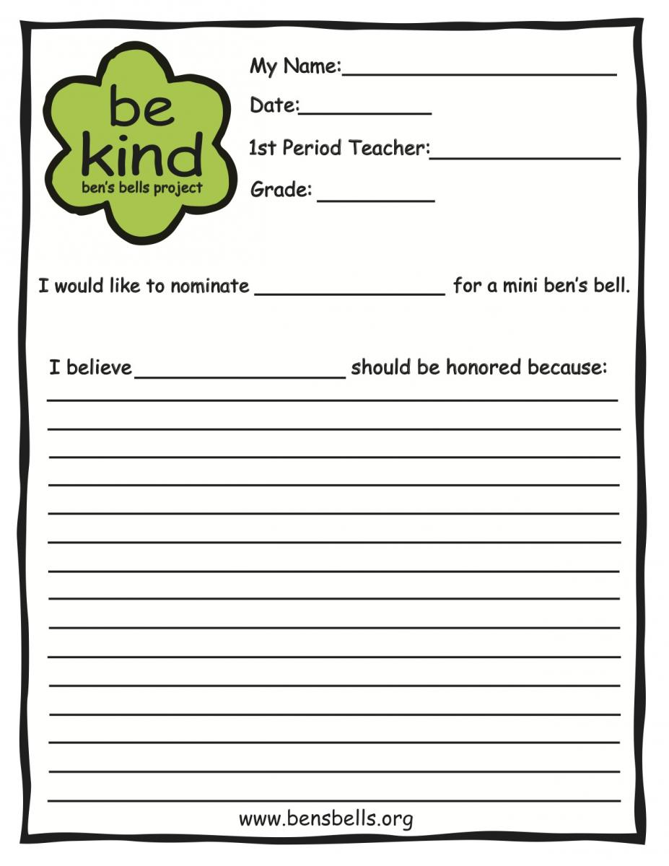](https://bensbells.org/sites/default/files/images/mshsminibellingnominationformcolor.pdf)

[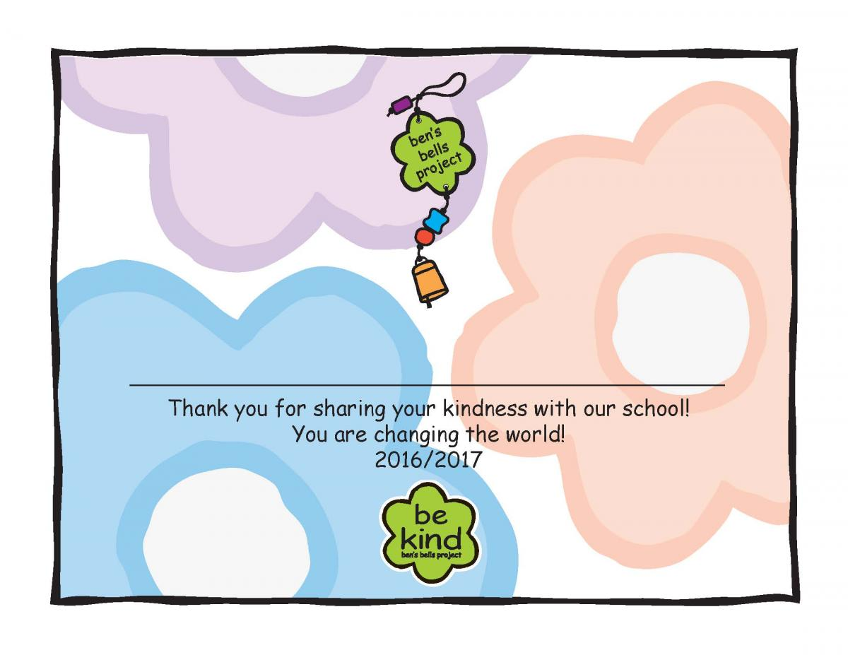](https://bensbells.org/sites/default/files/images/Mo3_CertMiniBellColor_16-17.pdf)

[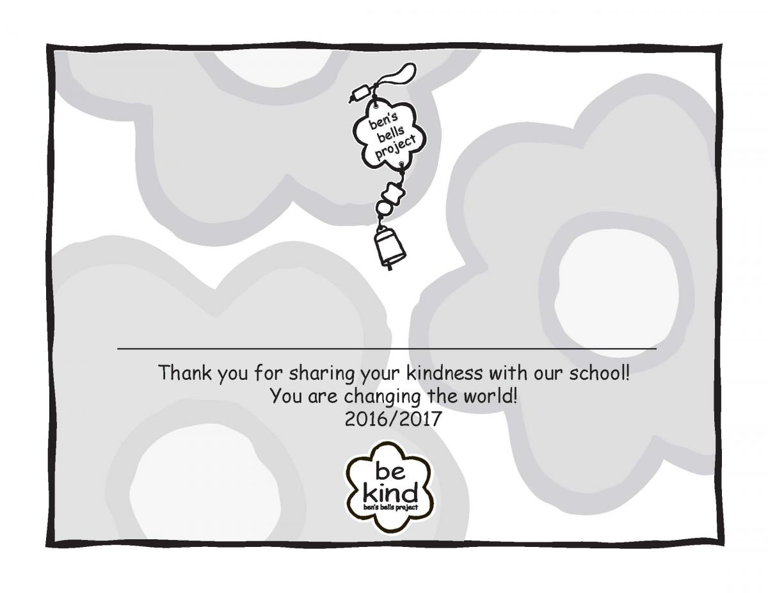](https://bensbells.org/sites/default/files/images/Mo3_CertMiniBellB-W_16-17.pdf)

[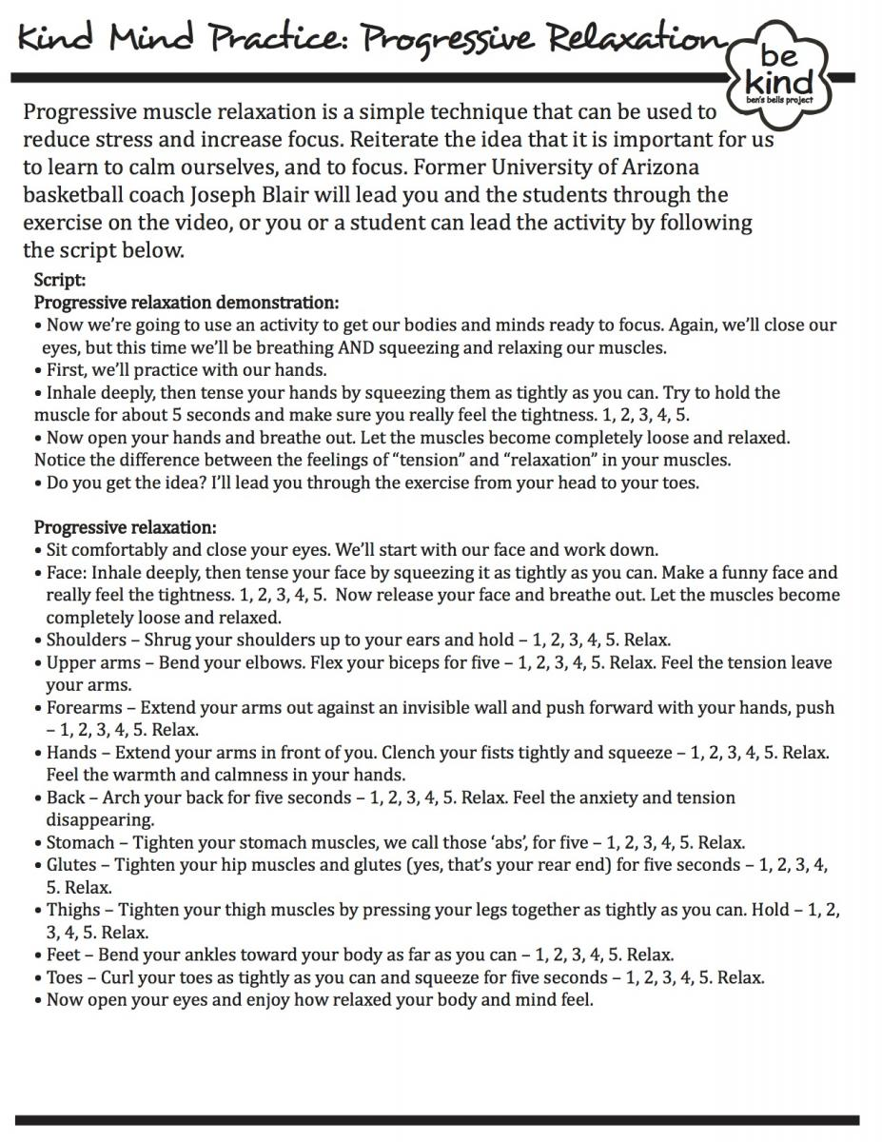](https://bensbells.org/sites/default/files/images/KindMindPracticeProgressiveRelaxationScript_0.pdf)

[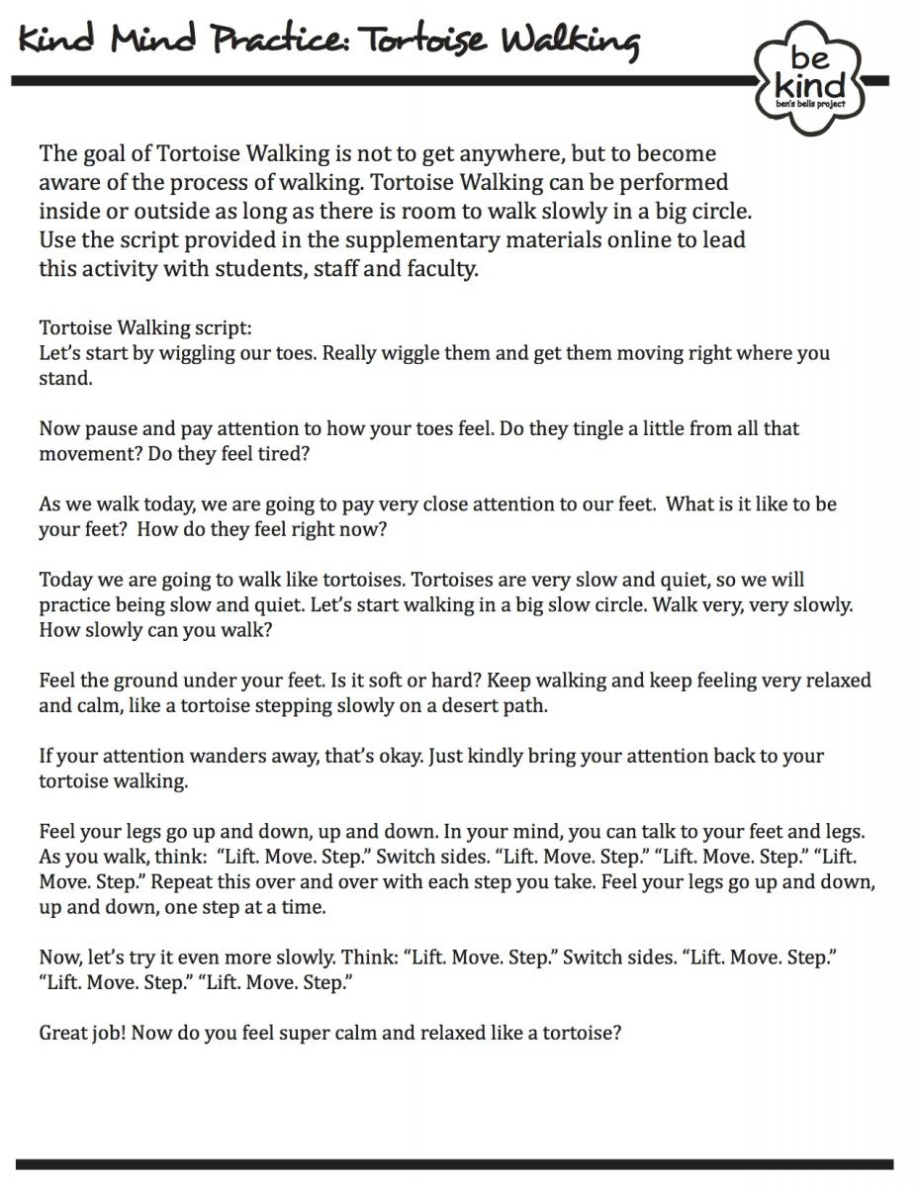](https://bensbells.org/sites/default/files/images/KindMindPracticeTortoiseWalkingScript_0.pdf)

[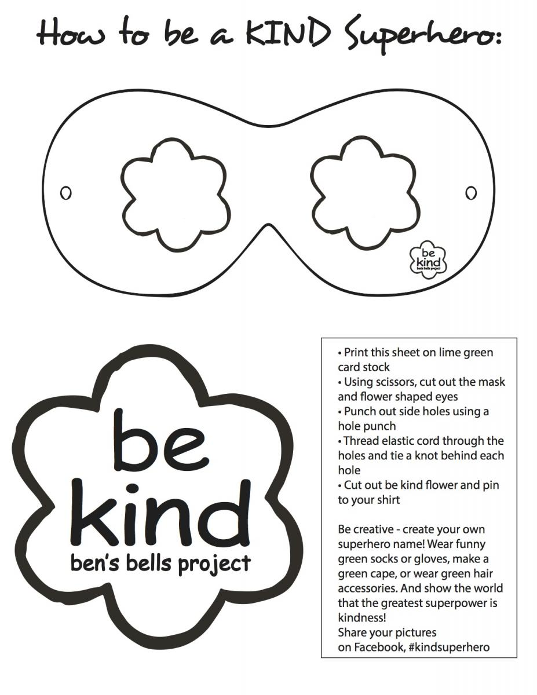](https://bensbells.org/sites/default/files/images/How%20to%20be%20a%20KIND%20Superhero.pdf)