[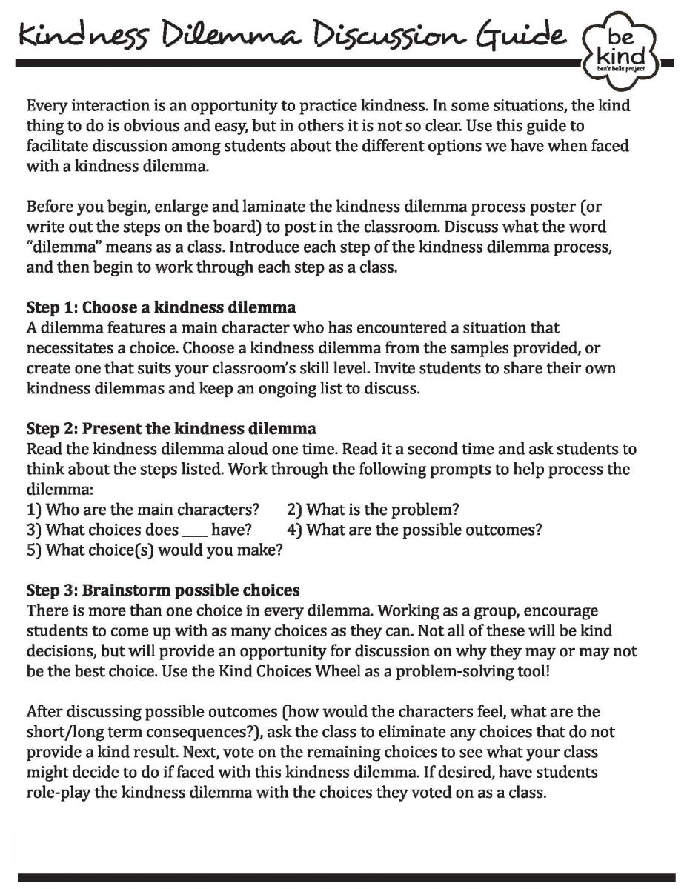](https://bensbells.org/sites/default/files/images/Mo1_DilemmaGuidePg1_16-17.pdf)

[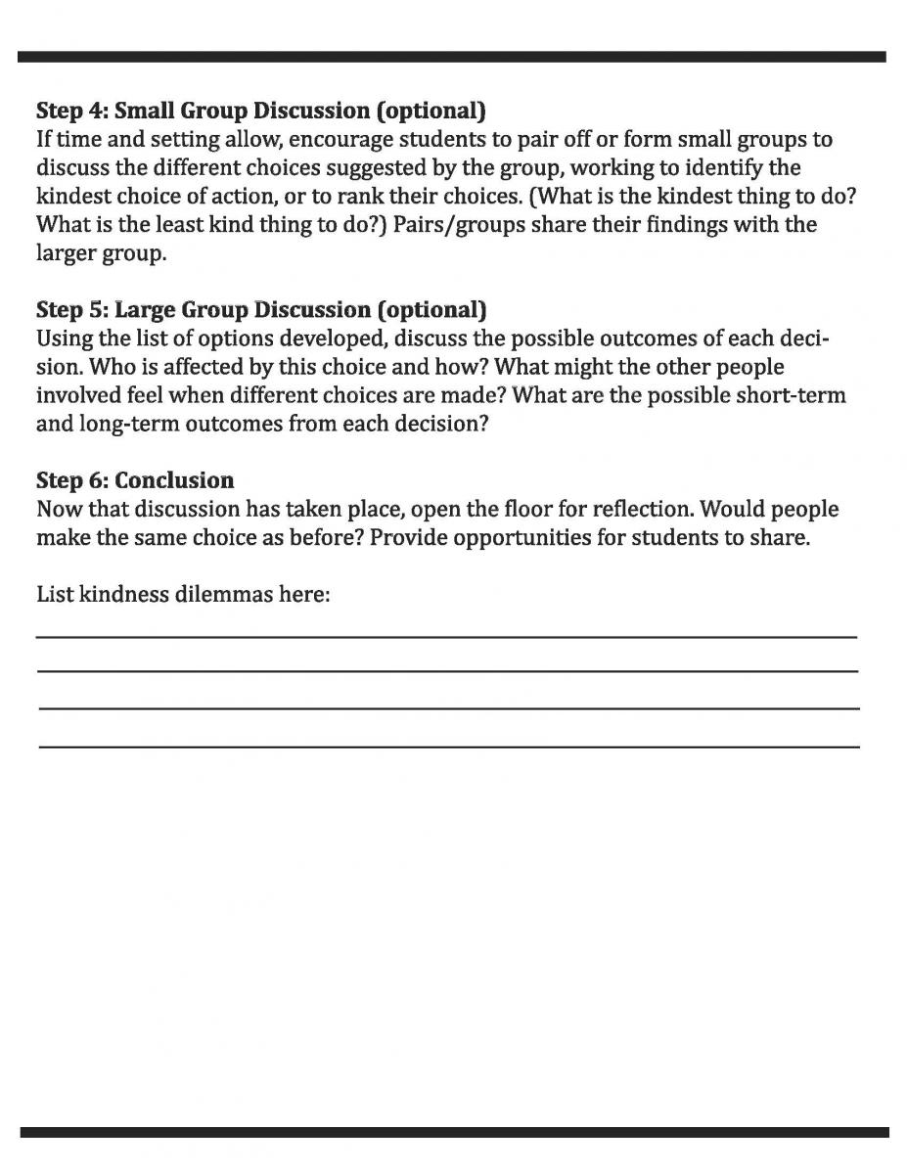](https://bensbells.org/sites/default/files/images/Mo1_DilemmaGuidePg2_16-17.pdf)

[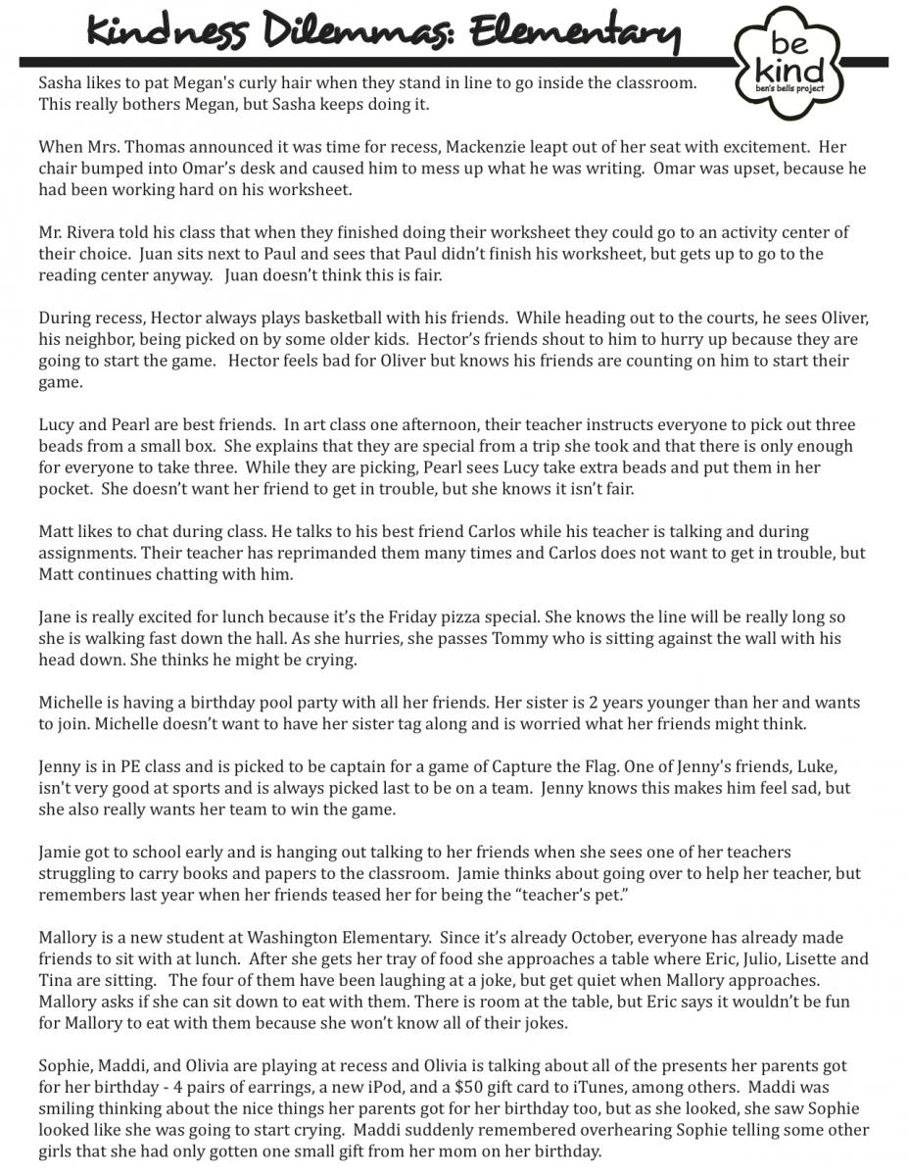](https://bensbells.org/sites/default/files/docs/kindnessdilemmasamples.pdf)

[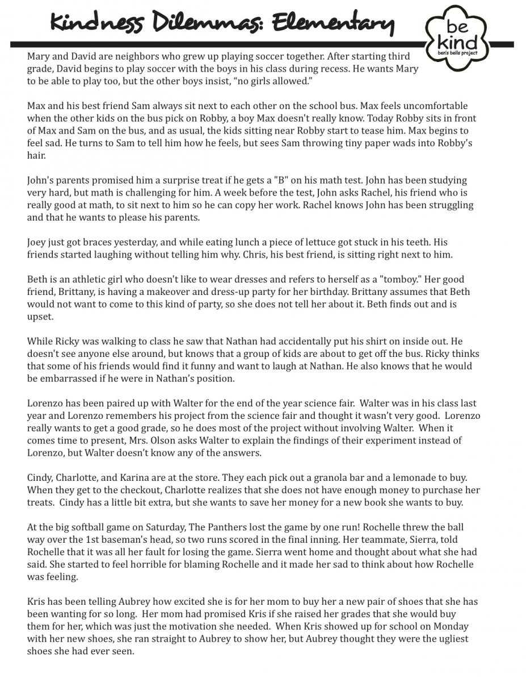](https://bensbells.org/sites/default/files/docs/kindnessdilemmasamples2.pdf)

[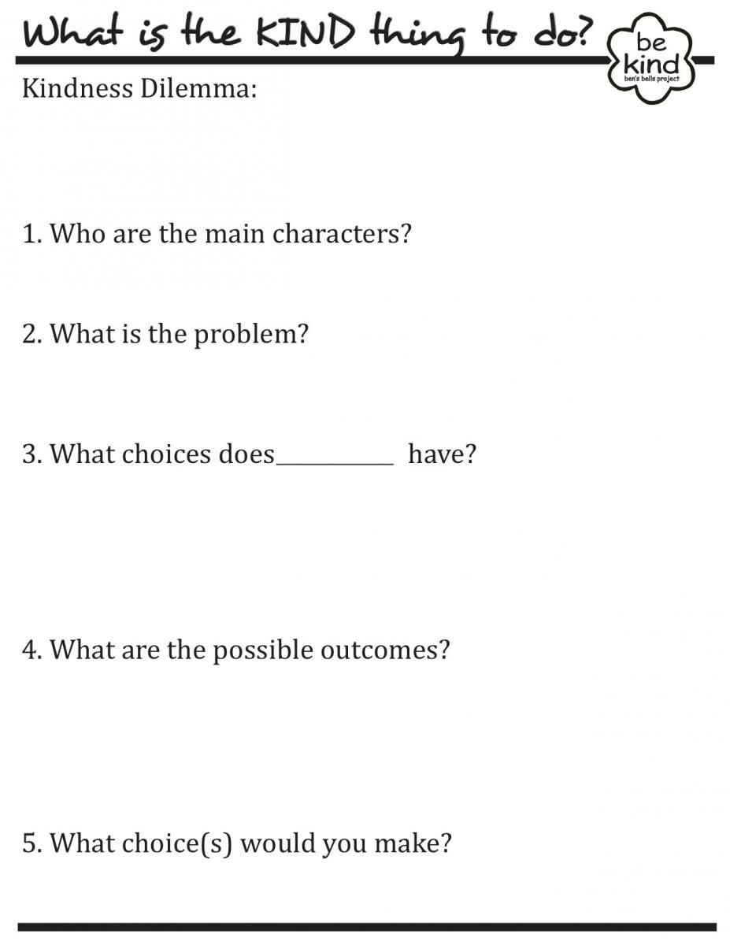](https://bensbells.org/sites/default/files/docs/kindnessdilemmadiscussionposter.pdf)

[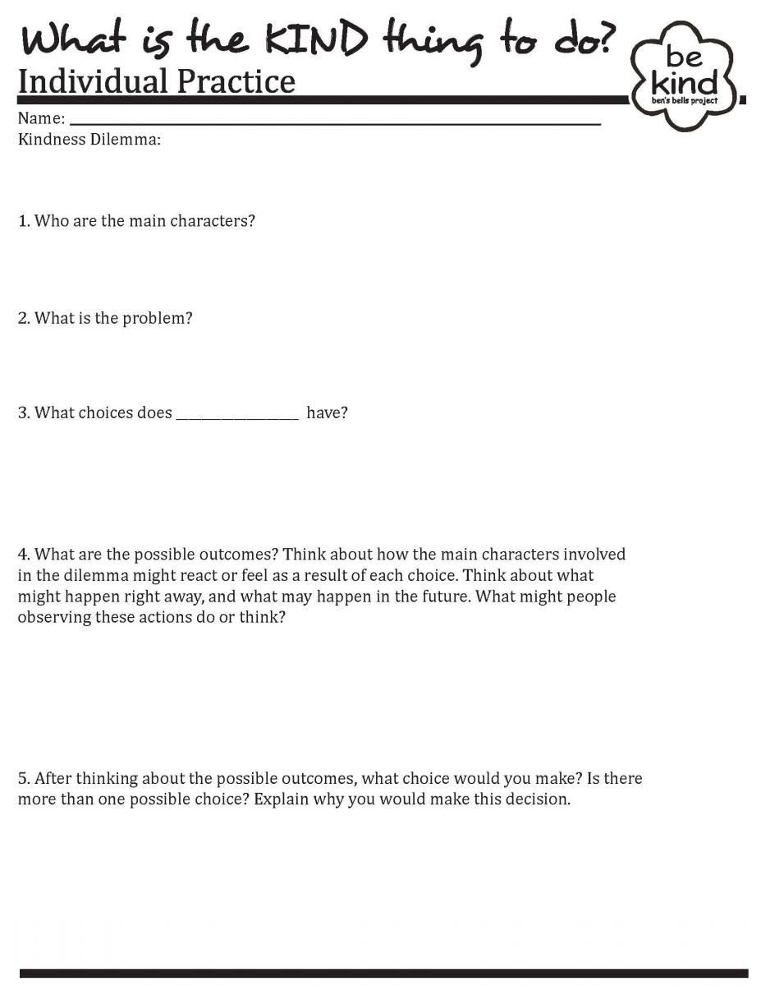](https://bensbells.org/sites/default/files/images/Mo1_WhatIsKindThingToDo.pdf)