[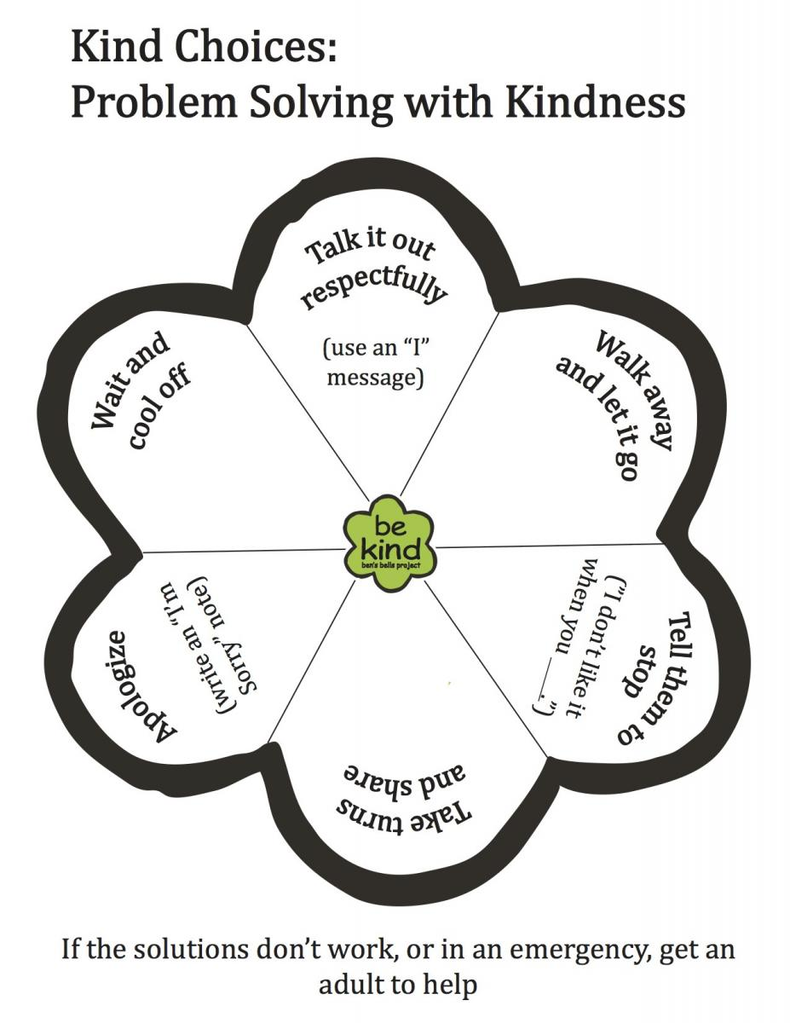](https://bensbells.org/sites/default/files/images/Kind%20Choices%20(1).pdf)