[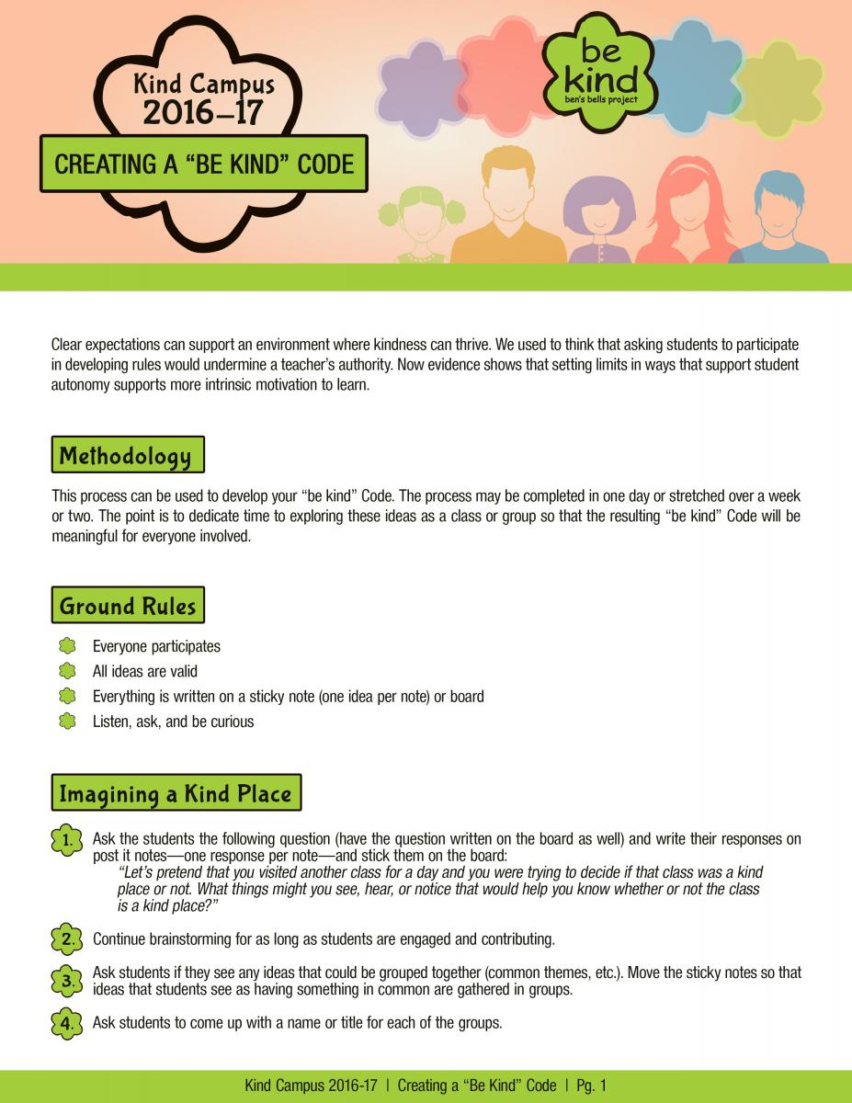](https://bensbells.org/sites/default/files/images/CreatingBeKindCode_16-17%201.pdf)

[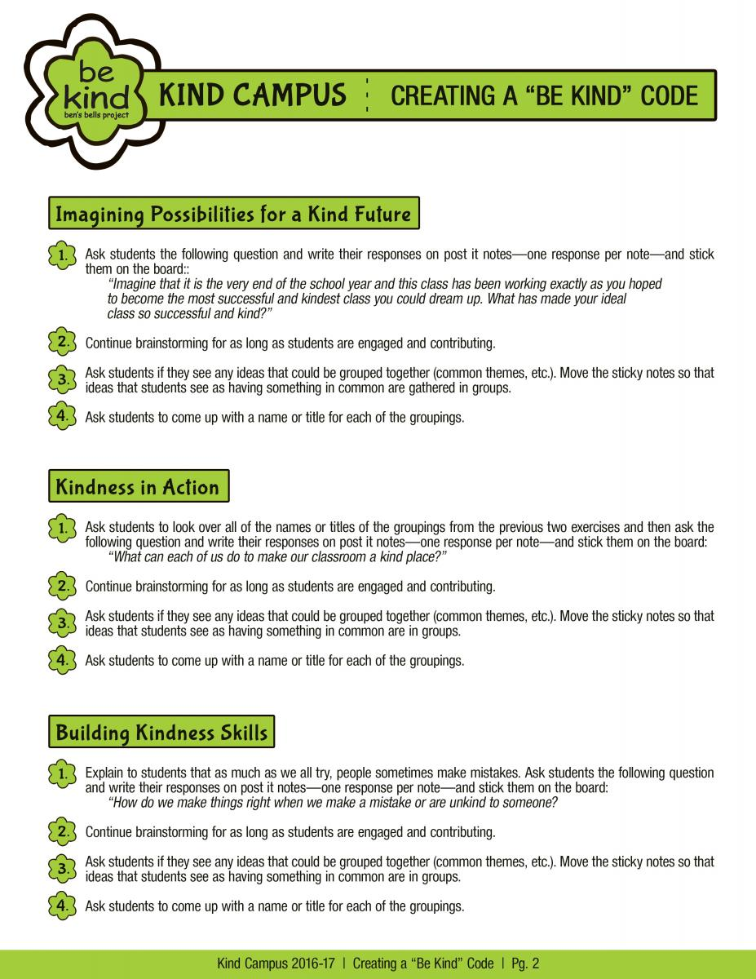](https://bensbells.org/sites/default/files/images/CreatingBeKindCode_16-17%202.pdf)

[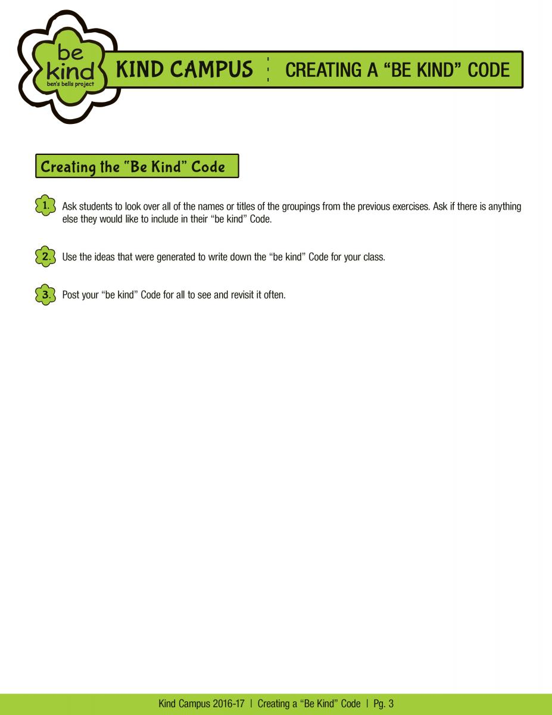](https://bensbells.org/sites/default/files/images/CreatingBeKindCode_16-17%203.pdf)