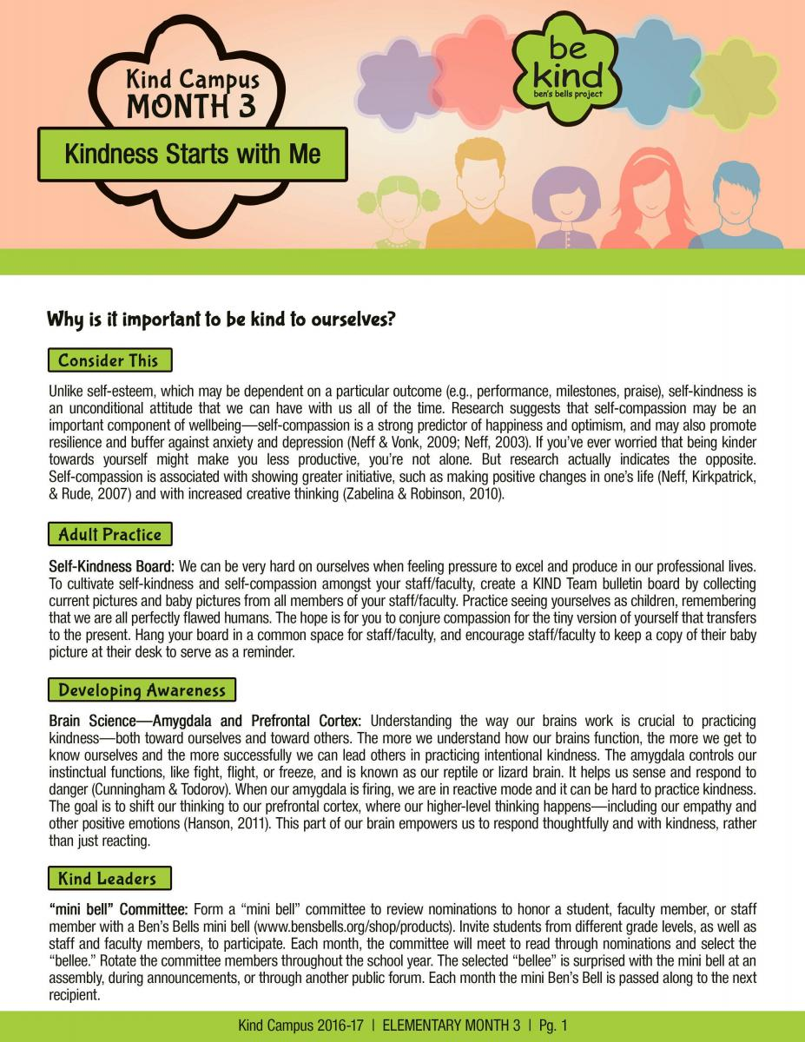

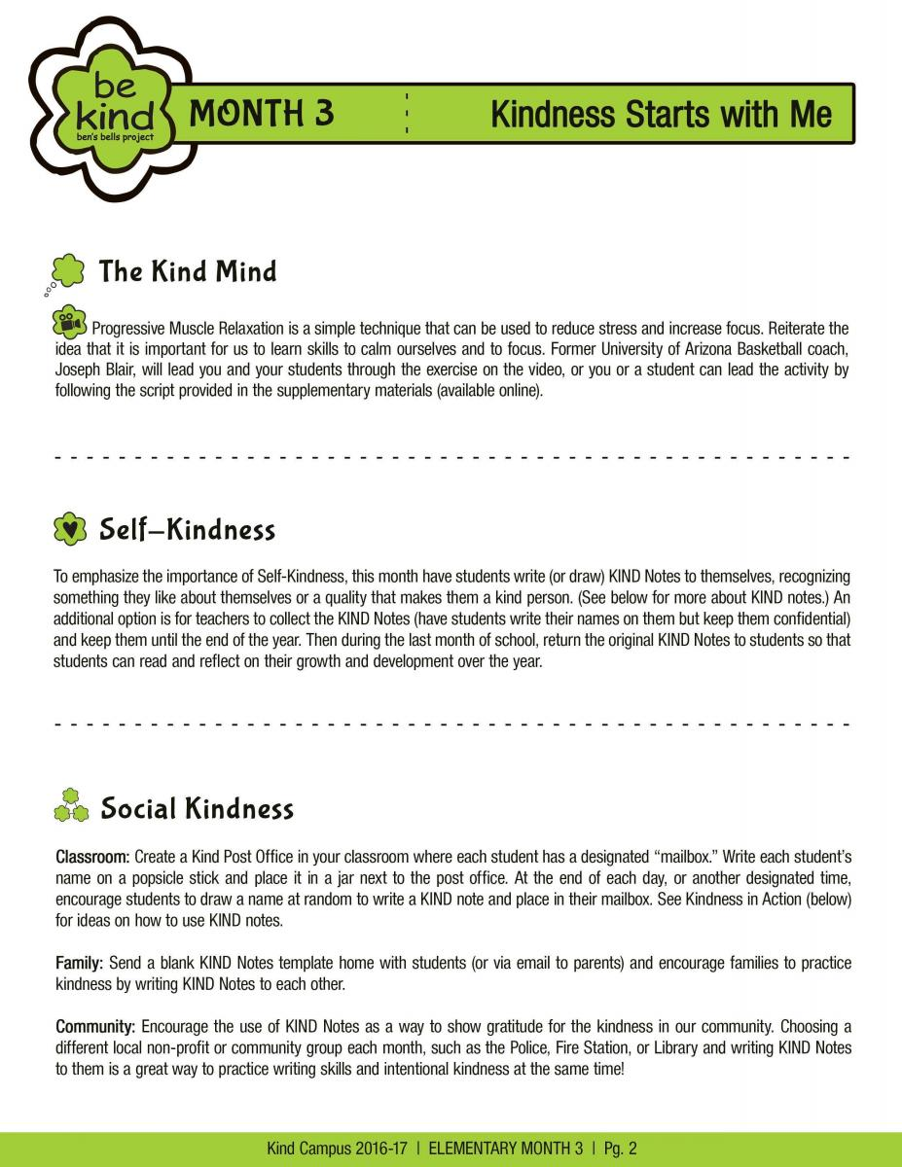

(See Kind Mind Practice: Progressive Relaxation worksheet for video websites)

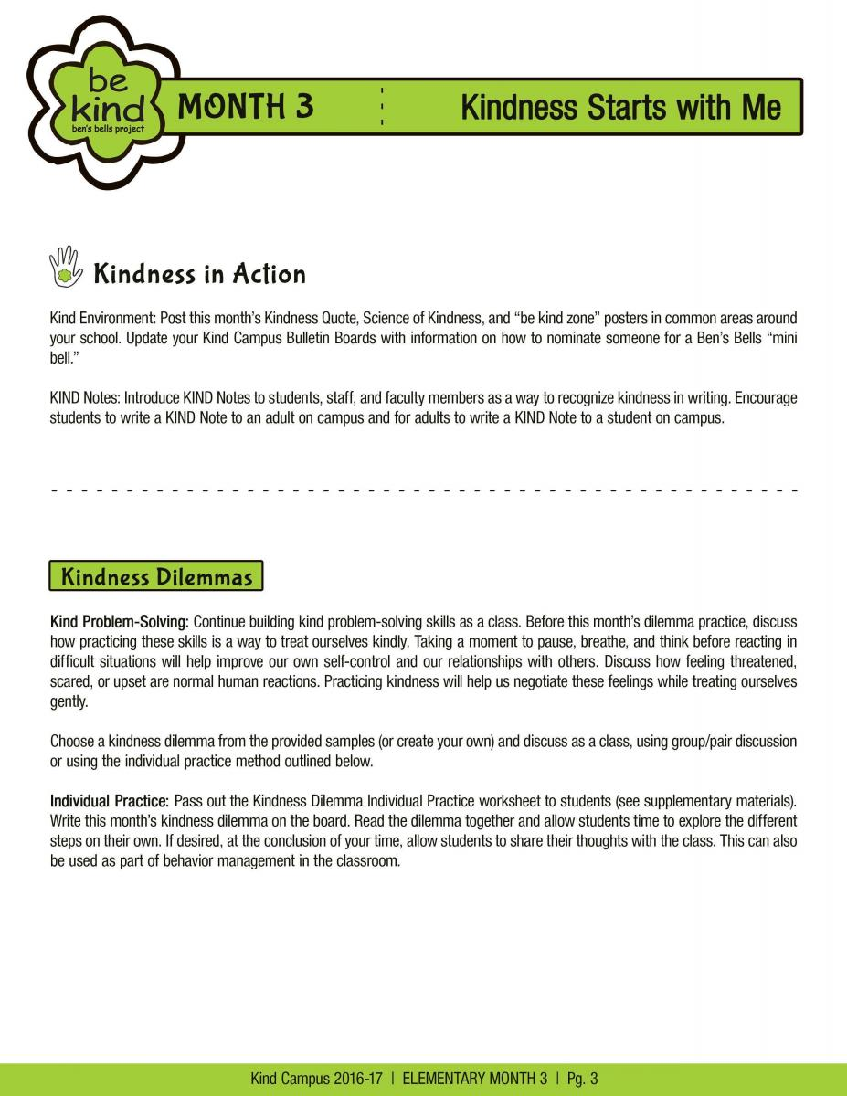

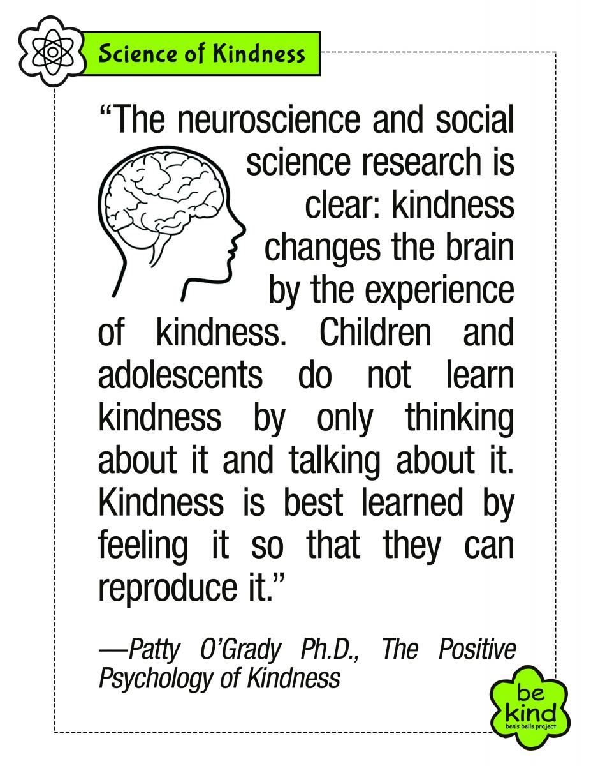

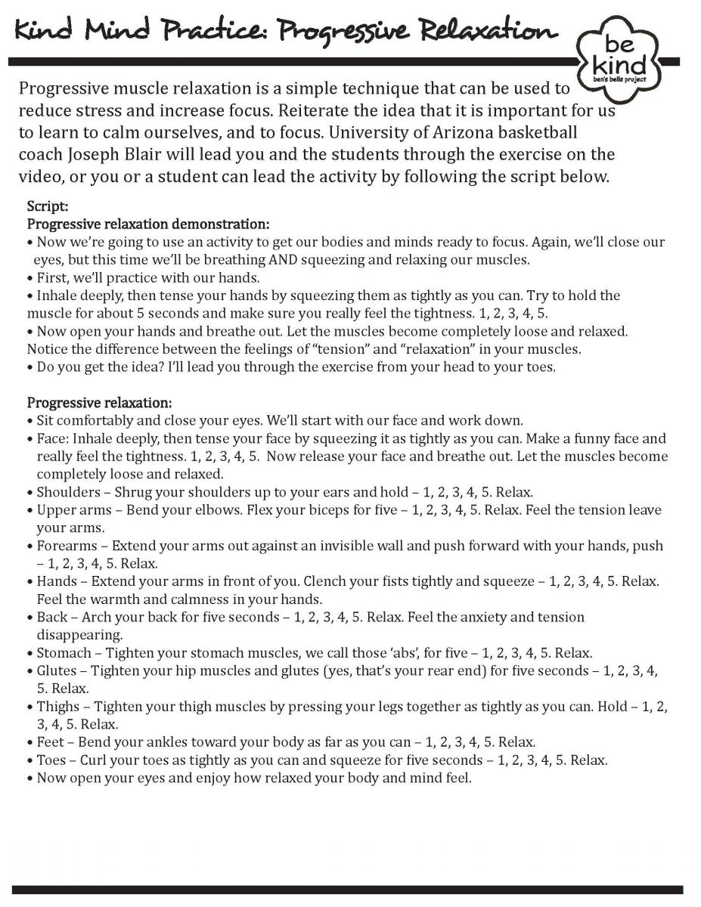

Kind Mind Practice: Introduction with Joseph Blair - https://www.youtube.com/watch?v=A-D4lv_detU
Kind Mind Practice: The Importance of Kind Mind Practices - https://www.youtube.com/watch?v=lMfRCXwlAoU
Kind Mind Practice: Progressive Relaxation Demonstration - https://www.youtube.com/watch?v=ZfHFsvYbaN0
Kind Mind Practice: Progressive Relaxation - https://www.youtube.com/watch?v=X5fDRxOtq8g

