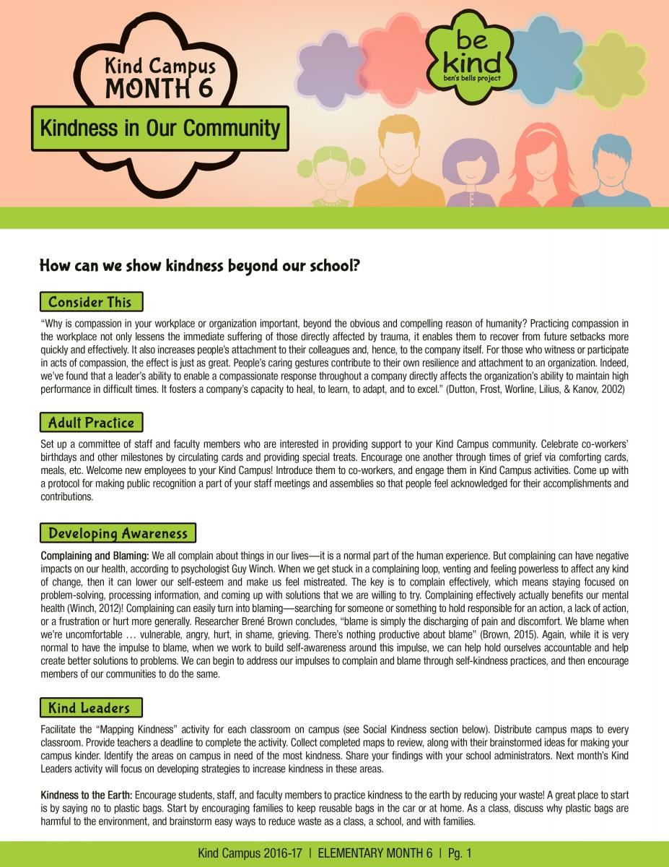

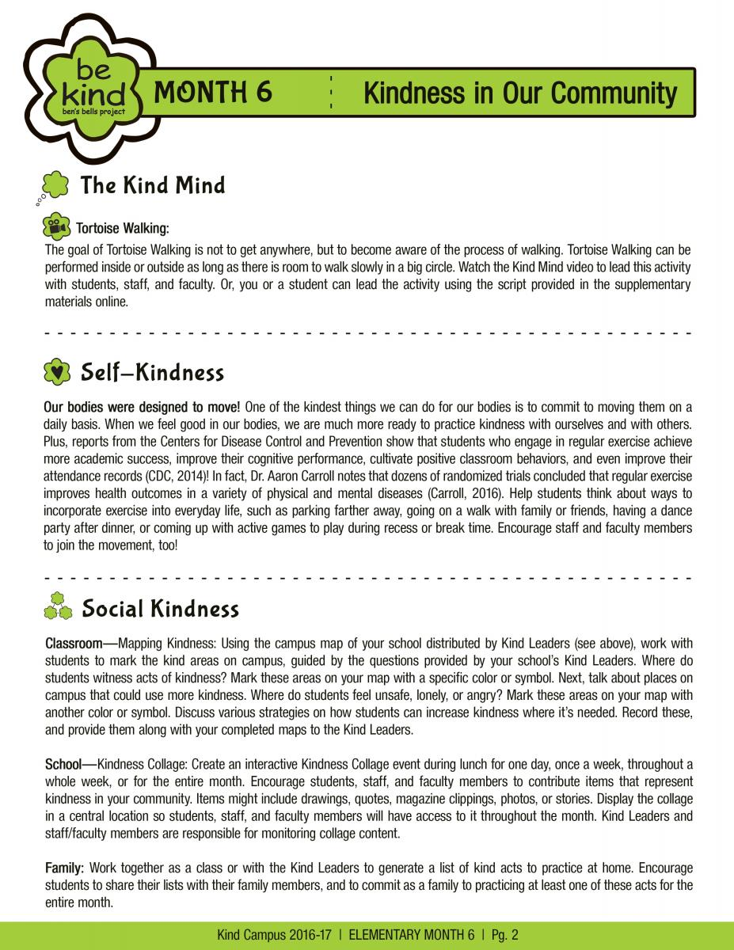

Kind Mind Practice Introduction video: https://www.youtube.com/watch?v=Uf3yjBCDDio
Kind Mind Practice Tortoise Walking video: https://www.youtube.com/watch?v=IKRm_y1J198

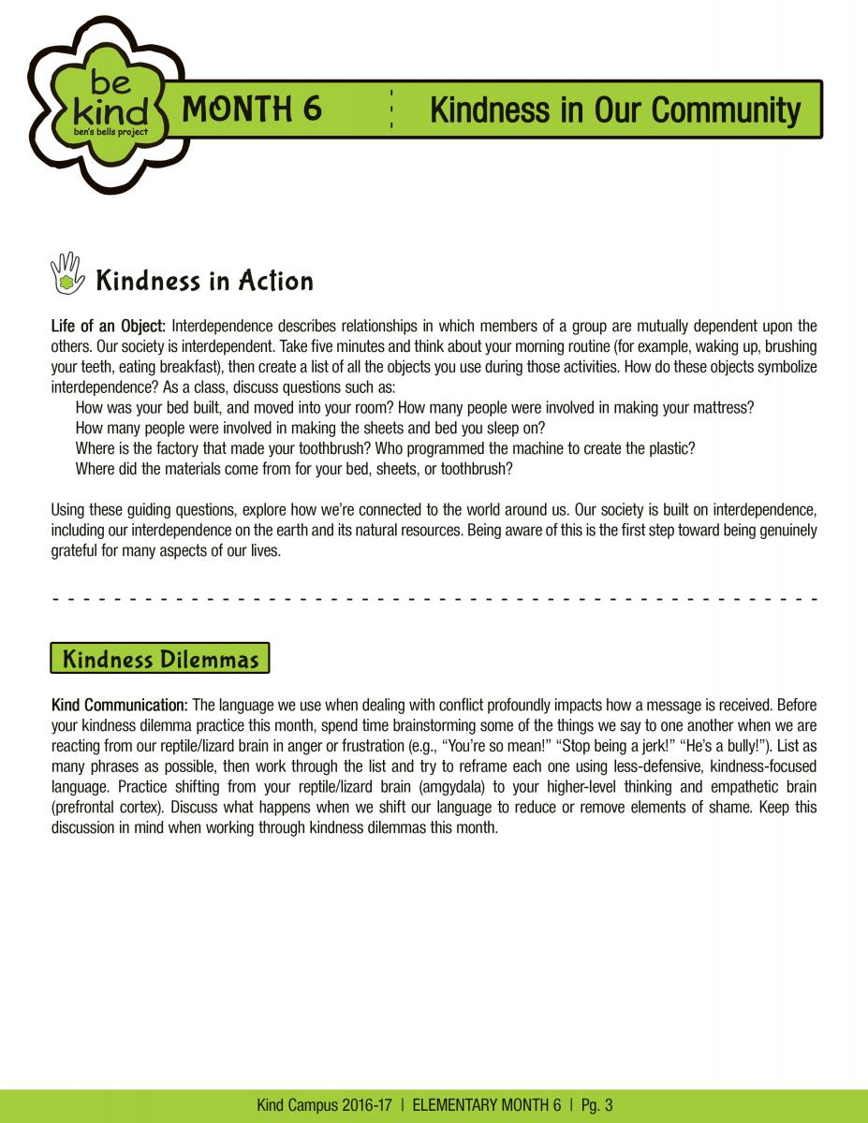

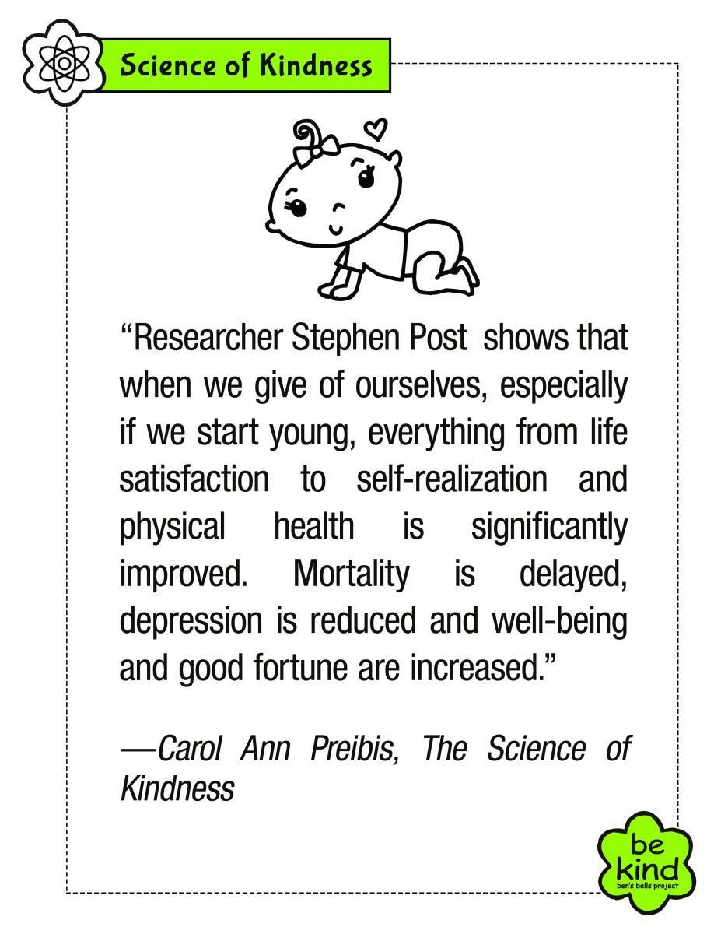

Name _______________________________________ Teacher_______________________________

Mapping Kindness at Elvira
Page 1

If we want to grow kindness in your school community, we need to think about WHERE we can plant the seeds of kindness. Answer the questions below to help you figure out where the best spot(s) for a kindness “garden” would be at your school site.

WHERE do you witness the most or least acts of kindness?
Please circle the 3 places where you see kindness happening the most at our school,
underline the 3 places at school that could use more kindness, and
cross out (put an “X”) over the 3 places where you feel unsafe, lonely, or angry.

Walkways around the Kinder Classrooms K-1 Playground

Walkways around the 1st Grade Classrooms 2-3 Playground

Walkways around the 2nd Grade Classrooms 4, 5, 6 Playground

Walkways around the 3rd Grade Classrooms On the field during afterschool sports

Walkways around the 4th Grade Classrooms K-1 Bathrooms

Walkways around the 5th Grade Classrooms 2-3 Bathrooms

Walkways around the 6th Grade Classrooms 4, 5, 6 Bathrooms

Walkway in front of the Cafeteria Inside the Cafeteria

Walkway in front of the Library Inside the Library

Walkways near the Front Office Inside the Front Office

Walkway near the “be kind” mural In the Nurse’s Office

Walkway near the College and Career Mural In the Prevention Office

Walkways near the Counseling Office In my class during Kindness or Guidance Lessons

Inside the Counseling Office In my classroom with my teacher _______________________

In my tutoring classroom In my other teacher’s classroom ________________________

In the Art/Music Room On the field during P.E. time

Walkways near Mrs. Thomas, Ms. White, and Mrs. Degand’s classrooms

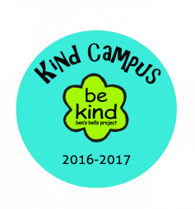

For 4th Grade and Up
Mapping Kindness at Elvira
Page 2

Write down the 3 places where you see the most kindness happening. Then, write down one reason you think kindness is growing so much in each of these places.

Place #1 _______________________________________________ I think kindness is growing in this place because __

____________________________________________________________________________________________________________

Place #2 _______________________________________________ I think kindness is growing in this place because __

____________________________________________________________________________________________________________

Place #3 _______________________________________________ I think kindness is growing in this place because___

____________________________________________________________________________________________________________

Write down the 3 places at school that could use more kindness. Then, write down one way we can help grow kindness in each of these places.

Place #1 _______________________________________________ We can help grow kindness in this place by________

____________________________________________________________________________________________________________

Place #2 _______________________________________________ We can help grow kindness in this place by________

____________________________________________________________________________________________________________

Place #3 _______________________________________________ We can help grow kindness in this place by________

____________________________________________________________________________________________________________

Write down the 3 places at school where kindness is needed the most because you have felt unsafe, lonely, or angry there. Then, write down one way you can help grow kindness in each of these places.

Place #1 _______________________________________________ I will help grow kindness in this place by___________

____________________________________________________________________________________________________________

Place #2 _______________________________________________ I will help grow kindness in this place by___________

____________________________________________________________________________________________________________

Place #3 _______________________________________________ I will help grow kindness in this place by___________

____________________________________________________________________________________________________________

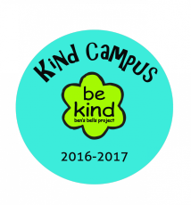

For 4th Grade and Up

Name _______________________________________ Teacher ___________________________________________
Kindness to the Earth

Practice kindness to the earth by reducing your waste.

A great place to start is by saying “no” to plastic bags. Start by encouraging your family to keep reusable bags in the car or at home. What are three reasons why plastic bags are harmful to the environment?

1.________________________________________________________________________________________________

2.________________________________________________________________________________________________

3.________________________________________________________________________________________________

Brainstorm easy ways to reduce waste…
(Write your ideas around each different earth.)

… as a class. … as a school.

… as a family.

Stretch towards Self-Kindness…
with these gentle stretching exercises.

It is important to remember to be kind to ourselves every day. One way to do that is by paying attention to what is going on with our bodies and looking for signs of stress, which is a pressure that we feel inside ourselves. It is important to learn skills that will help our bodies to calm down and our minds to re-focus during times of stress.
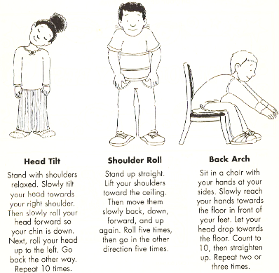
One easy way we can calm our bodies down and re-focus our minds is to do some gentle stretching. Practice these gentle stretches below on a daily basis to help your body feel less stressed and help your mind be even more focused on being kind!

* Pictures and descriptions of stretches are courtesy of “Believe, Achieve, and Succeed at Test Time! An Educational Activities Book” by Julie Theisz, 2005, Positive Promotions, pg. 15.

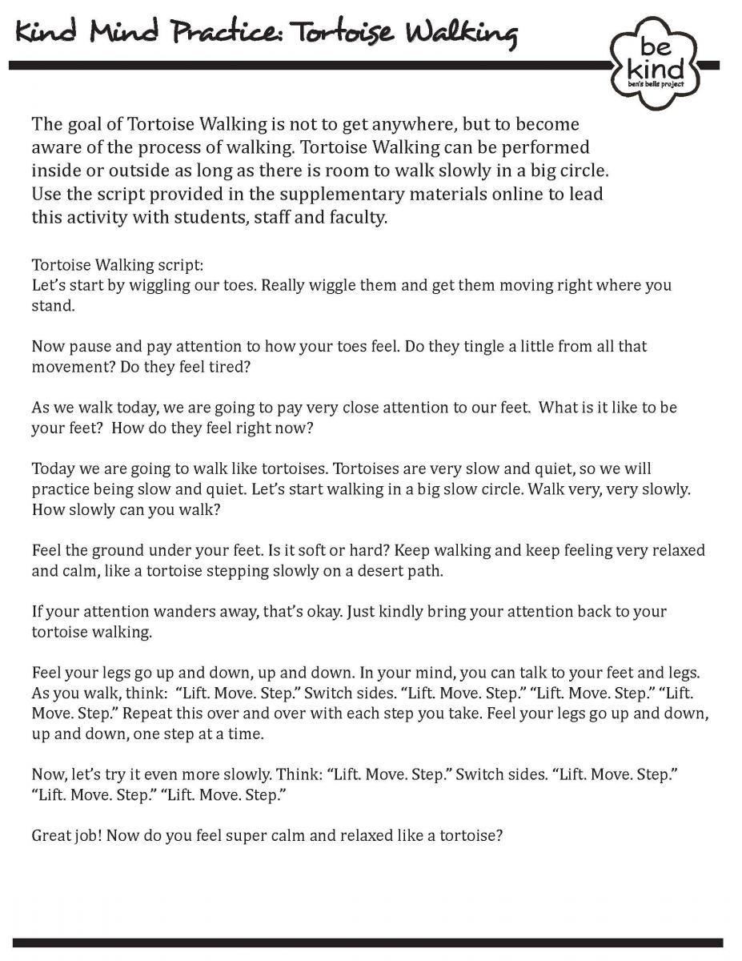

Name _______________________________________ Teacher_______________________________
My Family’s Commitment to Kindness

Kindness is about caring for others around you, wanting the best for them and understanding that they have the same wants, needs, hopes, and fears that you have. Kindness is strong, patient, trusting, loyal, and grateful.

Our Family members are committing to “be kind” to ourselves, each other, and other people around us from now on. To help us follow our Commitment to Kindness, we pledge to do the following acts of kindness within the next month:

The first act of kindness we will do is: ____________________________________________________________

The second act of kindness we will do is: _________________________________________________________

The third act of kindness we will do is: ___________________________________________________________

Signed by all the members of our family on this ________ day of _______________________, _________:
(date) (month) (year)

_______________________________________________ _______________________________________________

_______________________________________________ _______________________________________________

_______________________________________________ _______________________________________________
(Family Member Signatures) (Family Member Signatures)

