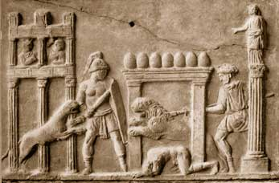
The gladiators who fought in these games were mostly prisoners, slaves and criminals who trained long and hard in schools like the one Caesar built; although a few such fighters were paid volunteers. Some of the latter became involved because they had financial difficulties, and these events offered generous prize money for the winners. Other volunteers were motivated by the physical challenge and appeal of danger or the prospect of becoming popular idols and symbols.
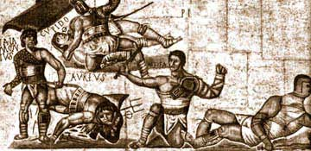
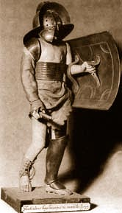
The terms "Thracian" and "net fighter" referred to the customary division of gladiators into various types and categories. Among the four main types that had evolved by the early Empire was the heavily armed Samnite, later called a hoplomachus or secutor. (The Romans may have recognized these three as separate and distinct types, but any such distinctions are now unclear; all employed basically the same weapons and tactics.) A Samnite carried a sword or a lance, a scutum (the rectangular shield used by Roman legionary soldiers),a metal helmet, and protective armor on his right arm and left leg. Another type, the Thracian (so named because he resembled fighters from Thrace, a region of northern Greece), was not as elaborately armed. He wielded a curved short sword, the sica, and a small round shield, the parma.
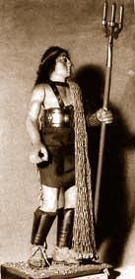
A third kind of gladiator, the murmillo, or "fishman" (after the fish-shaped crest on his helmet), was apparently similar to a Samnite but less heavily armed. A murmillo customarily fought still another kind of warrior, the retiarius, or "net-man," who wore no armor at all. A retiarius attempted to ensnare his opponent in his net (or used the net to trip the other man) and then to stab him with a long, razor-sharp trident, or three-pronged spear.
In addition to the pairings of these main gladiator types, there were a number of special and off-beat types and pairings. These included equites, who fought on horseback using lances, swords, and/or lassoes; the essedarii, who confronted each other on chariots; and, perhaps the most bizarre of the lot, the andabatae, who grappled while blindfolded by massive helmets with no eyeholes. Women gladiators came into vogue under the emperors Nero and Domitian in the late first century A.D. Evidence shows that Domitian sometimes pitted female fighters against male dwarves as well as against one another.

"We Who Are About to Die Salute You!"
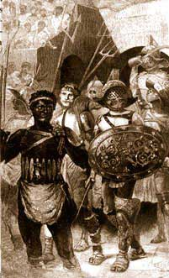
On the eagerly anticipated day when munera were scheduled at the Colosseum or another amphitheater, the gladiators first entered the arena in a colorful parade known as the pompa. This was similar in some ways to the procession of the athletes on opening day of the modern Olympic Games. They were usually accompanied by jugglers, acrobats, and other performers, and all kept time to marching music provided by musicians playing trumpets, flutes, drums, and sometimes a large hydraulic organ. (The organ probably also played during the actual fighting, producing the same effect as the background musical score of a movie.)
Following the pompa, the acrobats and other minor performers exited and the gladiators proceeded, in full public view, to draw lots, which decided who would fight whom. Then an official inspected their weapons to make sure they were sound and well sharpened. Finally, the gladiators soberly raised their weapons toward the highest-ranking official present (usually either the emperor or munerarius, the magistrate in charge of the spectacle) all recited the phrase, "Morituri te salutamus!" ("We who are about to die salute you!") After that, the first pairing began.
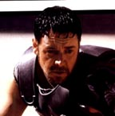
Having no rules or referees, the combat was invariably desperate and often savage. The spectators, like those at modern boxing matches and bullfights, reacted excitedly. Typical shouted phrases included "Verbera!" ("Strike!"), "Habet!" ("A hit!"), "iHoc habet!" ("Now he's done for! "), and "Ure!" ("Burn him up!").The fighting had several possible outcomes. If both warriors fought bravely and could not best each other, the munerarius declared the bout a draw and allowed them to leave the arena and fight another day. Sometimes both officials and spectators felt that the fighters were not giving it their all. Or one man turned and ran. "Officiosus fled on November 6 in the consulate of Drusus Caesar and M. Junius Norbanus," reads a Pompeian inscription. Such offenders were punished by whipping or branding with hot irons.
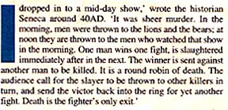
A more common outcome was when one gladiator went down wounded. He was allowed to raise one finger, a sign of appeal for mercy, after which the emperor or munerarius decided his fate, usually in accordance with the crowd's wishes. If the spectators desired a fighter spared, they either waved their handkerchiefs or pointed their thumbs downward, the signal for the victor to drop his or her sword. At the same time they shouted "Mitte! ("Spare him!") On the other hand, if the choice was death, they Pressed their thumbs toward their own chests (symbolizing a sword through the heart) and yelled "lugula!" ("Cut his throat!").
Test and pictures from Greek and Roman Sport by Don Nardo and from The Birth of Western Civilization

