Name: _________________________________________________________period_________________________________
DO NOW for the week of __Monday August 8-Friday August 12, 2016_________________________________________
20 pts per day
DATE | ASSIGNMENT
Monday | Free Write-What was the high and low of your weekend? Write in complete sentences.
Tuesday | Are you a leader or a follower? Read the paragraph below and write a commentary at the bottom of the paragraph.  Not every person is able to be a leader. Some people are born to be leaders: they are ambitious, knowledgeable, driven to learn something new and, most importantly, know how to set goals and guide people to meet those goals. Other people are followers and prefer to stay in the shadow of the team: they prefer being given a detailed guidance on what and how to do somwething. I belong to the first group of people, leaders, and I am not afraid to assume responsibility for the results of my leadership. Being a leader, I try to identify the strengths and weaknesses of the people I lead in order to elevate the potential of the team and achieve the set goals and objectives effectively and efficiently.
Wednesday | Quote Analysis- Analyze the quote below, write what you think the quote means and what it mean to you.  “The time is always right to do what is right.” – Martin Luther King, Jr.
Thursday | Answer the following questions about the image.  - Who is the scientist in the image?  - What area of science did he/she work in?  - When was he born?  - Is he still alive?  - What is he known for?  - How did he/she change lives or science for the better?  - Did his/her work lead to other discoveries?  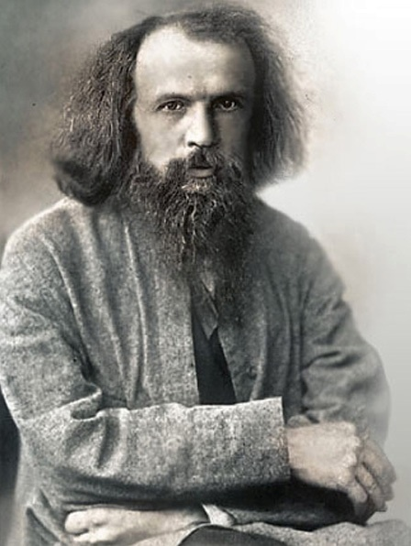
Friday | What was the high and low of your learning this week?

