Visual Auditory Kinesthetic/Tactile

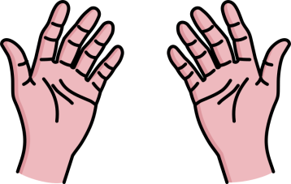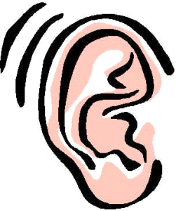

Name: _____________________________________________

Fill in the blank with the learning style or styles that the strategy applies to:

1. Write down key words or ideas during a lecture. ___________________________________________

2. Read directions out loud. ________________________________

3. Sit near the front of the class. ______________________ ___ and ________________________________

4. Trace words with your finger to learn spelling. ________________________________

5. Highlight key ideas in text. ___________________________

6. Create songs, poems or raps to process important information. _______________________________

7. Hold something in your hand while you learn or study. ________________________________

8. Make flash cards of important words, ideas or dates. ______________________ and _______________________

9. Read flash card out loud to yourself. _____________________________

10. Draw charts, diagrams or pictures on your notes. _______________­­­­­__________ and ________________________