Career I Have, Who Has  Start…..  Who has “a person who cares for the health of animals”? | I have a veterinarian.  Who has a person who studies life in the ocean?
I have a marine biologist.  Who has a person who installs and maintains electrical equipment? | I have an electrician.  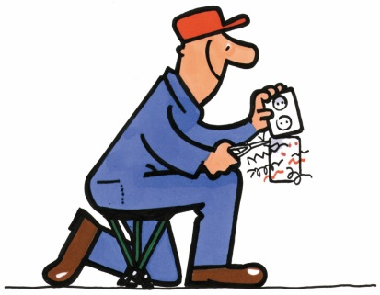  Who has a person who gathers facts and information about legal, financial & personal matters?
I have a detective.  Who has a person who plans and designs buildings and structures? | I have an architect.  Who has a person who greets visitors, answers phone calls and performs clerical duties?

I have a receptionist.  Who has a person who helps others get into shape? | I have a fitness trainer.  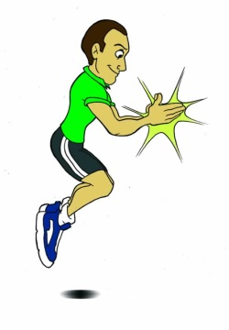  Who has a person who flies airplanes and/ or helicopters?
I have a pilot.  Who has a person who examines a patient’s teeth and mouth? | I have a dentist.  Who has a person who researches, analyzes and explains past events and people?
I have a historian.  Who has a person who works in conducting the business of a government? | I have a politician.  Who has a person who reviews cases and makes decisions about them based on laws?

I have a judge.  Who has a person who directs the sales of goods and services for businesses? | I have a sales manager.  Who has a person who plays a sport as a career?
I have a professional athlete.  Who has a person who supervises workers who produce artwork for magazines, ads or products? | I have an art director.  Who has a person who helps people manage social, financial and health problems?
I have a social worker.  Who has a person who gives care to an ill or injured person in an emergency situation? | I have an Emergency Medical Technician (EMT).  End.

