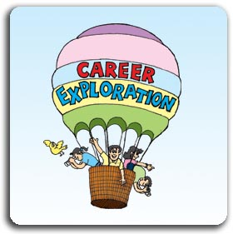
My Career Interests
On the following website, http://vacareerview.org/k5/check-it/kids-search/ you will explore many different careers that may be of interest to you and something you wish to pursue one day. Please select your top 3 and provide the following information on them.
1. Career:
Duties of this career include:

Skills needed for this career include:

I am interested in this career because….

I could prepare myself for this career by…..

2. Career:
Duties of this career include:

Skills needed for this career include:

I am interested in this career because….

I could prepare myself for this career by…..

3. Career:
Duties of this career include:

Skills needed for this career include:

I am interested in this career because….

I could prepare myself for this career by…..

