Name: Teacher:
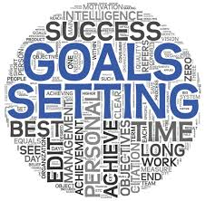
Ready, Set, Goal!!!
Create your own SMART goal to works towards and achieve!
Specific, Measurable, Action, Relevant, Timely

Step 1: Think of your goal and write it down.
The goal that I want to achieve is:
______________________________________________________________________________________________________________________________________________________________________________________________________
How is this goal going to help you? Why is it important to you?

When will I reach this goal?

Step 2: Create a plan that includes everything you need to do.
To reach this goal I will need to:
1.
2.
3.
4.
5.
6.

Step 3: Think of challenges you may face and how you will overcome them.
Some challenges I may face:
Challenge: | I will conquer it by…..

Step 4: Stick to it don’t give up!!
If I feel like giving up I will tell myself……

Step 5: Reach Goal!!!
When I reach this goal I will feel
_____________________________________.
I will have grown as a person because ________________________________________________
________________________________________________.

