Supplemental Ideas for “Understanding Goals and Goal Setting” lesson
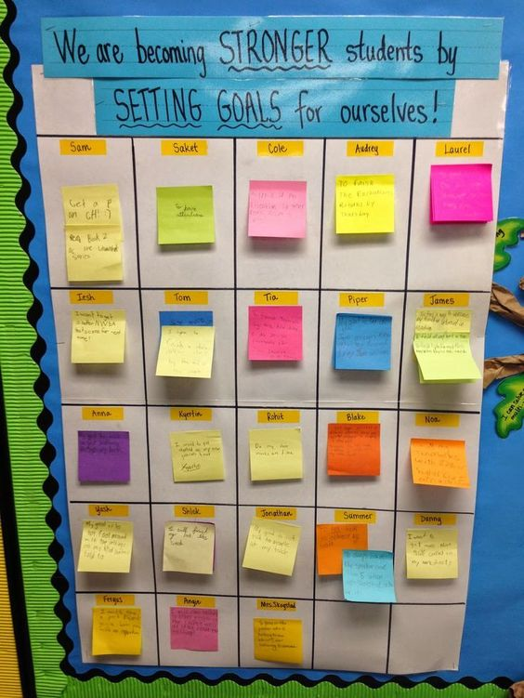
Students may write their goals on a post-it or index card to be posted on a classroom poster board for all to see their goals. Students will be told to encourage one another in achieving their goals.

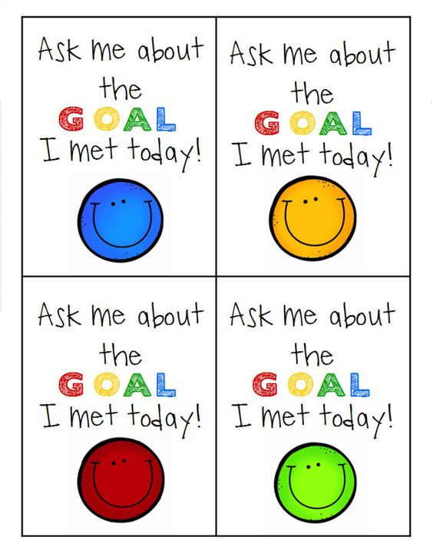
Counselor may choose to do some sort of recognition for students when they achieve their goals such as creating badges/ necklaces for them to wear stating they achieved a goal.

