
Write about your summer vacation and how you feel about coming back to school: | 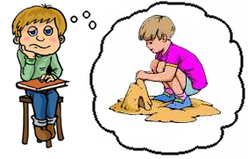
How was your summer? Did you have a good summer?
Are you happy to be back at school? ☺
What are you going to miss about summer?
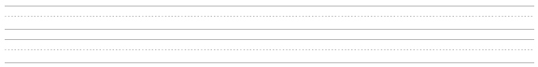
What was the most memorable thing that happened this summer?
What was the best thing that happened this summer?
What was the worst thing that happened this summer?
What movies did you see this summer?
Where did you go this summer?
Who did you hang out with this summer?
www.bogglesworldesl.com

