Running RAPS360 Report after the Update

- Click on SELECT REPORT

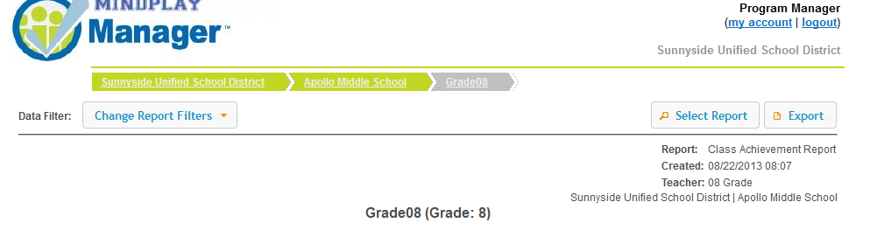

- For RAPS Benchmark data click on IMPROVEMENT REPORT

