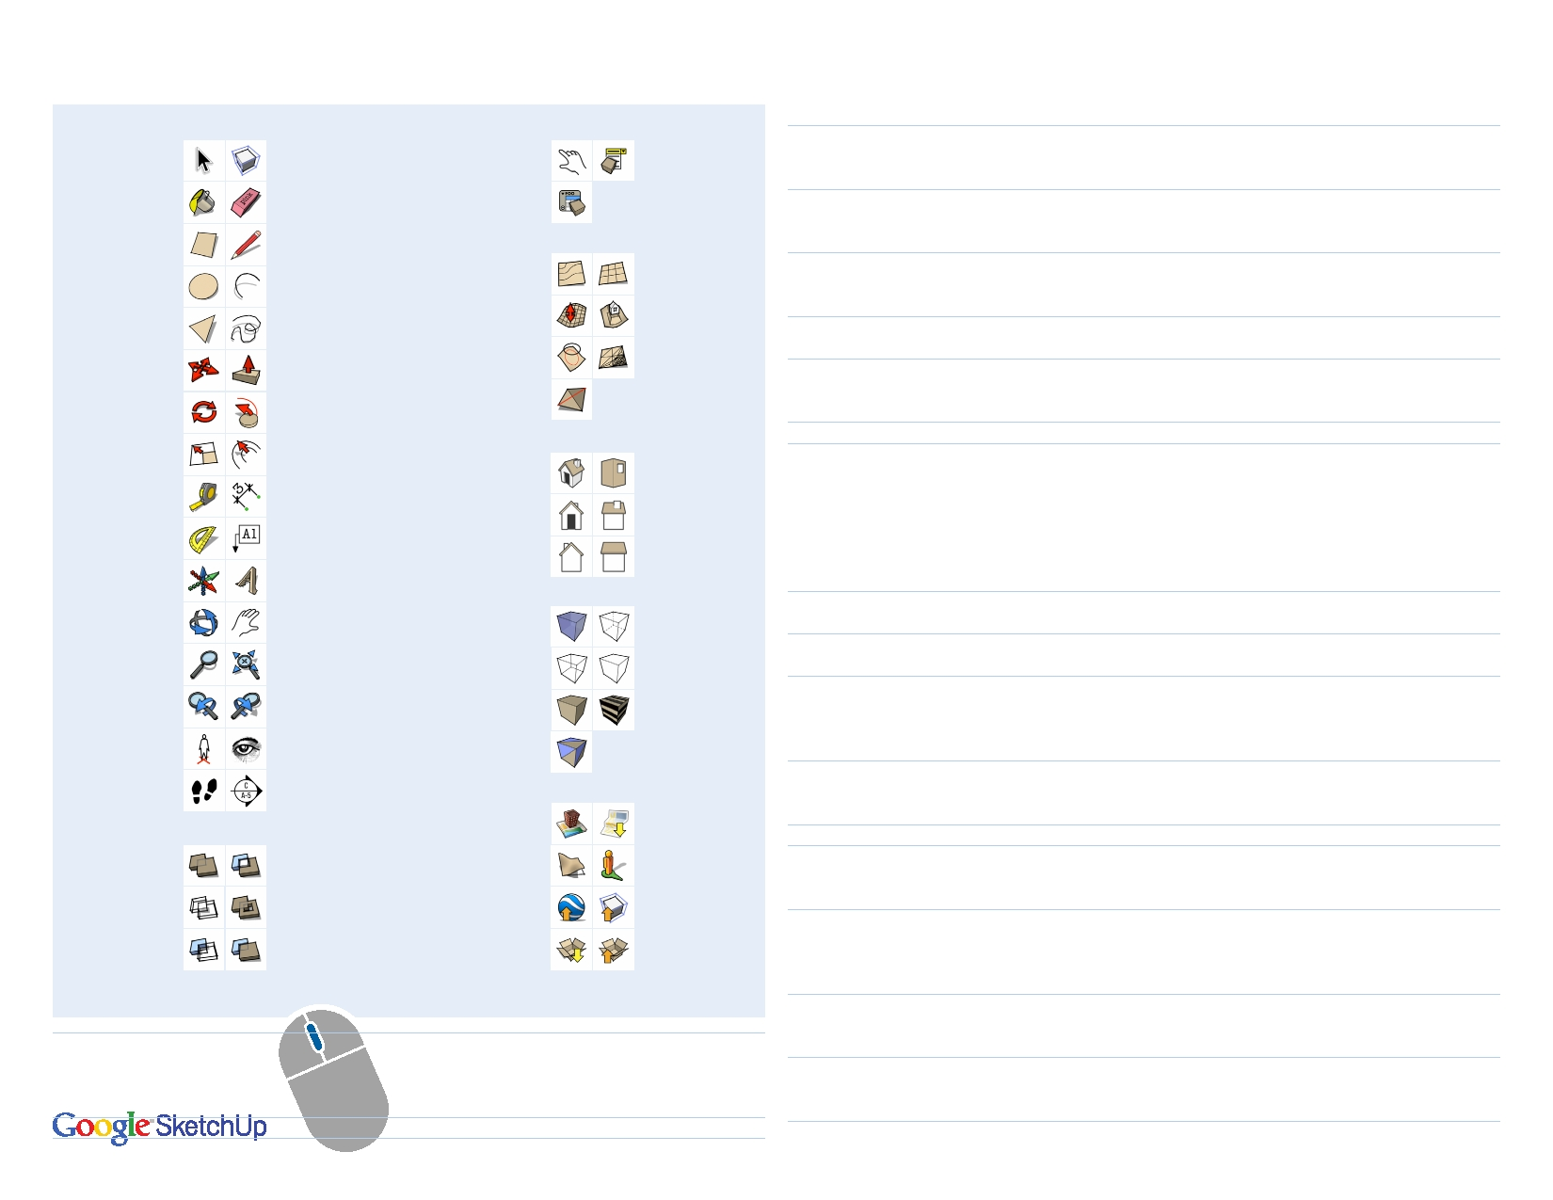
Sketch-Up 8 Quick Reference Card

Select (Spacebar)

Paint Bucket (B)

Rectangle (R)

Circle (C)

Polygon

Move (M)

Rotate (Q)

Scale (S)

Tape Measure (T)

Protractor

Axes

Orbit (O)

Zoom (Z)

Previous

Position Camera

Walk

Outer Shell

Intersect (Pro)

Subtract (Pro)

Tool Set

Solid Tools

Make Component

Eraser (E)

Line (L)

Arc (A)

Freehand

Push/Pull (P)

Follow Me

O set (F )

Dimensions

Text

3D Text

Pan (H)

Zoom Extents

Next

Look Around

Section Plane

Split (Pro)

Union (Pro)

Trim (Pro)

Interact

C o m p o n e nt
Attributes

From Contours

Smoove

Drape

Flip Edge

Iso

Front

Back

X-Ray

Wireframe

Shaded

Monochrome

Add New Building…

Show Terrain

Preview Model in
Google Earth

Get Models…

Dynamic Components

Component Options

Sandbox (Terrain)

From Scratch

Stamp

Add Detail

Standard Views

Top

Right

Left

FaceV

Back Edges

Hidden Line

Shaded
with Textures

Google

Add Location

Photo Textures

Share Component…

Share Model…

Tool
Arc (A)

Circle (C)

Eraser (E)

Follow Me

Line (L)

Look Around
Move (M)

O set (F )

Orbit (O)

Paint Bucket (B)

Push/Pull (P)

Rectangle (R)
Rotate (Q)

Scale (S)

Operation
Bulge
Radius
Segments
Shift
Radius
Segments
Ctrl
Shift
Ctrl+Shift
Alt
Better Way
Shift
Arrows Length
Eye Height
Ctrl
Shift
Alt
Arrows
Distance
External Array Internal Array Double-Click
Distance
Ctrl
Shift
Ctrl
Shift
Ctrl+Shift
Alt
Ctrl
Double-Click
Distance
Dimensions
Ctrl
Angle Slope
Ctrl
Shift
Amount
Length

Instructions
specify bulge amount by typing a number and Enter
specify radius by typing a number, the R key, and Enter
specify number of segments by typing a number, the S key, and Enter
lock in current plane
specify radius by typing a number and Enter
specify number of segments by typing a number, the S key, and Enter soften/smooth (use on edges to make adjacent faces appear curved)
hide
unsoften/unsmooth
use face perimeter as extrusion path
first Select path, then choose the Follow Me tool, then click on the face to extrude
lock in current inference direction
up or down arrow to lock in blue direction; right to lock in red; left to lock in green
specify length by typing a number and Enter
specify eye height by typing a number and Enter
move a copy
hold down to lock in current inference direction
auto-fold (allow move even if it means adding extra edges and faces)
up or down arrow to lock in blue direction; right to lock in red; left to lock in green
specify move distance by typing a number and Enter
n copies in a row: move first copy, type a number, the X key, and Enter
n copies in between: move first copy, type a number, the / key, and Enter
apply last o set amount to this face
specify an o set distance by typing a number and Enter
hold down to disable "gravity-weighted" orbiting
hold down to activate Pan tool
paint all matching adjacent faces
paint all matching faces in the model
paint all matching faces on the same object
hold down to sample material
push/pull a copy of the face (leaving the original face in place)
apply last push/pull amount to this face
specify a push/pull amount by typing a number and Enter
specify dimensions by typing length, width and Enter ie. 20,40
rotate a copy
specify an angle by typing a number and Enter
specify an angle as a slope by typing a rise, a colon (:), a run, and Enter ie. 3:12
hold down to scale about center
hold down to scale uniformly (don't distort)
specify a scale factor by typing a number and Enter ie. 1.5 = 150%
specify a scale length by typing a number, a unit type, and Enter ie. 10m

Display additional toolbars by choosing View > Toolbars from the menu bar.
Select (Spacebar) Ctrl add to selection
Shift add/subtract from selection

LR
L R
Middle Button (Wheel)

Right Mouse Button
Scroll
Click-Drag
Shift+Click-Drag
Double-Click
Click
Zoom
Orbit Pan
re-center view
show context menu

Tape Measure (T)

Zoom (Z)
Ctrl+Shift
Ctrl
Arrows Resize
Shift
subtract from selection
create a new Guide
up or down arrow to lock in blue direction; right to lock in red; left to lock in green
resize model: measure a distance, type intended size, and Enter
hold down and click-drag mouse to change Field of View

© 2010 Google Inc.

