Partner Appointment Clock

[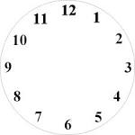](http://www.google.com/imgres?imgurl=http://www.primdoodles.com/images/Clockblank150dpi.JPG&imgrefurl=http://art-dbase.net/search.php?id=16968&usg=__uC7HoijS5O___wSogr8olVU8IXw=&h=1020&w=1020&sz=79&hl=en&start=6&zoom=1&tbnid=RdTxEQD-C5K-qM:&tbnh=150&tbnw=150&ei=eQL_UKDBM4m7iwL98oCYDQ&prev=/search?q=clock+face&hl=en&sa=X&rlz=1T4ADRA_enUS461US462&tbm=isch&itbs=1)