Step 1: Click on Management Tools
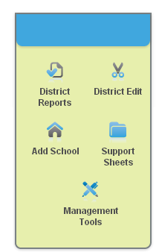

Step 2: Click on Materials
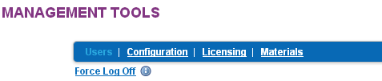

Step 3: Click on View Legacy Reports

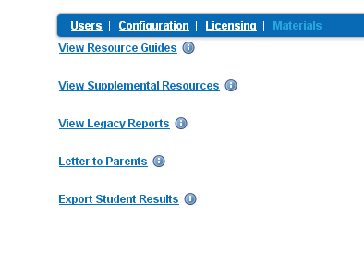
Step 4: Click on Student Reports

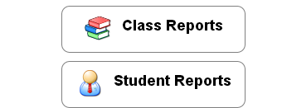

Step 5: Click on Choose a Classroom and select all students. Then click on Choose a Report

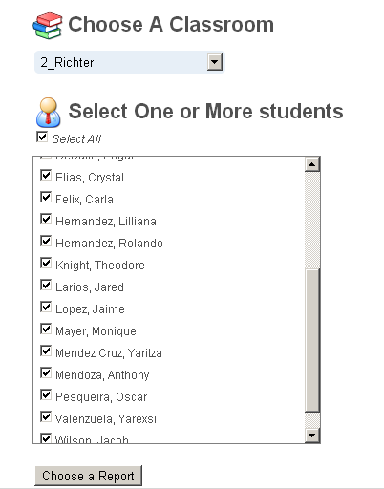
Joe Teacher

Step 7: Click on Parent Report and then Run Report
