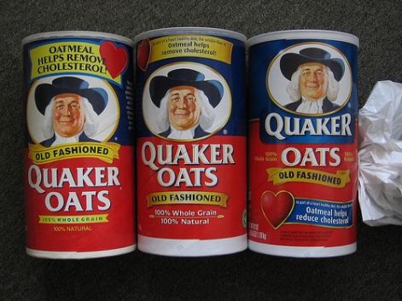 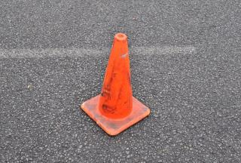

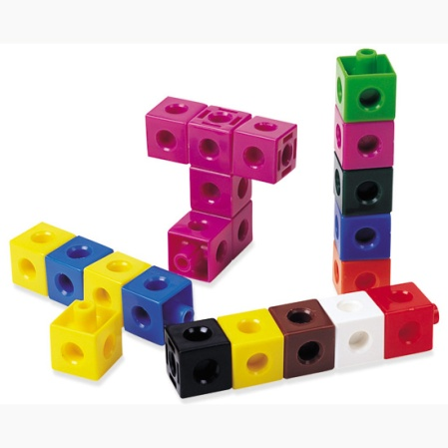 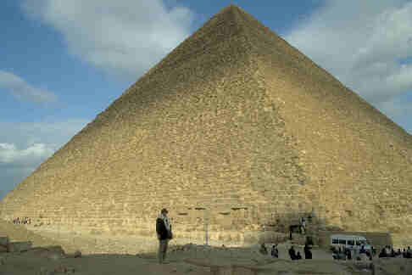

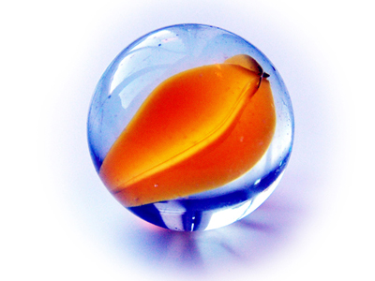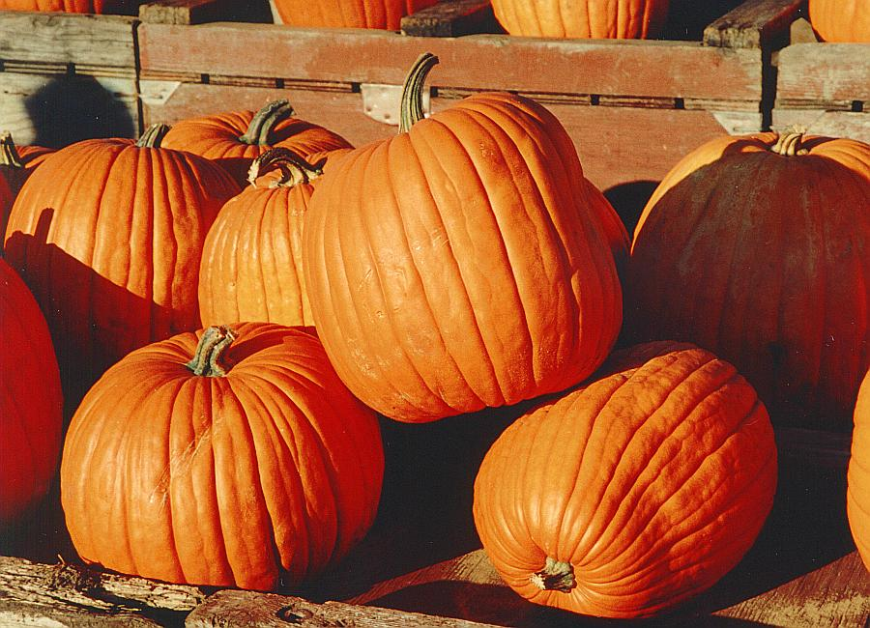

 [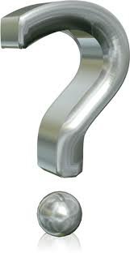](http://www.google.com/imgres?imgurl=http://wondrouspics.com/wp-content/uploads/2012/04/Question_mark_3d.png&imgrefurl=http://wondrouspics.com/cool-question-marks/&h=959&w=496&sz=204&tbnid=vjNrn6h6c9cPAM:&tbnh=91&tbnw=47&prev=/search%3Fq%3Dquestion%2Bmarks%26tbm%3Disch%26tbo%3Du&zoom=1&q=question+marks&usg=__dXA3PuarqUlG9vyQbrAtuT2BBck=&docid=qvnO1HOt4P32fM&hl=en&sa=X&ei=EAwMUaPNFa_8iQKSwYDwBA&sqi=2&ved=0CDIQ9QEwAQ)

