**Running RAPS360 Report**

**Two ways to access RAPS 360 data:**

**SUSD LEARN Page**

Assessment

RAPS 360 Educators

Login Screen Select School: User:**Teacher Name** Password: **Sunnyside12**

**Mindplay Website** [www.mindplay.com](http://www.mindplay.com/)

Teacher Login

School/Distirct Number: **10109**

Login Screen Select School:

User: **Teacher Name**

Password: **Sunnyside12**

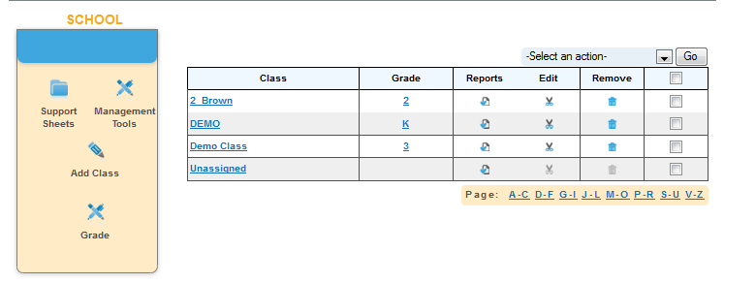

**1. Select your class**

1. Select Class Report

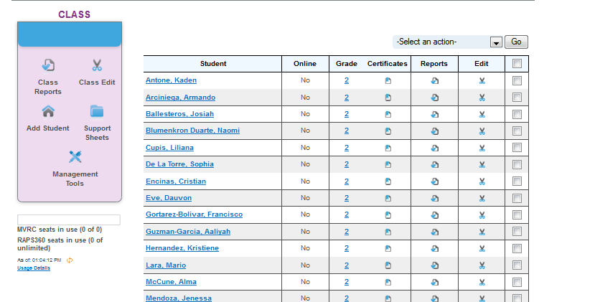

1. Make sure to change the date range to **Current School Year**. Then press the A**pply button** to make changes. This will allow you to see initial and current data.

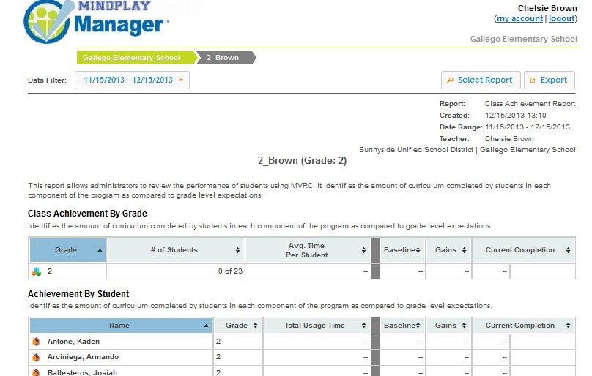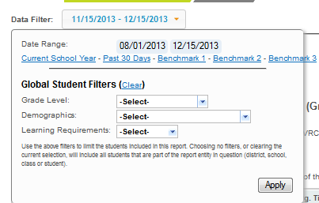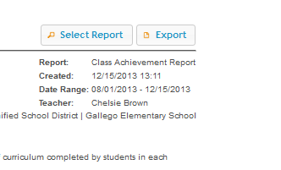

4. Select Report

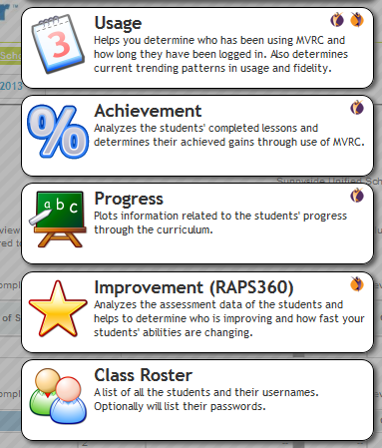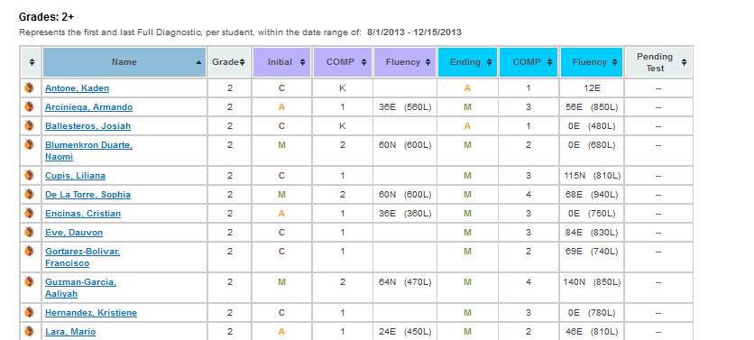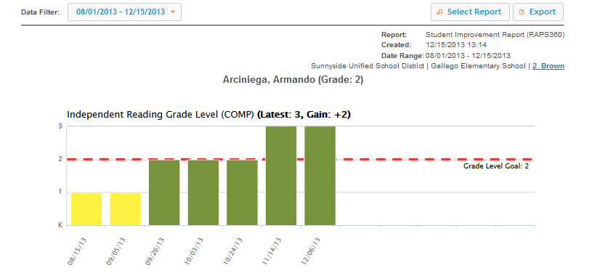

6. Select an Individual Student

7. Select Report

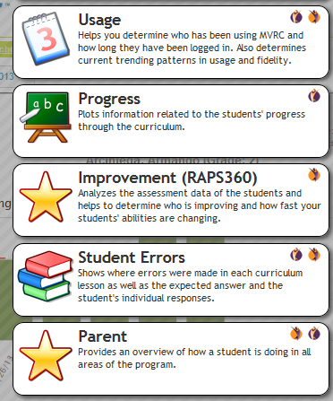

9. Print or Export report. This report will be sent home to parents or for Move on When Reading data collection.



