Name: Click here to enter text. Date:Click here to enter a date.
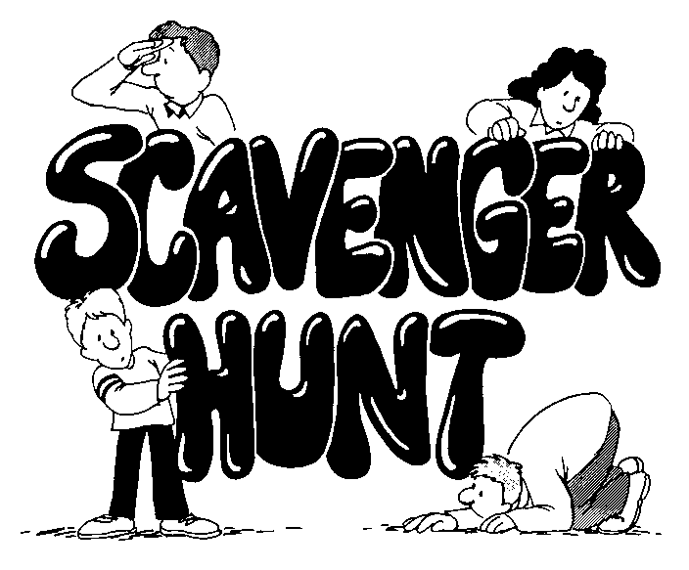
Internet Scavenger Hunt
DIRECTIONS: Use the START menu and the websites that you have bookmarked in class to try to locate the answers to the following questions…
START MENU
- What are THREE programs that are part of Microsoft Office?
Click here to enter text.
- What are THREE other programs that come installed on your laptop?
Click here to enter text.
- What is the name of THREE options that are on your Control Panel?
Click here to enter text.

Pima County Public Library
- What is the name of a book that has won a Caldecott Medal?
Click here to enter text.
- What are the THREE WAYS that I could get free Homework Help during the evening?
Click here to enter text.
- What are THREE games or sites where you can learn about being safe on the internet?
Click here to enter text.
- What is the TOP news story for kids today?
Click here to enter text.

National Geographic Kids
- Which kinds of camels have one hump and which have two humps?
Click here to enter text.
- Name THREE different species of sharks that are in the ocean.
Click here to enter text.
- How much does a full grown polar bear weigh?
Click here to enter text.
- What are THREE kinds of animals that tigers eat?
Click here to enter text.
Kids Know It (Featured Learning Activities)
- Check out the “Solar System” lesson. How many moons does the planet Saturn have?
Click here to enter text.
- What are TWO different kinds of sedimentary rocks?
Click here to enter text.
- Name TWO kinds of armored dinosaurs?
Click here to enter text.
- Where did the very first prehistoric humans live?
Click here to enter text.

Biography.com
- How old was Shakira when she signed her first record deal?
Click here to enter text.
- Where was Cesar Chavez born?
Click here to enter text.
- Who are THREE other major league baseball players that Barry Bonds is related to?
Click here to enter text.
- What is the name of TWO of Frida Kahlo’s paintings?
Click here to enter text.

BONUS!!! Guinness Book of World Records
- Who is the tallest LIVING man in the world?
Click here to enter text.

