Kathleen Murphy Art – Lesson Plans
Week 6.0 - Sept 9, 2013
Grade 3/4/5 – Family drawing using Pointillism / Impressionist art Week 4
Focus : Complete small practice dot painting, using rubric to determine compliance and completion.
Impressionist Art and Pointillism – (see Portfolio book for grade 3) pages 14-19 George Seurat (1859 – 1891), A Sunday Afternoon on the Island of La Grande Jatte

Other artworks by Seurat – on display wall.
The Circus – Le Circue ( Portforio 3-1B)1890-91

Seinne at Le Grande Jatte - 1888

Key vocabulary:
Procedures – as in clean up procedures for painting
Planning and practice – the process that Seurat used to make paintings,
Studies – Practice sketches/paintings that came before the final painting
Contrast – principle of design where one color stands out against another color

AZ Art Standards:
Concept #1 , Strand 2, Art worlds, Role that art plays in culture/history
Concept 2. Materials, Tools, and Techniques: Use materials, tools, and techniques in his or her own artwork
Concept 3. Elements and Principles: Use elements of art and principles of design in his or her own artwork . (shapes, line and color)
Concept 4.Meanings or Purposes: Express ideas to communicate meanings or purposes in artwork.

Objectives –
- I will follow artroom procedures and cleanup instructions the first time.
- I can use a variety of tools to complete a sample dot painting, according to the rubric

Question of the day: What combination of colors will you use in your ground and in your dog to make sure there is contrast and the dog is not camouflaged.
Materials: manila paper cut in quarter sheets, block paints, water containers, q-tips,pencils with unused erasers, paper towels, markers, pencils. Third grade Portfolio Book (page 16, 18 1nd 19 ) Picture of Sunday Afternoon on the Island of La Grande Jatte (on front wall), (utube video of dot painting if there is time)http://www.youtube.com/watch?v=xIRSRzmfVnw,
Lesson Steps:
- Anticipatory Set: review of dot painting and its connection to Pointillism, George Seurat and more interesting facts about him, his life and process. Review of a few student paintings that are finished and what works about them.
- Review procedures: Entering class lineup and name handout, question for buddy buzz, objectives. Move to carpet area.
- In carpet area – show u tube examples of dot painting. Review procedures for dot painting (example Portfolio page 18) and the rubric of what all practice paintings need to be complete.
- Move to tables, complete practice dot paintings. This is week 3.
- Cleanup – Students will dispose of q tips in container on table. Tempera block paints back on small tray. Brushes cleaned with water in center of table in painting carriers with bristles up.
- close – silent ball – one painting rule.

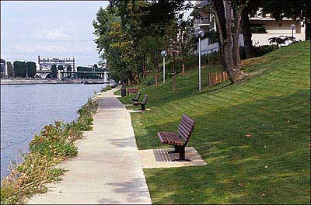
La Grande Jatte today (suburb of Paris)

