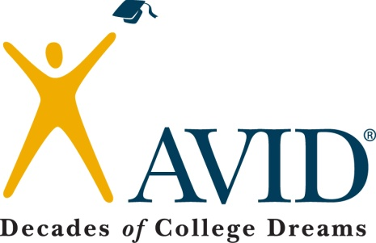
Professional Learning: Higher Level Thinking
Topic to be covered: Higher level thinking

Time – 30minutes
General Notes: Effective questioning strategies can be the key to raising rigor in any content area.

Materials:
- Powerpoint on Costa’s Levels
- T-chart on sentence starters

Objectives:
Each teacher will be able to:
- Identify how questions can raise rigor for students
- Identify question starters to reach higher levels of thinking

