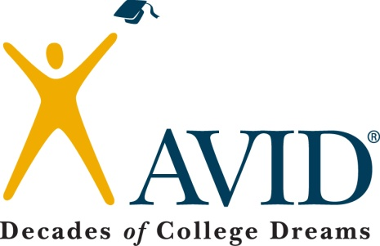
Professional Learning: Non-Cognitive Variables of Success
Topic to be covered: Non-Cognitive Variable of Success

Time –
General Notes:
- The research of William Sedlacek identifies non-cognitive variables that are correlated to student persistence and success in college. These variables form the foundation for the questions in many scholarship competitions including the Gates-Millenium award.

Materials:
- Lesson Plan
- Article/Research on the Variables
- College “Street Smarts”

Objectives:
Each teacher will be able to:
Identify the non-cognitive variables of success
Explain the relationship between the variables and student persistence in college
Support student achievement through fostering the variables in students

