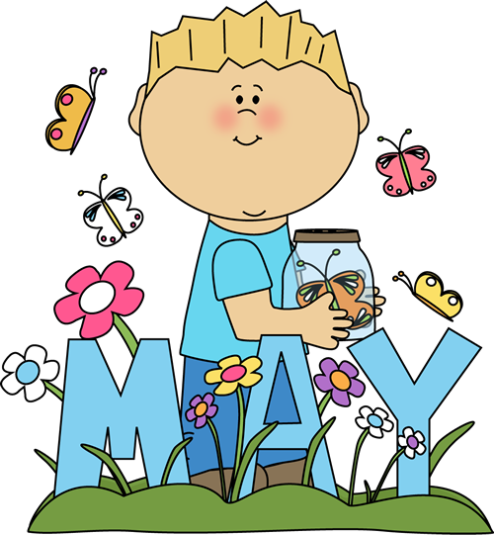
Ms. Samaniego’s Newsletter

Tuesday, May 6th, 2014

Snack Friday
Thank you to all parents that donated snacks throughout the year. You have supported our class in having in afternoon snack thank you so much for your help.

Classroom News

WE ONLY HAVE 12 DAYS LEFT UNTIL SUMMER VACATION!!

* We are collecting box tops for our class. Please send them in on the collection sheet!

Reading

Your child will be reading every day and will be learning about the solar system and space.. Comprehension, main idea & details, tell the difference between fiction and nonfiction, and vocabulary.

Math

In math, students will be learning— to add and subtract with three digit problems, word problems, multiplication, arrays, and a review of math throughout the year.

ELA/Writing

Students will be learning about friendships with the story: Charlotte’s Web. They fill be writing about the story and filling in graphic organizers. They will learn how to find grammar mistakes in sentences and write the sentences with the corrections.

Grammar

Students will be learning abbreviations, ABC order, transitions, and a school year review.

Holidays & Special Days
Wednesday is early release school will be let out at 1:45pm.
May 5: Cinco de Mayo- School day
May 6: Teacher Appreciation- School day
May 16: End of the year party
May 22: Last day of school
May 10 & 11: Mother’s Day
May 26: Memorial Day

Student of the Month
April Student of the Month
These students have the following requirements:
They do not exceed 2 excused absences and 2 excused tardies, turn in ALL homework assignments, do not have ANY DDR's, they do not have any principal referrals, they participate in all classrooms activities

Lori-Elizabeth Alcivar
Gabriel Garcia
Atillana Henderson
Connor Soliwoda

Ms. Samaniego’s
Newsletter

Homework
*Only 2 weeks left for homework packets! Next week is the last week of homework!
Homework packets are given out every Monday, they are to go home and return every day.
** If your child needs help in any type of homework that is sent out have them come in and see me from 8:30 am T-F so I can help them. I have already told the front office staff about this.

Upcoming Events
May 16: End of the Year party
May 22: Last day of school

May, June, July Birthdays
Happy Birthday to you all!!
Amari 5/1
Anthony A. 5/23
Tiahana 5/25
Lori R. 6/1
Ms. Samaniego 6/6
Luis 6/26
Lori R. 6/1
Anthony C. 7/11
Andrew 7/16
Kaitlynn 7/18

Parent Information
- Please have your child read every night for at least 20 minutes.
- Have them practice writing their spelling words found in their homework packet.
- Check your child’s homework folder every Monday it has the in class work done from the week before.

Dear Parents, we are going to be having a party the last Friday before summer break.
I will be asking for donations for the party and will be sending out a letter later on this week.

Ms. Samaniego

