Find your RAPS360 Data
- Go to the LEARN site, find the “Assessment” tab and select “RAPS 360” and “Educator”
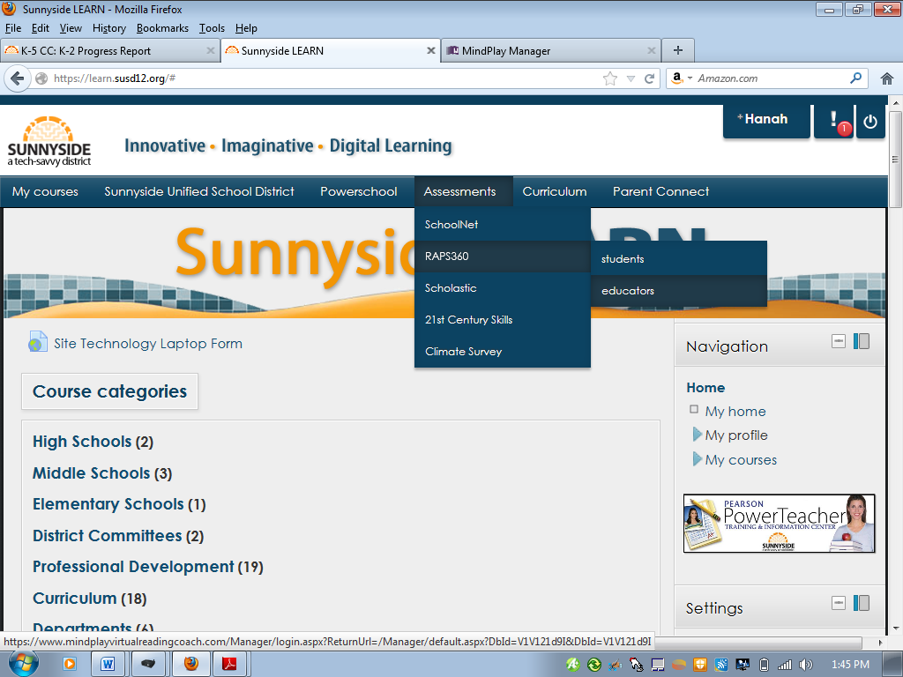

- Log In. Temporary Password if you haven’t changed it: TMP1234
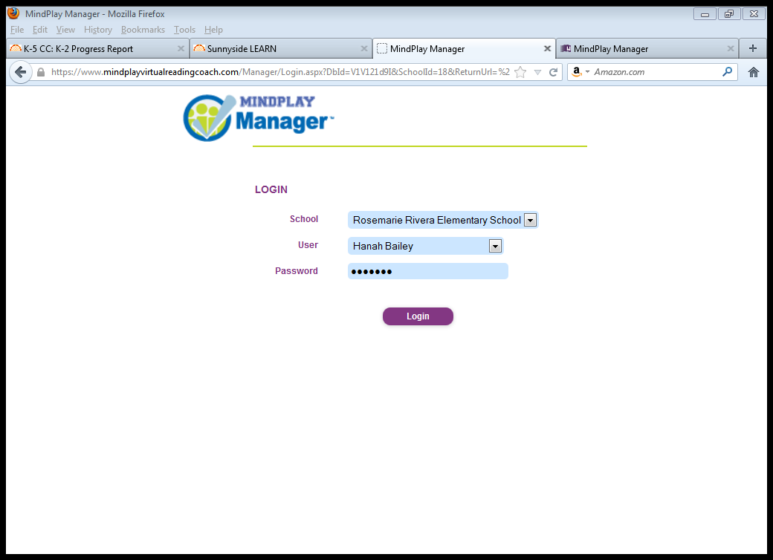

- Go to “Management Tools”
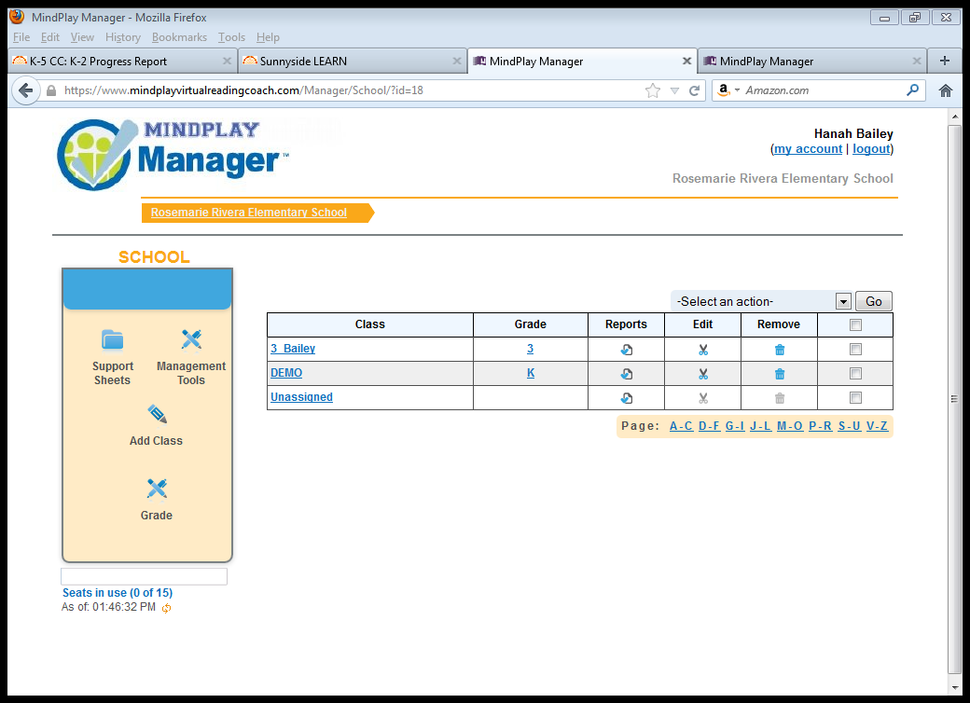

- Select “Materials”
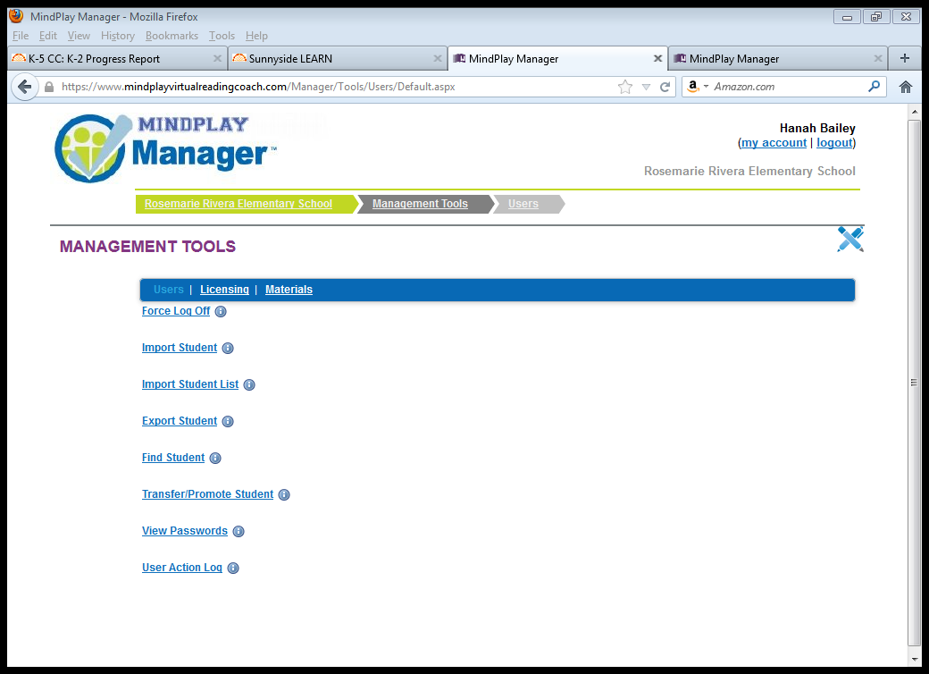

- Click “Legacy Reports”
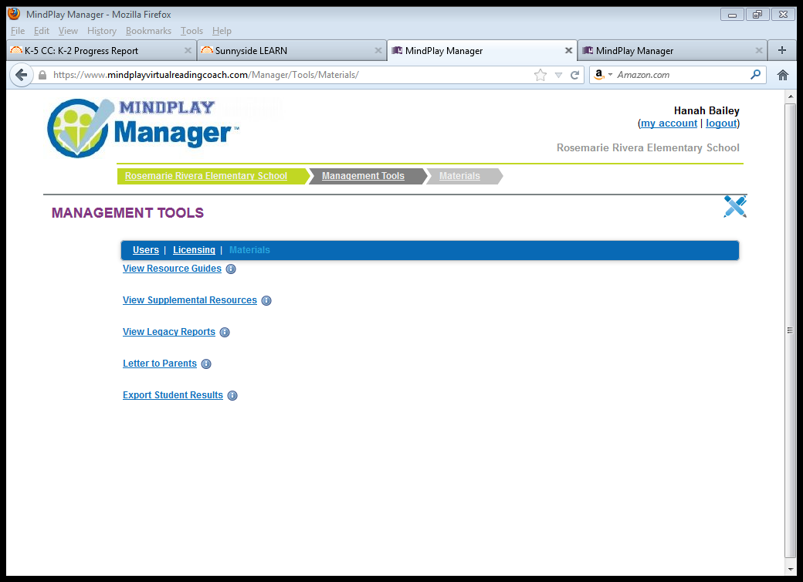

- Click “Class Reports”

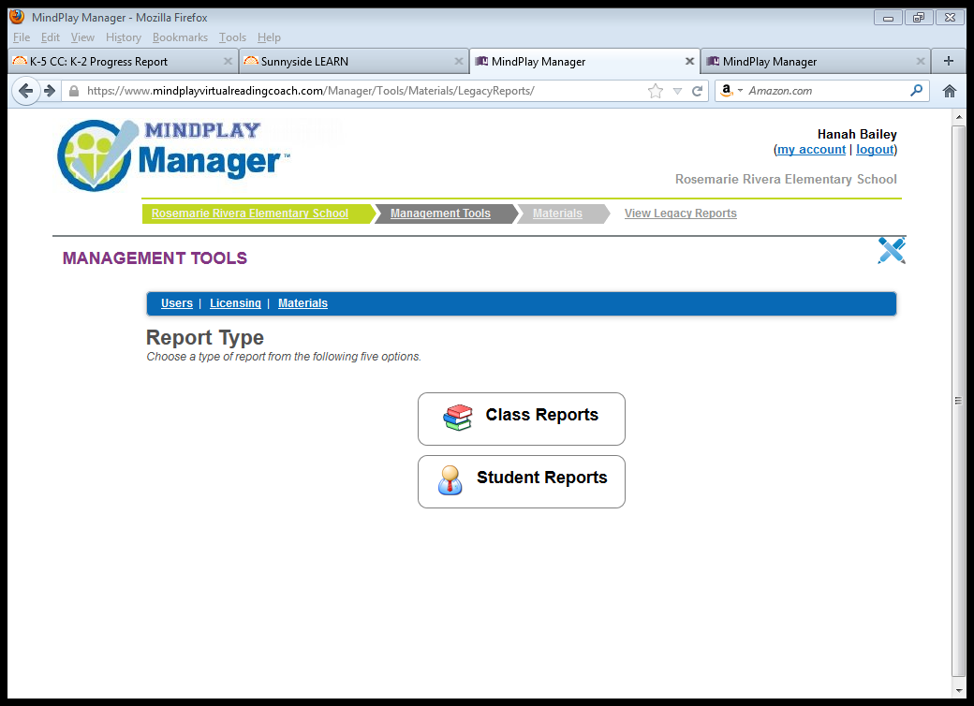
- Select your class
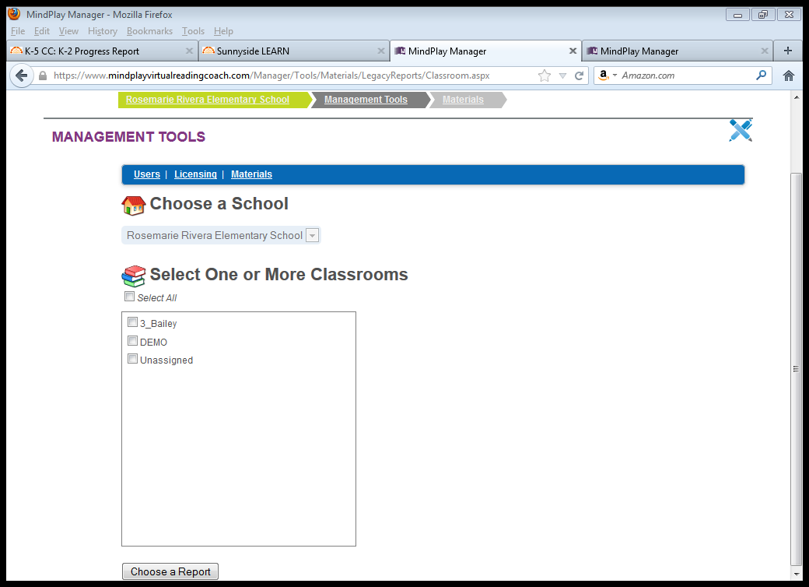

- Select “Progress Report” and click “Run Report”
