Using “google docs” for classroom collaboration
Topics to be covered:
- Using google docs for classroom collaboration
Time:
- Approximately 30 minutes
Objectives:
Each teacher will be able to:
- Demonstrate to students how to use google docs on their laptops.
- Demonstrate how students can share document with their peers and teacher.
- Demonstrate how to create a binder for the different subjects.
Materials:
- Send email to teachers reminding them to bring their laptops to “google doc” training as well as a google account set up prior to training.
- Send directions on creating an account prior to training.
- Have a main lap top connected to a projector to model “google docs”.
- Have teacher present who utilizes “google docs” within their classroom.
- Have student present how they use “google docs” and benefits. (Testimony and model for teachers)

- Go to: www.google.com
- Click on “Gmail” and create a new account.
- You will create a user name and password to log into your “google docs”
- Click on “Drive”
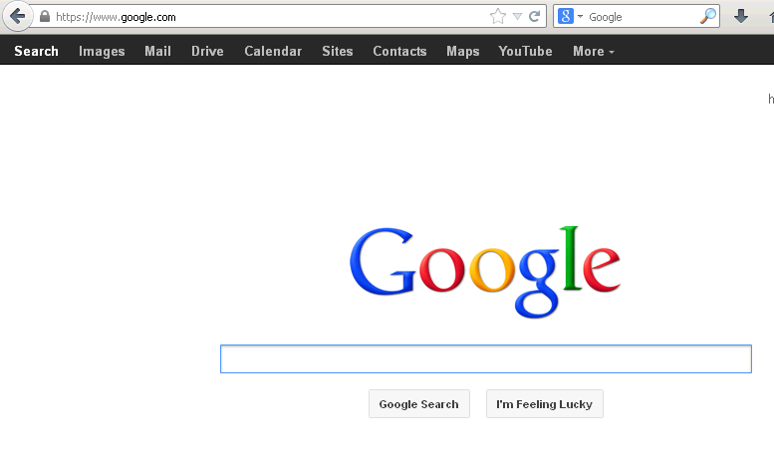

- Click “Create” on left hand side. 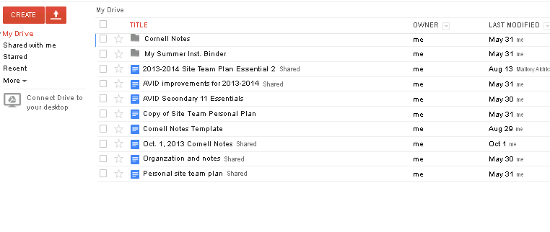

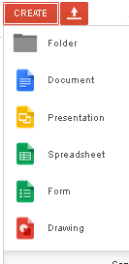
- Click on “Document”
- Create a fake document to experiment….
- Click on “Untitle document” and title it “experiment”
All changes are automatically saved in google docs drive.
- Click “Share”. Blue Box. Upper right hand corner.
- Students can “invite people”and “done” to work collaboratively on a document.

