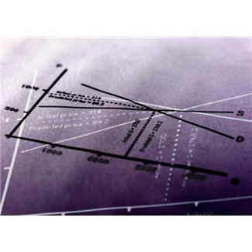
“The Nexus…Where Rigorous Academic, Technical and Innovative Skills Intersect”
Annual CTE Program Evaluation/College and Career Academy Planning Meeting
Wednesday, October 9, 2013, 7:30 a.m., Desert Diamond Conference Center, 7350 S. Nogales Highway
Agenda
Session Objectives: By the end of the morning session, stakeholders will have had the opportunity to review CTE program performance measures data and will have had an opportunity to provide feedback regarding the data and offer suggestions or comments regarding the program’s performance and action plan. By the end of the afternoon session, attendees will have had the opportunity to participate in an activity to deepen their knowledge and understanding of fellow CCA academy members and the diverse experiences, knowledge and skills that members can bring to the academy real-world challenge-based learning experience and have an opportunity to begin the handbook foundation of their respective academy.
7:30 a.m. Registration and Breakfast
7:45 a.m. Welcome and Introductions-Dr. Manuel Isquierdo, Superintendent
8:00 a.m.-8:10 a.m. High School Technology/CTE BioSci and Precision Mfg.-Engineering-Drafting and Film/TV Lennon Bus Videos
8:15 a.m.-8:30 a.m. SUSD Career and Technical Education/College and Career Academies Update-Kathy Prather, Director of Career and Technical Education/JTED; NJ Utter, Director Of College Readiness
8:30 a.m.-9:15 a.m. CTE Program-Specific Data Review and Action Plan Discussions by Table
- Table Discussion Highlights-What is working? What needs action?
9:15 a.m.-10:00 a.m. Table Share-Out (2 minutes per table)
10:00 a.m. Break-Business, Industry and Community Representatives are excused
******************************************************************************************************
10:20 a.m.-10:45 p.m. Welcome Additional Teachers, Videos-Challenge-Based/Project Based Learning
10:45 a.m.-12:15 p.m. SUSD College and Career Academy Collaboration Interactive Presentations/Demonstrations:
Desert View Visual and Performing Arts Academy- Team 1: Mae Casey and Michael Franklin and
Team 2: Teresa Driver and Ericka Quintero
12:15 p.m.-12:45 p.m. Lunch Discussion
12:45 p.m.-1:30 p.m. Collaboration Activity Share Outs by Academy
1:30 p.m.-2:15 p.m. Academy Handbook Discussion and Activity
2:15 p.m.-2:30 p.m. Next Steps Meeting Evaluation: Attendees will be sent an online survey after the event to complete

