This week I am teaching in grades 3-6. Our third through sixth grades are receiving lessons about me, their school counselor, and how I am a resource to them. Third grade have been playing a "thumb ball" game that allows them to move and build oral language while recognizing how I am a resource in the Summit View community. Fourth and fifth graders are learning the same content but through different means, they are experiencing a cool technology resource called Plickers and enjoying the game I have made of the lesson.
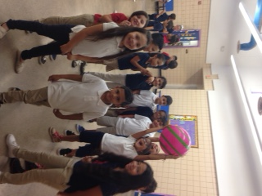
Mrs. Shay's Third Graders
