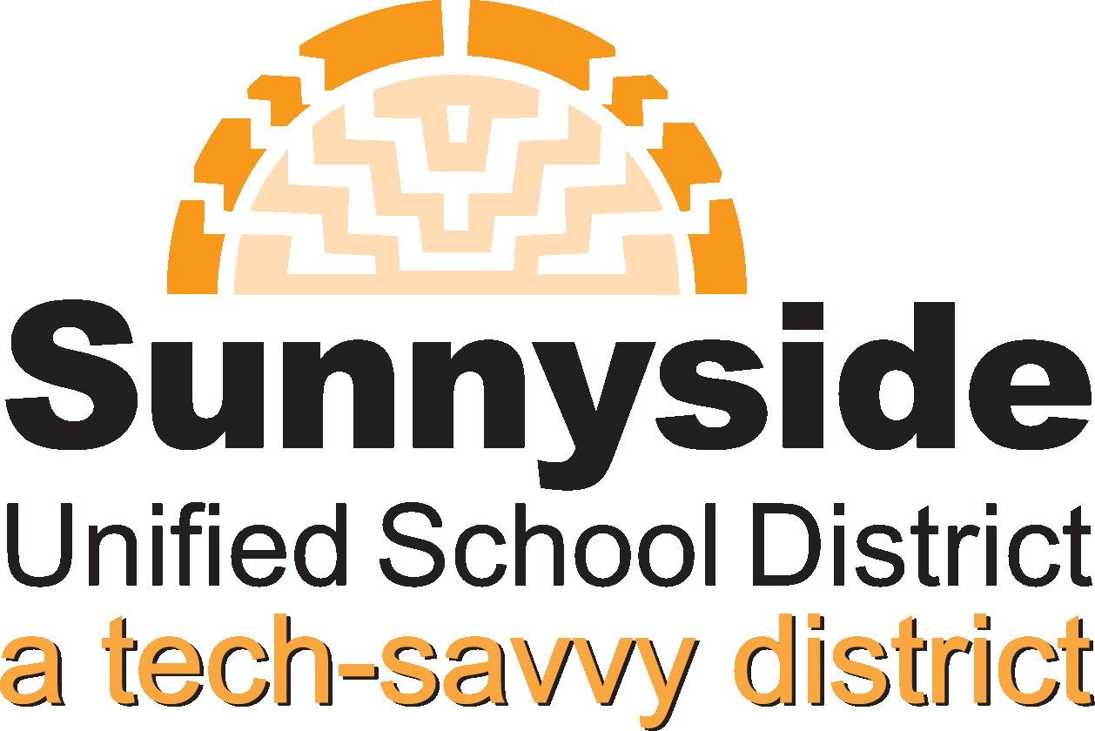
Sunnyside Unified School District
August 2012

Scope of Services

Sunnyside District Service Program:
One-to-One and Project Graduation

Service Program Districts

During the 2012-13 school year, Sunnyside Unified School District has proposed the service program of Project Graduation and One-to-one Computing to seven school districts in Arizona and across the nation. Targeting districts where demographics are similar to those in Sunnyside and located in an urban setting, the following have been chosen through a careful application process including discussion with district leadership.
District Program Service School Districts
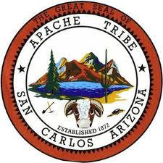
San Carlos Unified School district #20 is a public school district in Gila County, Arizona. San Carlos serves over 1300 students in grades pre-kindergarten through 12th grade. San Carlos, a city located about 115 east of Phoenix, Arizona is on the San Carlos Apache Reservation. The student population is 97% American Indian. San Carlos district consists of three schools, Rice Elementary, an Intermediate & Secondary School and an Alternative School.

Pawtucket School District in Providence County Rhode Island is made up of two comprehensive high schools, three junior high schools, ten elementary schools and an alternative high school, spanning grades pre-kindergarten through 12th grade with a total student enrollment of 8,838. The ethnic makeup of the student population is approximately 45% White, 23% Black and 30% Hispanic.

Kokomo-Center Schools in Howard County Indiana hosts 11 campuses (6 Elementary, 2 Middle schools, 1 high school, 1 career center and one alternative school) serving approximately 6700 students. The ethnic makeup is 80% White, 16% Black and 3% Hispanic.

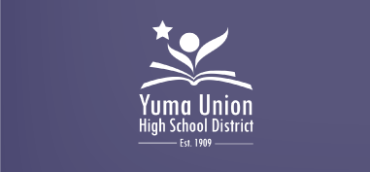
Yuma Union High School District #70 located in Yuma Arizona consists of 5 comprehensive high schools and 1 Alternative high school. Serving approximately 11,000 students grades 9-12 Yuma Union also has four elementary partner districts (Crane, Gadsden, Somerton, and Yuma). Approximately 80% of the student population is minority and 14% are Migrant eligible. The district is 68% free/reduced lunch eligible.
The Gu Vo District is sponsored by the Native American Advancement Foundation which has a total enrollment of 2050 with 828 living on the Tohono O’odham reservation. The Native American Advancement Foundation sponsors Native American Students from the Tohono O'odham Nation located within the Sonoran Desert in south Arizona. The Nation is made up of 11 districts. Each district is comprised of a Chairman, Vice-Chairman, Secretary and Treasurer.

Massillon City Schools is located in Stark County Ohio and consists of one high school, a junior high and intermediate school, and three elementary schools. Massillon City Schools also has a Digital Academy for online learning open to any student who believes a different educational setting is preferable. Washington High School has a strong Career and Technology program with approximately 70% of the school’s junior and senior class students participate in 13 career programs with the ability to earn 12 to 30 semester college credits. Approximately 20% of the student population is minority with as 60% free/reduced lunch eligibility.
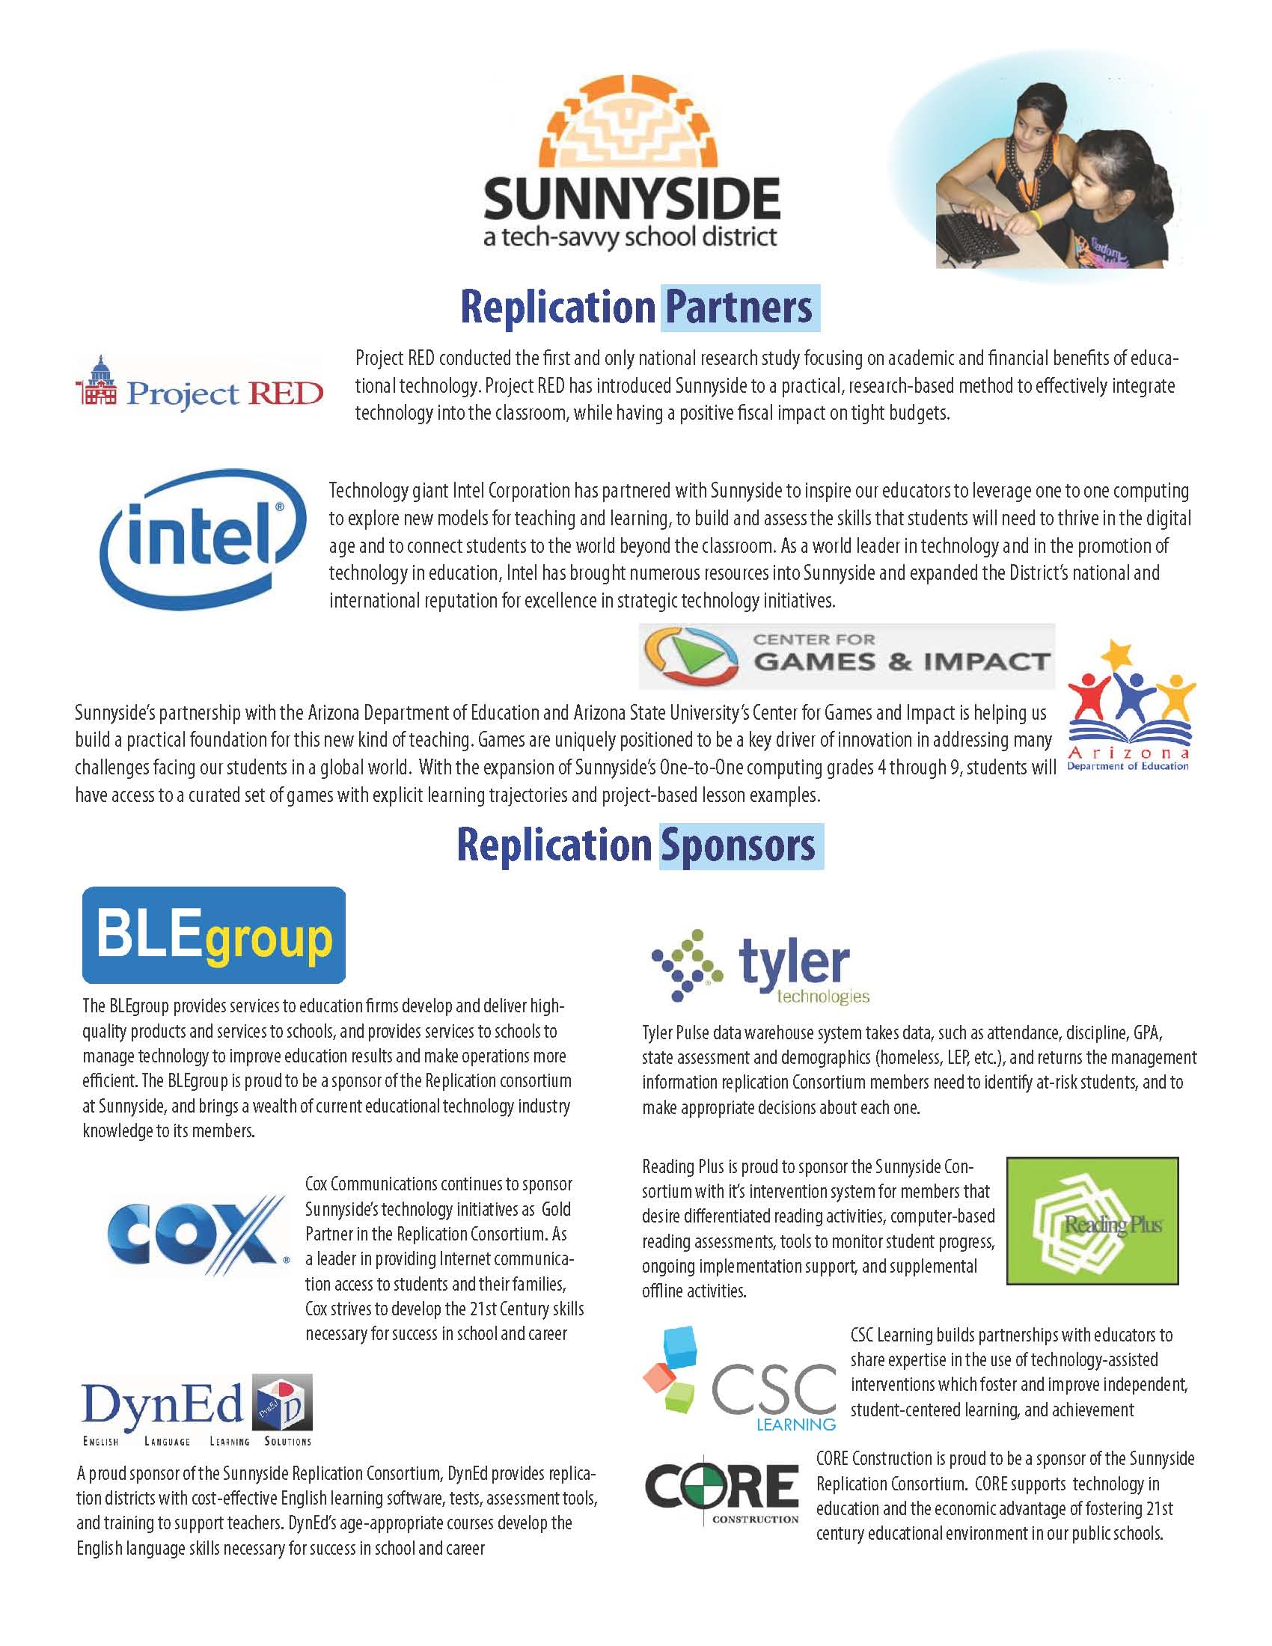

Areas of Support
There are four general areas of support offered within the Sunnyside District Service Program Scope of Services. In addition, consortium members will also have the benefits of support for Parent/Community Engagement, Project Graduation: Digital Advantage, and Drop-out Recovery.

1. Four (4) 2-day on-site visits to the Consortium Schools/Districts
The purpose of these visits vary based on the results of the feasibility/needs assessment, the goals of the Consortium school/district and the strategic implementation plan developed in collaboration with the Sunnyside Executive Team. The standard areas of focus for the visits include:

- Technical Assistance (e.g., team development, infrastructure assessment, teacher readiness evaluation, calendaring, marketing plan/design, manual development, etc).
- Professional Development (e.g., teacher support, coaches support, one-to-one integration training, change leadership trainings, etc.)
- Stakeholder meetings (e.g., Board presentations, parent orientation meetings, staff discussion, teacher association, community, etc.)

2. Consortium Summit (Fall each year)
The 2-day One-to-One Summit allows leadership teams from all consortium schools/districts to learn new information on transforming educational environments into effective one-to-one computer integrated systems. Throughout the summit technology integration leaders from the Sunnyside One-to-One Service program SPONSORS (Intel, Capstone, Atomic Learning, Project Red, BLEGroup) along with representatives from digital leaders from One-to-One Institute, International Society for Technology in Education (ISTE) and other organizations will lead round-table discussions on how Consortium schools can deeply embed technology throughout their educational system.

Consortium teams will observe Sunnyside one-to-one classrooms and will be afforded opportunities to discuss with school principals, staff and teachers about the practical implementation and growth of technology integration in the classrooms. Time for team reflection and planning are also built into the agenda structure.
3a. Monthly Sunnyside Webinars
The Sunnyside Service Team has recorded various standard One-to-One Implementation trainings that will be placed in the Consortium Training Space. Each month Sunnyside technology administrators, coaches and trainers will conduct live webinars addressing subjects within the 9 key implementation strands. Topics include but are not limited to:

- Foundations of One-to-One Computing
- Managing the One-to-One Learning Environment
- Essential Elements of Instruction in a Digital Classroom
- Building a Web-based Curriculum Framework
- Moodle Rooms
- Web Apps, Widgets, Browsers, Wikis and Blogs
- Digital Storytelling
- Technologies to Support ELL students
- Learning Management Systems
- Technology Intervention Integration/Alignment
- Engaging Students through Gaming Technology
- Safely using Social Networking in One-to-One Classrooms
- Helping Students Make Smart Choices Online
- Effective Change Leadership in the World of Technology

3b. Project RED Consortia Webinars
As a Service program partner, your school will have access to participate in Project RED’s 10-webinar Implementation Series that kicks off Sept. 19, 2012. Over the course of 10 months your administrators and staff will gain deeper information necessary to implement a successful, financially beneficial 1:1 program. Sunnyside Service Team members will collaborate with your implementation executive team to discuss how these concepts align with the Sunnyside service program structure. Topics include:

- Overview of research & pedagogy
- Strategic planning
- Financial planning
- Infrastructure
- Device selection

- Common Core Curriculum
- Teaching and learning
- Leadership
- Processes, protocols & procedures
- Project management

- Ten (10) Service Program Support Strands
As a Service Program partner, all of your stakeholders (administration, teachers, support staff, parents, community members, and board) will be supported on the ten essential service program strands to ensure a successful one-to-one implementation. The following describe the Sunnyside Service Teams and the ten service program strands.

District Service Program Teams

The Sunnyside Service Team is structured to allow for the most efficient use of personnel resources for planning and servicing the One-to-One Consortium schools/districts. The Executive Team is responsible for generating the service program plan and type and amount of services required for each Consortium school and/or district:

Executive Team
Dr. Manuel Isquierdo, Superintendent  - Administrative Leadership  - Governing Board Support | Mary Veres, Project Management  - Sunnyside Coordination of Activities  - Strategic Design  - Administration of District Program Service Project  - Marketing  - Travel Coordination
Pam Betten, Curriculum & Instruction  - Curricular Alignments  - Common Core Alignments  - Coaching  - Teacher / Instruction Support | Dr. Ed Dawson, Systems and Data  - System-wide Integration  - Budgeting & Grant Writing Support  - Strategic planning support  - Data and Assessment Systems  - Program Evaluation
- Javier Baca, Information Technologies
- Infrastructure Analysis
- Hardware / Software Alignment
- E-Rate Support

The Service Team is Sunnyside personnel who will provide direct services and support to the Consortium schools. The personnel listed below were chosen based upon the unique skills they possess in supporting the integration of technology within classroom instruction at the elementary, middle and high school levels. Members of the Service Team will be chosen to support schools based upon the match between the needs of the school and the unique skills of the team member.

The type of support provided will vary based upon the needs of the Consortium schools and districts. Support includes, but is not limited to on-site professional development / training, webinars, conference calls, workshops, classroom observations, and direct coaching.

District Service Program Team
- Kathy Dong, Technology Coach (Elementary Support
- Mark Bryant, Technology Coach
- Frank McCormick, Technology Coach (Middle School Support)
- Mario Castro, Technology Coach (High School Support)
- Caitlyn Campbell, High School Support
- Adriana Molina, High School Support
- Lauren McIntyre, Technology Facilitator
- Bob Pratt, Technology Facilitator
- Veronica Ortega, Technology Facilitator
- *Andrea Foster, Parent and Community Engagement
- *NJ Utter, Career and College Alignment
- * AOI Coordinator
- * as needed

10 Service Program Strands

The Sunnyside Service Program Framework distinguishes ten interrelated strands for successful One-to-One service program. In this section a description of each strand is forwarded including potential areas of support the Sunnyside Service Team will provide each district and school based on the results of the Feasibility Study and System Assessment Audit. In a collaborative process we will prioritize the stages of a strategic plan of implementation.

- Organizational Implementation Design
- Infrastructure
- Policy Development (Use of Digital Resources)
- Leadership/Change Management
- Coaching/Teacher Support Model
- Digital Curriculum
- Professional Development & Classroom Support
- “Project RED” Keys to Technology Transformation
- Family and Community Engagement
- Marketing & Messaging

Strand 1: Organizational Implementation Design
(Sunnyside Team leads: Dr. Manuel Isquierdo, Mary Veres)

Establishing the most effective design teams is an essential part of successful implementation. Members of these teams, both at the district and site level, must be chosen strategically and goals, outcomes and expectations delineated explicitly to ensure continued progress of the One-to-One or Project Graduation initiative. These groups include:

- District One-to-One / Project Graduation Executive Committee
- District One-to-One / Project Graduation Advisory Team
- District-level Technology Integration Coaching team
- District Technology Infrastructure and Facilitation Team
- Site Leadership Team

Strand 2: Infrastructure
(Sunnyside Team lead: Javier Baca, Mark Irwin)

As service program schools and districts develop their 1:1 learning environments an initial focus is to plan for the technological infrastructure needed to support the digital environment. The infrastructure is the tangible materials necessary for the 1:1 environment; including the laptop or Tablet PC, the software, the wired and wireless networks, the servers and all the things that are needed in the data and information centers.

- Network topology (WAN bandwidth to all sites, Internet bandwidth at all sites
- Wireless Network; WLAN infrastructure; Wireless access points dual-band, managed (lightweight) and fully support 802.11 B/G/N clients
- WLAN Security; Wireless authentication and encryption are
- Client Radios (dual-band)
- Server infrastructure
- Learning Management System (LMS)
- I.T. Technical Support staff
- Facilities readiness

Strand 3: Policy Development (Use of Digital Resources)
(Sunnyside Team lead: Mary Veres)

Acceptable Use Policies (AUP) is focused on creating proactive policies that ensure safe and orderly behaviors in a digital environment and prevent abuse of the district’s computer network. Consortium schools and districts are encouraged to develop or modify district policy that provides a policy endorsement and rationale for the use of Information and communications technologies (ICT) as a critical component of the teaching/learning process.

- Acceptable Use Policy | - Discipline Matrix
- Expectations (Teacher and Students) | - Cyber-bullying Awareness and Response
- Social Media Policy | - Student E-mail
- Student Handbook | - CIPA Compliance

Strand 4: Leadership/Change Management
(Sunnyside Team leads: Dr. Manuel Isquierdo, Dr. Ed Dawson)

One of the most fundamental and integral strands that ensures effective implementation and sustained success of a One-to-One / Project Graduation Project is support for the district and site leadership. These projects are Second-Order Change and as such leadership (superintendents, principals, site leadership teams) need to be fully aware of how to lead second-order change, how to manage staff and teachers at various cognitive and skill levels, and the effective methods of communicating the efficacy and need for change to all stakeholders. Areas of emphasis include:

- District / school leadership technology use
- District and school leaders readiness to guide integration of technology
- School leadership site plan for effective use of technology in the classroom
- Monitoring the Technology plan
- Leading and managing second-order change
- Leadership support for implementing one-to-one computing
- Evaluating and addressing teacher readiness

Strand 5: Coaching/Teacher Support Model
(Sunnyside Team lead: Pam Betten)

Coaching and teacher support are essential for teachers to successfully integrate technology into the classroom. A comprehensive embedded coaching model will include focused and ongoing support designed from both the District level and each site.

- District level Coaching structure (to support site level coaches and teachers)
- Site level Coaching structure (provide high frequency support to site teachers)
- District directed formal coaching model with subsequent training for all levels of Coaches
- Coaching focused on individual and small groups of teachers/students
- Modeling a variety of meaningful integration strategies in the classroom
- Provide tech and curriculum support including lesson design
- Facilitate online communication between and among teachers
- Collect and analyze trend data to include both the level of coaching support being provided as well as the levels of integration in the classrooms

Strand 6: Digital Curriculum
(Sunnyside Team lead: Pam Betten)

It is vital that students and teachers have access to a digital high-quality and common-core-aligned curriculum for the core subject areas. Without this capability, both students and teachers struggle to get value from their digital devices. Promoting new instructional practices is also dependent on the use of digital curriculum programs and computer enabled learning strategies. This new engaging digital learning environment allows your schools to provide anytime-anywhere access to students and teachers.

- Technical assistance on curricular integration of technology tools
- Training on lesson planning, management and tech-integration strategies
- Use of a technology integration rubric for curriculum evaluation
- Examples of Common Core developed Digital Curriculum
- Alignment with tech-assisted interventions
- Coordination of digital curriculum with extant resources

Strand 7: Professional Development Design for One-to-One
(Sunnyside Team lead: Pam Betten, Debbie Bergman)

Consortium districts are encouraged to develop a professional development plan. Key features of the Program Services Professional Development Plan include a set of foundational and integration skills. Technical support will be provided to Consortium districts in developing your comprehensive Professional Development Plan. Such a model should include such elements as:

- The 21st Century Skills Assessment
- Teacher technology integration proficiency assessment
- Foundational Learning
- Integration Learning
- Digital Curriculum
- District Support Model
- Classroom Support Model

Strand 8: Project RED Keys to Technology Transformation
(Sunnyside Team lead: Dr. Ed Dawson, Mary Veres)

Project RED is perhaps the most important research completed in 2010 by a collection of expert researchers. This research identified a number of success factors when looking at what contributed to success in schools using computers as a primary resource. The five factors that districts and schools will be given support are:

- Designing Learning Plans that allow all students frequent and appropriate opportunities to use technology in all classrooms and other learning places
- District and site leadership receiving extensive and embedded professional learning and technology training
- Designs that help students become continually engaged in using technologies such as social media, games and simulations to learn and collaborate with others in the learning environment
- Students using weekly online assessments to gauge their learning and then tailor instruction for personalized learning experiences
- Use technology applications daily in intervention programs.

Strand 9: Family & Community Engagement
(Sunnyside Team lead: Dr. Ed Dawson and Andrea Foster)

One-to-One / Project Graduation is not simply a system change that only affects teachers and students within the school. The power of these programs is the profound influence it will have on entire families and the community. Proper preparation of materials for, and communication with families and community groups is an essential strand that will lead to successful implementation and program sustainability. Areas to address include:

- Staff members to coordinate parent and community engagement efforts on a district-wide level
- Staff member designated to coordinate parent and community engagement efforts at the site level
- Parent and community engagement outreach efforts
- Programs to engage parents
- Parent portal (or other program to allow parents to look up their child’s information online)
- Communicating with parents
Strand 10: Marketing and Messaging
(Sunnyside Team lead: Dr. Manuel Isquierdo, Mary Veres)

Communicating the structure, function and benefits of a One-to-One Learning environment to all stakeholders is essential to a successful service program and is critical for the transformation brought about by integrating technology in the schools. In addition to the internal marketing with teachers and students directly using the technology, all stakeholders including board members, parents, administrators and state department personnel must be provided with information to ensure continual support and resources for the service program.

- Designing printed materials
- Designing Websites
- Data Analysis/Reporting
- Resource Materials Design
- Board Development
- Keynote Presentations
- Add-on Specialty Areas
- Parent Engagement Alignment
- Community and Local Business Partnership Development

Sunnyside Service Program Audit

Gathering information on key strands from the district or school system implementing a One-to-One computer initiative is the most pivotal phase of the service program process. This “inside-out” assessment helps the district take a detailed look at where it wants the one-to-one initiative to take it in the future, sets realistic goals and measurable objectives, helps Sunnyside implementation team better understand the organization's internal attitudes, values, and vision for the future, and evaluates the district/school’s present level of “readiness” on key implementation strands.

The Service Program Audit allows the Sunnyside implementation team to uncover:

- Problems or deficits that need to be solved to ensure successful implementation
- Opportunities that the district can take advantage of to facilitate ease of implementation of the Service Program
- Strengths that the organization can leverage to increase the success of sustaining the initiative
- Points of entry and depth of support for the Sunnyside Service Team to service the district/schools in their service program

Your Service program Audit is a tool for you to evaluate your current realities in regard to these eight components. The Sunnyside Service Team will analyze these answers together with your district/schools Service Team determine:

- A list of the necessary needs
- Resources to address the needs (monetary, human, external, internal, etc)
- A Gantt chart delineating the alignment of activities, timelines, milestones, responsible parties, etc, and
- A holistic Strategic Service program Plan tailored to your district/school’s culture and unique requirements.

(Audit will be structured within the 10 implementation / Service Program Strands. Detailed Audit to follow)

