Commecial Digital Text and Online Resources:
Sample Commercial Digital Text for K–12

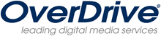
OverDrive School Download Library: Cleveland, Ohio-based OverDrive, perhaps best known for its widespread distribution of e-books to 7,500 public libraries worldwide, maintains an online library of about 600 books geared toward K–12 students, from abstract algebra workbooks to William Golding’s often-taught novel Lord of the Flies. It may provide a way for schools to experiment with e-content through their own school libraries.

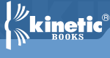
Kinetic Books creates and publishes Kinetic TextbooksTM, a line of comprehensive textbooks that are built from the ground up to take advantage of computers. Kinetic Textbooks are fully interactive, including hundreds of simulations, thousands of animations, audio, video, multiple self-assessment tools for students, scoring, and much more. Flexible, full-featured, and standards-compliant, Kinetic Textbooks work with all types of learning styles. http://www.kineticbooks.com/index.php

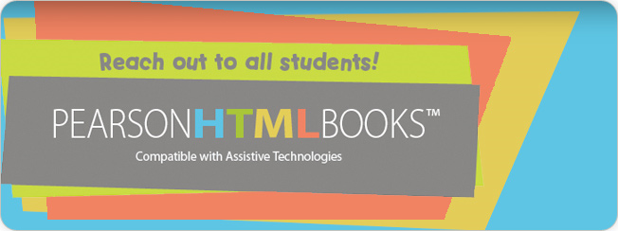
Pearson HTML books are fully compatible with assistive technologies. Their versatile digital design makes them ideal for students with disabilities who may have an Individual Education Plan/Program (IEP) and/or 504 plans. Pearson’s HTML books deliver core content found in Pearson textbooks, which provides equal access to all students. They also are perfect for students who need additional support at home. http://www.pearsonschool.com/index.cfm?locator=PSZ4Z4&pageitemid=1&PMDbProgramId=67381&PMDbSiteId=2781&PMDbSolutionId=6724&PMDbSubSolutionId=6732&PMDbCategoryId=806&level=4&prognav=pt&CFID=35409131&CFTOKEN=10524882&jsessionid=5230547afc9f584d2814

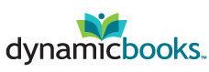
Dynamic Books provides a digital publishing platform and line of interactive digital textbooks from Macmillan that can be freely customized by professors, downloaded, accessed online, or purchased in print editions. http://dynamicbooks.com/

Sample Public Domain E-Text Resources on the Web

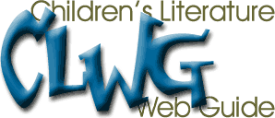
The Children's Literature Web Guide is an attempt to gather together and categorize the growing number of Internet resources related to books for children and young adults. Much information that can be found through these pages is provided by others: fans, schools, libraries, and commercial enterprises involved in the book world. http://www.acs.ucalgary.ca/~dkbrown/

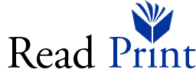

Read Print is a free online library. The web site offers thousands of free books for students, teachers, and the classics enthusiast. http://www.readprint.com/


The Online Books Page is a web site that facilitates access to books that are freely readable over the Internet. It also aims to encourage the development of such online books for the benefit and edification of all. http://onlinebooks.library.upenn.edu/aboutolbp.html

Major parts of the site include—
- An index of thousands of online books freely readable on the Internet
- Pointers to significant directories and archives of online texts
- Special exhibits of particularly interesting classes on online books
- Information on how readers can help support the growth of online books

UNIVERSITY OF VIRGINIA'S E-BOOK LIBRARY
(MS READER and PALM formats)


About these titles: 1,800 publicly available e-books, including classic British and American fiction, major authors, children's literature, the Bible, Shakespeare, American history, African-American documents, and much more.

Thousands more titles (currently web versions only) can be found in the Electronic Text Center's collections and projects, many of which are publicly accessible.

Sample “Chafee” E-Text Repositories on the Web

(For more information about who qualifies for alternate-format materials under the Section 121 copyright exemption (Chafee Amendment) see http://www.loc.gov/nls/reference/factsheets/copyright.html.

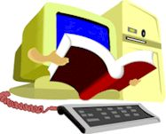
The Accessible Book Collection is a non-profit corporation. Its primary mission is to provide high interest/low reading level digital text to qualified persons with disabilities. Government and non-profit schools and others can subscribe to the very affordable Accessible Book Collection and have a large selection of e-books for all of their eligible students for one low price. http://www.accessiblebookcollection.org/FAQs.htm


Bookshare.org dramatically increases access to books for the community of visually impaired and otherwise print-disabled individuals. This online community enables book scans to be shared, thereby leveraging the collections of thousands of individuals who regularly scan books, eliminating significant duplication of effort. Bookshare.org takes advantage of a special exemption in U.S. copyright law that permits the reproduction of publications into specialized formats for the disabled. http://www.bookshare.org

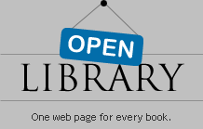
Open Library from the Internet Archive http://openlibrary.org/subjects/accessible_book is a service that brings free access to more than 1 million books—from classic 19th-century fiction and current novels to technical guides and research materials—now available in a specially designed format to support those who are blind, dyslexic, or otherwise visually impaired.

E-Text Searches on the Web
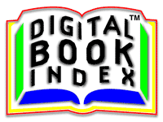
Digital Book Index provides links to more than 114,000 title records from more than 1,800 commercial and non-commercial publishers, universities, and various private sites. About 75,000 of these books, texts, and documents are available for free, while many others are available at a modest cost. http://www.digitalbookindex.com/about.htm

Accessible Books and E-Texts
http://matnonline.pbwiki.com/Accessible+Books+and+E-Texts
The Accessible Books and E-Texts web site hosts an ever-expanding list of e-text resources with a particular emphasis on K–12 education. The majority of the sites included are free. Below is a screenshot of sample entries from a comparison table:

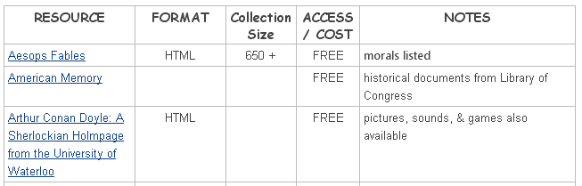

This site is also linked to the “AT Toolkit” site at http://matnonline.pbwiki.com/AT+Toolkit

And to the Delicious pages of the The National Center for Supported Electronic Text at http://delicious.com/Supported_etext.

