To Make a Prezi Account

If you haven’t used Prezi before, you’ll want to make an account.

Go to prezi.com
Then, click on the <Sign Up> tab top right corner. It will take you to the page <Choose a License>, select <Student/Teacher Licenses>, and then the column Edu Enjoy and <Get>. You will need to use your district email to be verified as an active teacher for an education account (more features).

Use Sunnyside Unified School District as the School Name, and the main SUSD website www.susd12.org as the address:
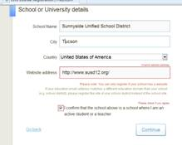

They will send you a confirmation in your district email, click on it and you are set.
