The Harlem Renaissance 1920s-1940s
"We return.
We return from fighting.
We return fighting.
Make way for Democracy! We saved it from France, and by the Great Jehovah, we will save it in the United
States of America, or know the reason why."
W. E. B. Du Bois, "Returning Soldiers," The Crisis, XVIII (May 1919)

Beginning in 1904, Harlem, centered around 135th Street and 5th Avenue,
became a mecca for middle-class African-Americans moving north from
Hell's Kitchen, Clinton, and other neighborhoods in New York City. Black
intellectuals, writers, and other artists were among the first inhabitants of
Harlem, the home of the New Negro movement, as the literary and cultural aspects of the renaissance came to be called.

Importantly prefigured by the writings of W. E. B. Du Bois and Booker T.
Washington, the Harlem Renaissance and the New Negro movement
generated an explosion of creativity unique in its breadth and depth; it
included groundbreaking work in poetry, fiction, essays, music, dance, and
theater. Earlier racism, including lynching and officially sanctioned
murder, had forced many creative black Americans abroad; among
them Josephine Baker and Paul Robeson (later James Wright and James
Baldwin would also become exiles). Black soldiers returning home from the
war were defiant in the face of white people's lack of appreciation for their
service; the U.S. Army's policy had forbidden them from marching in the
victory parade on the Champs Elysées in Paris, but the formidable 369th
Regiment, better known as the Harlem Hellfighters, marched up Fifth
Avenue to Harlem on February 17, 1919. They had served longer than any
other U.S. regiment (191 days on active duty). Their triumphant return was
a point of pride for the community and stirred the rallying cry from the
political leaders of Harlem for black equality in exchange for their sacrifice.
At the same time, Marcus Garvey's Back to Africa movement inspired
working-class African Americans to take control of their lives and histories.
Garvey told UNIA members, "We have a beautiful history, and we shall
create another one in the future."
Write the 5Ws + H of the Harlem Renaissance.

2. Station 2
Langston Hughes was the movement’s best-know poet. Many of Hughes’ poems described the difficult lives of working-class African Americans. Some of his poems moved to the tempo of jazz and blues music, including his famous poem, “I too, sing America.”
Read the poem and quickwrite 2-3 sentences how the poem presents Hughes’ dream of freedom and equality for African Americans.

I, too, sing America.
I am the darker brother.
They send me to eat in the kitchen
When company comes,
But I laugh,
And eat well,
And grow strong.

Tomorrow,
I'll be at the table
When company comes.
Nobody'll dare
Say to me,
"Eat in the kitchen,"
Then.

Besides,
They'll see how beautiful I am
And be ashamed--

I, too, am America.
3. Station 3:
African Americans during the Harlem Renaissance used their art to celebrate African culture. The 1920s is often called the “Jazz Age.” Jazz music is a distinctly American, specifically African American, form of music combining blues, ragtime, and African rhythms. It was founded in New Orleans by African Americans. This style of music traveled with the Great Migration and filled the night clubs of Harlem, most notably the Cotton Club, which only served whites. Edward Kennedy “Duke” Ellington and Louis Armstrong were the most influential Jazz musicians at the time. Louis Armstrong in particular was known for his astounding sense of rhythm, ability to improvise, and use of personal expression as a key component of Jazz.
Listen to this youtube clip of Duke Ellington and Louis Armstrong:
https://www.youtube.com/watch?v=h2iEulpX910

List 5 characteristics of Jazz music. What type of music can jazz be compared to today? Be ready to discuss with the class.
4. Station 4:
Along with celebrating their African heritage, Harlem Renaissance artists used their art to bring awareness to issues plaguing the African American community. Billie Holiday was an influential Jazz singer and songwriter. One of her most significant (important) songs was “Strange Fruit.” It was first a poem, protesting American racism, that was later put to music. Billie Holiday performed the song almost every night.
Watch this clip:
https://www.youtube.com/watch?v=h4ZyuULy9zs

What social issue is Billie Holiday trying to bring attention to in “Strange Fruit?” How can you tell?

5. Station 5:
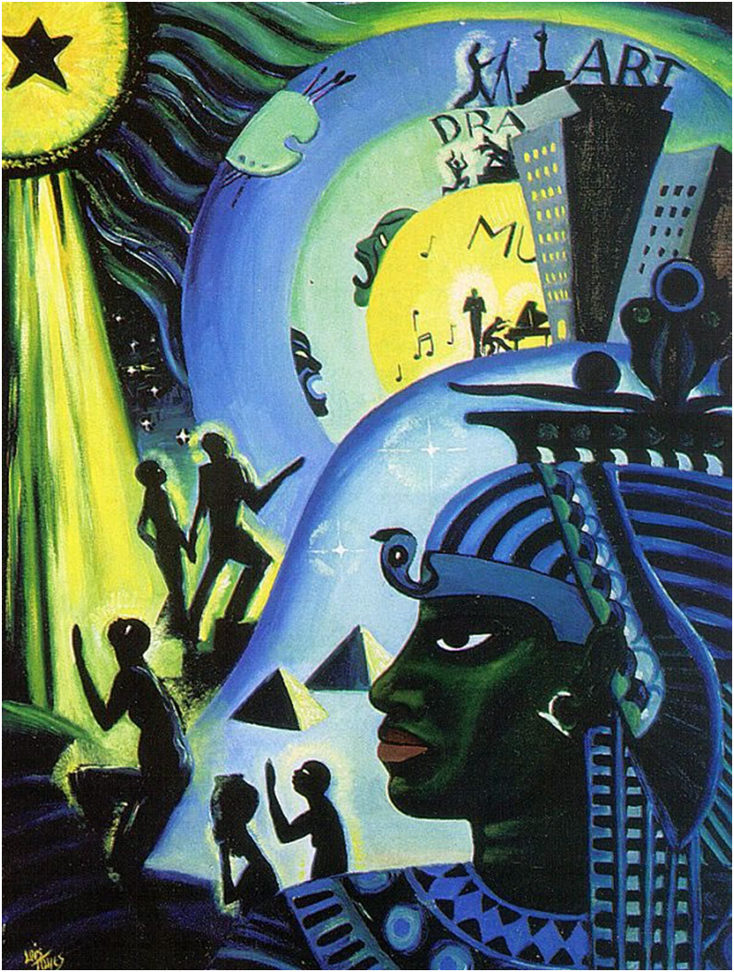
African American artists also used paintings to express both their historic and modern-day culture. “Ascent from Ethiopia” by Louis Mailou Jones is one such example.
Analyze this painting, explaining how it demonstrates a celebration of African culture and heritage both past and present. What is the journey African Americans are going on in this painting?

