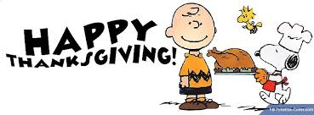
Do Now’s for the week of November 24-26, 2014
Monday,  November 24, 2014 | Quick write: Read the title of the book & the first page of the novel. Make a prediction about what you think you’re going to be reading. ________________________________________________________  ________________________________________________________
Tuesday,  November 25, 2014 | Define the vocabulary word palpable, and use it in a quality 7 UP + sentence. _________________________________________________________  _________________________________________________________
Wednesday,  November 26, 2014 | Quick write: What do you infer that Jonas is thankful for? Write 2 to 3 quality 7 UP + sentences justifying your response.  ________________________________________________________  ________________________________________________________  ________________________________________________________.

