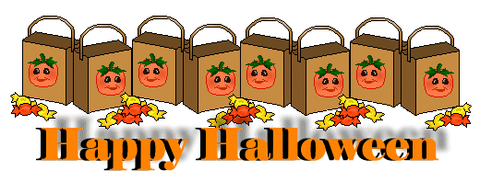

Monday,  Oct. 27, 2014 | Quick write for 2 to 3 minutes the following statement…  How does a warm, clear summer day make you feel?  __________________________________________________________________  __________________________________________________________________  __________________________________________________________________  __________________________________________________________________
Tuesday,  Oct. 28, 2014 | “What would you do if you won the lottery”? List the five most important things you would do with your winnings.  - _________________________________________________________________  - _________________________________________________________________  - _________________________________________________________________  - _________________________________________________________________  - _________________________________________________________________
Wednesday,  Oct. 29, 2014 | “What are some of the differences between the lottery in the past and the lottery today?  ____________________________________________________________  _________________________________________________________________  _________________________________________________________________  _________________________________________________________________
Thursday,  Oct. 30, 2014 | What does the symbolic meaning of the black box, black dot, and the stones within the story?  _________________________________________________________________  _________________________________________________________________  _________________________________________________________________  _________________________________________________________________
Happy Halloween!  Friday,  Oct. 31, 2014 | Today you’re going to repeat what we did last week. I want each one of you to check your grades on Power School. Record them all onto the back of the Do Now.
Use the back for answering Friday’s Happy Halloween Do Now!

